Master of Science in Data Analytics

**A Deep Learning Approach for Flood Detection from Social Media Imagery**

Nupur Pathak, Revathi Boopathi, Sree Divya Cheerla, Vani Bhat

Department of Applied Data Science, San Jose State University

DATA 270: Data Analyst Processes

Final Group Report

Dr. Eduardo Chan

December 11, 2022

**Abstract**

Social media platforms are gaining tremendous popularity as people post live videos and images broadcasting events around the world. These are instrumental for tracking events and planning disaster management. Advancements in Deep Neural Networks and Computer Vision made it easy to deploy models for object detection and image classification. In this paper, the authors have used images shared on social media to identify floods to help disaster management organizations and communities to identify appropriate emergency responses to disaster situations. This helps the front-line workers in assessing the severity of the situation and estimating the damage incurred to take necessary actions. Previous studies focused on traditional methods using the threshold-based methodology to detect floods based on backscatter coefficients. Convoluted Neural Networks (CNNs) are consistently performing the best for flood classification as compared to other machine learning and threshold-based methods. In order to identify flood-related photos, several of the most advanced CNN models, including ResNet-50, GoogleNet, VGGNet, and AlexNet, are used in this study. Based on the performance of these models, VGG-16 is identified as the best-performing model with an accuracy score of 71.5 % and a precision of 70.1%. This demonstrates that CNN methods are effective in detecting floods from social media images and can be deployed when a disaster strikes. As future work, the study can be further extended to identify earthquakes, wildfires, and other disasters.

**A Deep Learning Approach for Flood Detection from Social Media Imagery**

# Introduction

## ***1.1 Project Background and Executive Summary***

Natural disasters induced by climate change like floods, droughts, wildfires, heat waves, and storms cause severe damage to infrastructure, the environment, and human lives. The development of a system that will detect floods and send early warning signals to the emergency response team is necessary to prevent flood damage. A swift response is required to address the alarming effects of climate change. These natural disasters cause extensive damage to the environment, infrastructure, and people. Based on a report released by the World Meteorological Organization in 2021, "44% of disasters have been associated with floods (riverine floods 24%, general floods 14%) and 17% have been associated with tropical cyclones". Furthermore, it is stated by the World Health Organisation in 2022 that "Floods are the most frequent type of natural disaster, and this trend is expected to continue, and are often caused by heavy rainfall, rapid snowmelt or a storm surge from a tropical cyclone or tsunami in coastal areas". They added that "Drowning accounts for 75% of deaths in flood disasters". Having known the statistics on the extreme extent of damage floods can cause, it is essential to identify a solution that could prevent the damage.

Diverse efforts are undertaken to detect floods through the data gathered by social media, Unmanned Aerial Vehicles (UAVs), and remote sensing satellites using deep learning methodologies. With the technological improvements, the ability to quickly respond to emergencies and recognize disasters, minimizing overall damage to the environment and human life is now available. Finding out about the situation right away after a calamity is really difficult. Information from social media like Twitter, Flicker, and Facebook can be a potential source of information. Images shared on social media by users who are in disaster zones could be used to locate and provide emergency assistance.

This research project aims to detect post-flood disasters by categorizing the images collected from social media into two categories flood and non-flood. Deep learning models are adopted to accurately detect floods and provide necessary information for the emergency response teams. It could assist different disaster management teams in evaluating the situation in flood-prone areas, determining the severity of disasters, and then providing essential care for the vulnerable, such as food and evacuation measures.

Based on a comprehensive review of multiple research papers, the potential of developing a solution for flood detection and its use in disaster management response is realized. As per Nguyen et al. (2017), microblogging social networks like Twitter have been used extensively to post situational updates in times of disaster. Information gathered from Twitter feeds during emergency situations “about the number of injured or dead people, most urgent needs of affected people (e.g. shelter, food, water, etc.), donation offers, etc.” is very useful for the disaster recovery teams. Figure 1 depicts the key stages of the process flow adopted in the project.

**Figure 1**

*Process Flow Diagram*



*Note.* Key stages in the process flow. Adapted from The Data Science Processes, A Visual Guide to Standard Procedures in Data Science.

Social media images are used as input data to assess the impact of the natural disaster. Nguyen et al. (2017) have covered the challenges faced when analyzing images from disaster sites like the cold-start problem. Labeled data is required to enable the machine learning models to begin the damage assessment analysis from the input social media images. The training and testing of the model will be delayed if the labeled data are obtained after the disaster has begun. Therefore, the models will be trained using CrisisMMD, a labeled dataset from previous crisis events.

Asif et al. (2021) compared various models used to classify disaster types including flood, fire, earthquake, hurricanes, and others. “The model evaluation studies reported good accuracy in identifying different disaster types using Convolutional Neural Network (CNN) algorithms” (p. 9).

Jony et al. (2019) contrasted the metadata categorization strategy using a simple neural network and the visual feature extraction approach utilizing sophisticated convolutional neural networks (CNN). The performance of these methods is measured with the Mean over Average Precision (MAP) metric on the MediaEval dataset as shown in Figure 2. The MAP scores are higher when two methods are used to identify floods than when they are used alone.

**Figure 2**

*Performance of popular CNN models*

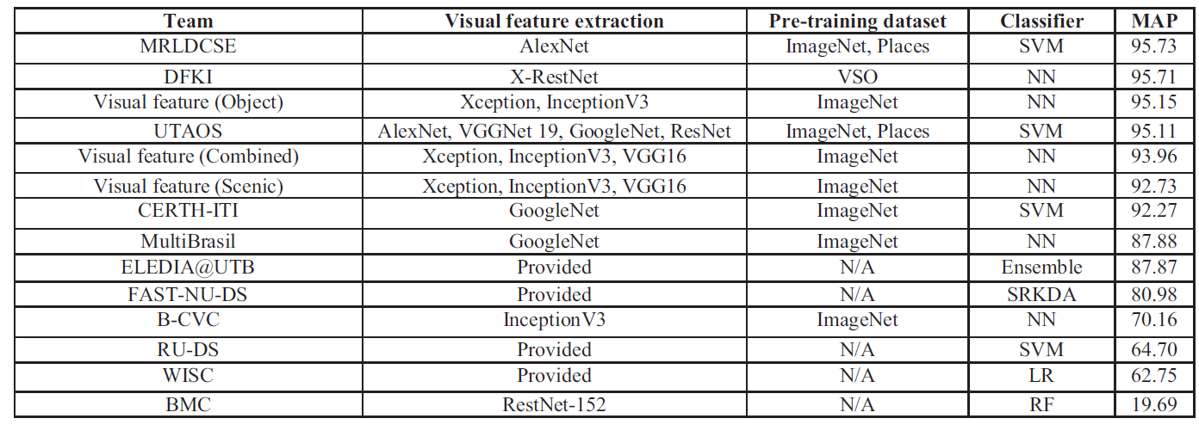

Alam et al. (2020) employed neural network models to categorize social media photographs in accordance with the tasks addressed, including the disaster type (flood, fire, earthquake, and others), the significance of the images to identify the catastrophe, crisis management area, and the severity of the damage. Some of the neural network models used are AlexNet, VGG-16, ResNet50, ResNet101, and MobileNet. Figure 3 shows the comparison of the model performance on the image dataset. EffiNet model outperformed other models for most of the tasks, followed by ResNet50, VGG16, and ResNet10

**Figure 3**

*Comparison of neural network models for image classification tasks*

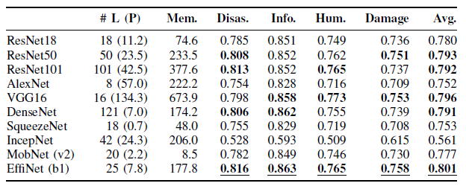

CNN models selected for the implementation are VGGNet, ResNet, GoogleNet, and AlexNet to accurately identify flooded areas as these models are the popular models that provide high accuracy. Since most studies employed satellite and unmanned aerial vehicle (UAV) data to identify flood intensity, this study aims to further the field of social media-based image analysis since it is accessible and suggests popular sentiment. The findings of this study will aid in the development of an effective flood response system that depends on input from the general public on various social media platforms like Twitter. A cost-effective solution for poor nations that are frequently affected by floods might be provided by self-help groups and other organizations who operate in flood response by utilizing this type of approach for studying and categorizing flood impact.

***1.2 Project Requirements***

The essential packages will be pre-installed in the Jupyter Notebook where the code will be hosted. For this to work, Anaconda must be set up on the computer where the Jupyter Notebook will be started. If there is time, scope of this project is expanded to include data extraction directly from tweets on social media. This will include gaining access to the Twitter API with the necessary authorizations from Twitter. Since the resources used in the research are accessible to the general public, no special legal authorization or regulatory restrictions are necessary.

Applications ranging from computer vision to natural language processing use CNN, a deep learning technique. While CNN's architecture is similar to that of other neural networks, it includes a number of convolutional layers to increase complexity. The use cases for CNN range from categorization and picture identification to time series data processing employing voice or text data

**ResNet.**ResNet is one of the depth-based CNN models used to address issues in natural language processing (NLP). It has 152 layers and more than one million parameters. With less computational complexity, fewer errors, and superior picture identification and localization performance, ResNet is deeper than AlexNet and VGG.

**GoogleNet.**GoogleNet uses a deeper architecture than traditional convolutional layers and is computationally expensive due to its use of a number of different algorithms and global average pooling. Its architecture is comparable to Network in Network (NIN) since it uses tiny blocks instead of traditional convolutional layers. By introducing 1x1 convolutional layers, it controls the computational complexity and employs sparse connections to cut down on duplication. In order to decrease the density of connections, fully connected layers are replaced by global average pooling at the bottom layers.

**AlexNet.**AlexNet is one of the well-known CNN models for classifying and identifying images. Its architecture is similar to that of LeNet but has deeper and bigger convolutional layers stacked on top of each other. It has five convolutional layers, including two dropout layers, three fully connected layers, and one max pooling layer. All layers employ ReLu as a non-saturating activation function, while the output layer uses Softmax. Its architecture contains roughly 60 million parameters.

**VGGNet - 16/19.** VGGNet is a 16/19-layer CNN with up to 95/138 million parameters and is trained on more than one billion images. The VGG model is a strong foundation for many applications in computer vision in various object recognition tasks because it controls the complexity of the network by adding 1x1 convolutions in between, which makes it computationally efficient. It is mostly utilized for localization and classification of images.

The dataset is sourced from multimodal CrisisMMD dataset, which includes tweets and photos that have been scraped from Twitter. The collection includes pictures and text about global natural disasters that occurred in 2017, including earthquakes, hurricanes, wildfires, and floods. It comprises information that can be applied to four distinct objectives, including determining the sorts of disasters, their informativeness, the humanitarian categories, and the degree of the damage. All the images are of the type .jpg and the size of the dataset is 1.8 GB. Figure 4 shows the sample images from this dataset.

**Figure 4**

*Social Media Images*

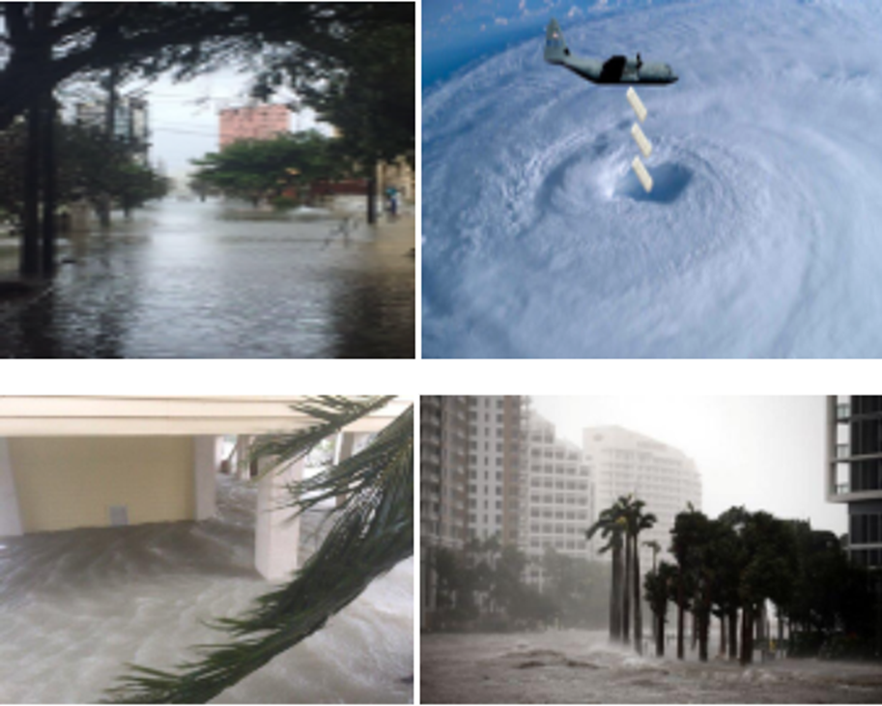

*Note.* Sample images are gathered from social media (Twitter). Dataset for Flood Detection and Damage Assessment.

* 1. ***Project Deliverables***

Deliverables include each significant stage of the project, starting with the project proposal and ending with the final report. The project deliverables are described briefly below.

**Project Proposal.**The project proposal document comprises of the proposed research problems, background, literature survey, and sample data from relevant sources.

**Introduction.** The introduction document includes the suggested research problem, its history, its purpose, its necessity, and its significance. The methodologies taken to tackle the problem should be included, as well as information on the data that will be used and expected contributions and applications of the research in the actual world. It should also discuss related research in the field, a literature review of the previous studies, and a comparison of the various methodologies, models, and findings.

**PM Tool and Work Breakdown Structure.** Project management software like Jira, ClickUp, Monday.com, or Smartsheet will be utilized in this project to efficiently distribute, organize, track, and manage all of the activities. Each step will be supplied with documentation. The project milestones, component deliverables, and work packages are listed in the Work Breakdown Structure (WBS).

**Effort Estimates, PERT, and Gantt Chart Creation**. The effort put forth for each of the research project's deliverables will be listed in the document. It will also include a Gantt chart and a PERT (Program Evaluation and Review Technique) chart, with the Gantt chart displaying the project schedule, tasks, duration, status, and people responsible for each of the deliverables. The PERT chart sequentially shows milestones, individual tasks, and dependencies involved.

**Data and Project Management Plan.** This document will include data collection techniques, involved development processes, a work breakdown structure to show the project's organization, software, and hardware requirements, a Gantt chart outlining the tasks, deadlines, resources needed, and deliverables for each team member, and a PERT chart outlining individual tasks and dependencies.

**Data Collection and Data Exploration.** The data collection and data exploration document include numerous techniques for gathering and assembling data from diverse sources that can aid in resolving suggested research issues. It will include information like where you found the data, how you collected it, how long it took to acquire it, and who is in charge of collecting the data. Additionally, it will provide a step-by-step breakdown of any potential insights that could be drawn from the data.

**Data Engineering.** This document has detailed steps on processes including data collection, pre-processing steps of raw data, data transformation, data preparation, and data reduction.

**Abstract.** This paper will provide an overview of the subjects being studied and the particular research issue, the problem statement addressed, and some background information on previous research.

**Project Presentation.** A high-level summary of the issue and how the research is used to address it is provided in this PowerPoint presentation.

**Individual Research Paper on Model Development.** Details on the deep learning model that each team member individually constructed will be included in this paper. Each team member's copy of the document must be distinct and concentrate on various deep-learning models.

**Group Project Report.** This deliverable is the end-to-end documentation of all the milestones covered in the project.Figure 5 shows the deliverables and due dates for each of them.

**Figure 5**

*Project Deliverables*

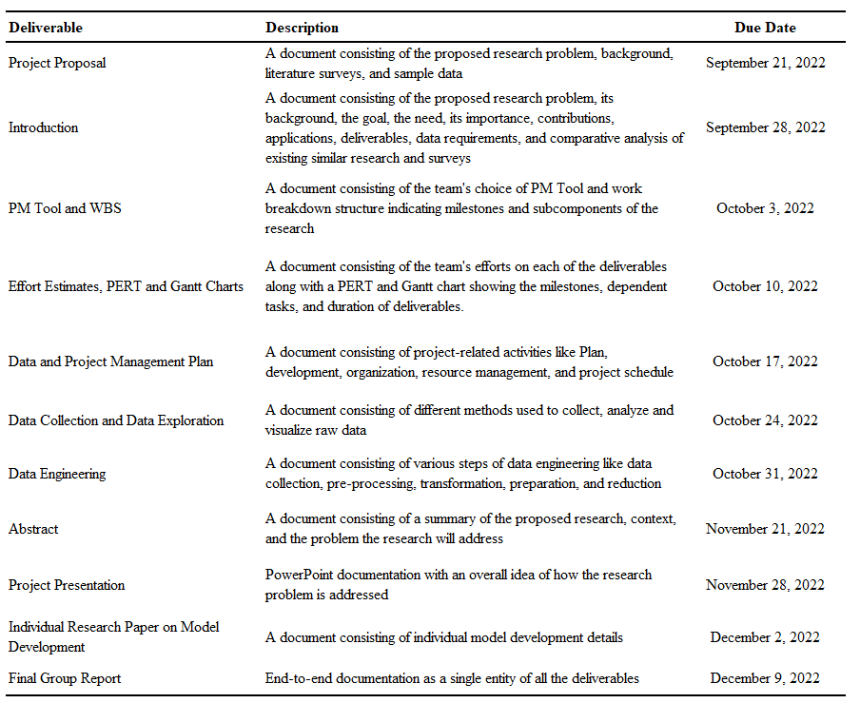

​​***1.4 Technology and Solution Survey***

He quotes, “Deep learning is emerging as a powerful tool and has become a leading machine learning tool in computer vision and image analysis” (2020, p. 174). CNN, Recurrent Neural Network (RNN), Graph Neural Networks (GNN), and Generative adversarial networks (GAN) have been prevalent in image classification scenarios. Based on the technological survey, it is observed that CNN has surpassed traditional machine learning for supervised image classification applications in flood monitoring because of its ability to provide higher accuracy, find precise patterns in images, ability to be tuned in a variety of different ways, etc. through a layered training. They contain a convolutional layer that finds portions of the image that matches the target, and a pooling layer that aids reduction in the dimension of the feature space. Figure 6 shows the variations that are observed from various technological reviews in the domain of image segmentation.

**Figure 6**

*Model description of selected CNN Model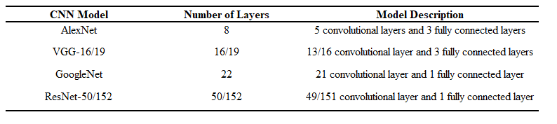*

*Note.* Model description for selected CNN models. Khan, A., Sohail, A., Zahoora, U., & Qureshi, A. S. (2020). A survey of the recent architectures of deep convolutional Neural Networks. Artificial Intelligence Review, 53(8), 5455–5516. https://doi.org/10.1007/s10462-020-09825

Multiple research papers are referred to understand the approaches for flood detection. Below are the summaries of the existing research papers which could help to address the target problem and provide the solution.

Nguyen et al. (2017) address the problem of understanding the level of damage assessment at the time of a disaster. Situational updates in such scenarios are posted by people on social networks “in a variety of forms such as textual messages, images and videos” (p. 569). To identify the severity of the damage as severe, mild, and little-to-no damage, there are two techniques applied. Bag-of-Visual-Words (BoVW), a traditional computer vision technique, and CNN model, a deep-learning technique are used. The VGG-16 model is used in two settings, VGG-16-fc7, and VGG-16 fine-tuned. The study found that the performance of domain-specific deep learning techniques using VGG-16 outperformed the BoVW model when tested on multiple datasets. Figure 7 summarizes the performance of the models for different datasets.

**Figure 7**

*Performance of BoVW, VGG-16-fc7, and VGG-16 fine-tuned models for event-specific datasets* 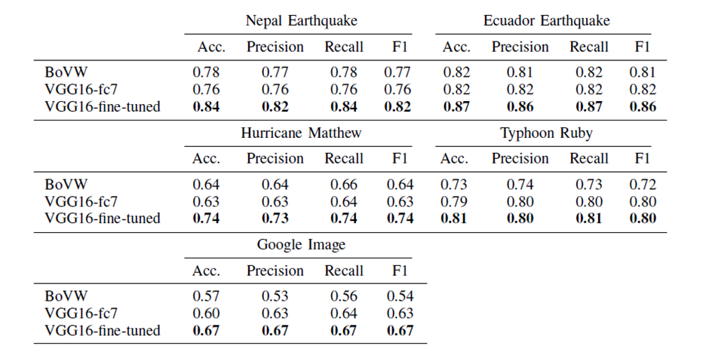

*Note.* Event-specific macro-averaged results for all events in terms of precision, recall,

f1 score, and overall accuracy using three different learning schemes. Nguyen, D. T., Ofli, F., Imran, M., & Mitra, P. (2017). Damage assessment from social media imagery data during disasters. Proceedings of the 2017 IEEE/ACM International Conference on Advances in Social Networks Analysis and Mining 2017.

Asif et al. (2021) in their paper stated, during the time of a crisis, the emergency response time is critical to saving the lives and property of people in the affected areas. They have proposed a novel method by applying cloud-based deep learning algorithms for real-time crisis management using social media images to automate emergency information recognition. The algorithms proposed are "VGG-16 and You Only Look Once (YOLO) algorithms to analyze disaster-related images and identify disaster types and relevant cues (such as objects that appeared in those images)" (p. 1). In addition, the performance of image classification techniques such as "Bag-of-Visual-Words (BoVW) and CNN for evaluating the level of damage severity of social media images" have also been compared (p. 5). CNN models VGG-16, YOLOv3, and YOLOv4 are implemented and compared. The VGG-16 algorithm is used to classify the type of disaster, while the YOLO algorithms are used to detect the objects for emergency response.Based on their study, they found that the VGG-16 algorithm received a training accuracy of 0.98, precision of 0.99, and recall of 0.97. Whereas YOLOv3 could correctly classify 85% of images, and YOLOv4 could accurately categorize 96% of the images. Figure 8 compares the performance of the models.

**Figure 8**

*Performance of VGG-16,* YOLOv3, and YOLOv4

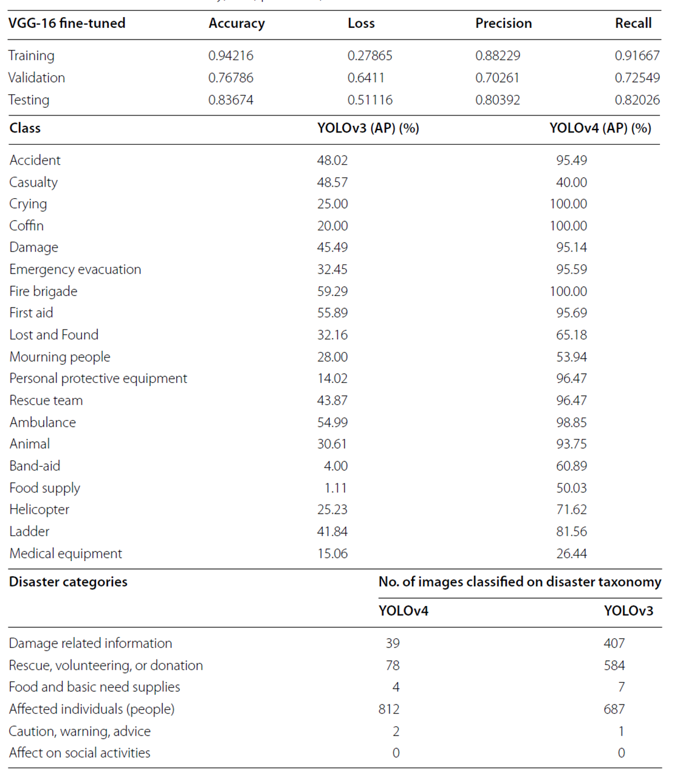

*Note.* Comparison of different models using Accuracy, Loss, Precision, and Recall parameters. Asif, A., Khatoon, S., Hasan, M. M., Alshamari, M. A., Abdou, S., Elsayed, K. M., & Rashwan, M. (2021). Automatic analysis of social media images to identify disaster type and infer appropriate emergency response. *Journal of Big Data*, *8*(1).

Alam et al. (2020) have used various transfer learning approaches like ResNet18, VGG-16, and InceptionNet to classify the images to address four disaster-related tasks namely the type of the disaster (fire, floods, earthquake, and other), the quality of information they possess (filtering out not related and redundant content ), the section of crises management it belongs to (healthcare management, infrastructure damage department, rescue teams, voluntary organizations, etc.), and finally severity of the damage incurred. They used new datasets, relabelled some of the older datasets for better efficiency of the model, and compared the results for performance and computational complexity involved using different network architectures like ResNet18, SqueezeNet, ResNet50, InceptionNet, ResNet101, EfficientNet, AlexNet, VGG-16, DenseNet, and MobileNet.By using individual and consolidated datasets collected from various social media platforms like AIDR, Google, Bing, Flickr, Instagram, etc. When comparing the different network architectures, they observed that EfficientNet outperforms the other models in most of the tasks and InceptionNet has the least performance as seen in Figure 9. They also analyzed the trade-off between performance and computational complexity by calculating the number of layers present, the parameters used, and the consumption of memory for all the network architectures.

**Figure 9**

*Comparison of different neural network models*

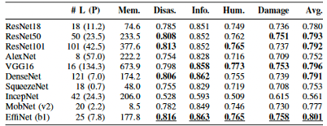

*Note.* Comparison of performance of models using #L(P) - number of layers and parameters used and Mem. - memory consumption. Alam, F., Ofli, F., Imran, M., Alam, T., & Qazi, U. (2020). Deep learning benchmarks and datasets for social media image classification for disaster response. 2020 IEEE/ACM International Conference on Advances in Social Networks Analysis and Mining (ASONAM).

Rahnemoonfar et al. (2021) through this paper mention that the usage of satellite images for disaster management like identifying wildfires, highly flooded areas, earthquakes, and damage severity has been significant but because of the low resolution and duplication of images due to repeated recapturing of images has proved difficult to be used for assessment of post-disaster damage. They observed that in recent times, Unmanned Aerial Vehicles (UAVs) have replaced satellite images as they capture images with high resolutions and can cover lower-lying and difficult-to-access areas with ease. They discussed some of the base models used like InceptionNetv3, ResNet50, and Xception for image classification and emergency response. Fully Convolutional network (FCN) algorithms like PSPNet, ENet, and DeepLab have been used for clustering image parts that belong to the same object class called Semantic Segmentation.For image classification, as seen in Figure 10, they observed that InceptionNetv3 has the highest performance at an overall level compared to the other 2 models. For Semantic segmentation, though detecting small objects like vehicles, flooded roads and buildings is a tough task PSPNet seems to have outperformed in all the classes.

**Figure 10**

*Comparison of performance of different models*

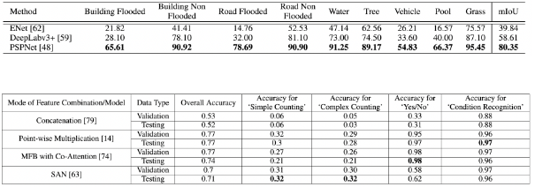

*Note.* Used per-class intersection over union ( %) , accuracy , mean value (mIoU) parameters for comparison. Rahnemoonfar, M., Chowdhury, T., Sarkar, A., Varshney, D., Yari, M., & Murphy, R. R. (2021). FloodNet: A high-resolution aerial imagery dataset for post-flood scene understanding. IEEE Access, 9, 89644–89654.

Jony et al. (2019) mention that most of the time the metadata that comes associated with the images is not considered. In this paper, they have performed visual feature extraction using three CNN models for classification and evaluated their performance by combining two types of visual features and comparing them. To test the potential of metadata, they applied Support Vector Machine (SVM) on metadata for classification and combined it with image data to measure the performance of the model. They used Scikit-learn and Keras Python library for classification and network modeling respectively. For the Visual feature approach, they performed classification using three techniques: Visual features (Object), Visual features (Scenic), and Visual features (Combined) employing models like InceptionV3, GoogleNet, Xception, ResNet, and VGG-16 and compared their performance. For the Metadata approach, after pre-processing the textual metadata using some of the approaches present in Scikit-learn like Bag-of-Words, Vectorization, removing stop words, extracting bi-gram features, and supervised Chi-squared technique to extract the best features, they used the pre-processed data to train Support Vector Machine (SVM) algorithm for classification. They have compared both the visual feature and metadata approaches to determine the accuracy of the classification model and compared them with MediaEval2017 participants' data. They observed that for the visual feature approach, the features extracted from models like Xception and InceptionV3 have outperformed the results achieved by using the approach with VGG-16 whereas the NN approach has given better accuracy than SVM using the same feature sets as depicted in Figure 11. While coming to metadata approaches, they observed that even though they didn't perform as well as visual feature approaches, the User Tags only technique has higher accuracy. They observed that combining metadata with visual data has a better performance compared to their performances.

**Figure 11**

*Classification accuracies using various approaches*

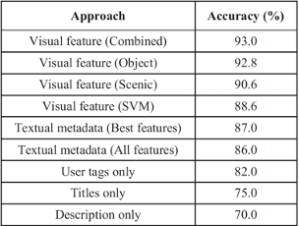

*Note*. Comparison of performance using Accuracy. Jony, R. I., Woodley, A., &amp; Perrin, D. (2019). Flood detection in social media images using visual features and metadata. 2019 Digital Image Computing: Techniques andApplications (DICTA).

The authors also compared both Visual feature extraction and Metadata approaches with models used in MediaEval 2017 by calculating Mean Average Precision (MAP) as in Figure 12. They observed that the visual features (scenic) technique did not perform well, but the visual feature (object) technique achieved better performance than decision fusion approaches which are opposite in terms of classification accuracy. They concluded that though the visual feature approach has better performance than the metadata approach, metadata can be used for flood detection in case of missing visual data.

**Figure 12**

*Comparison of visual feature and Metadata approach with MediaEval 2017 participants' approaches*

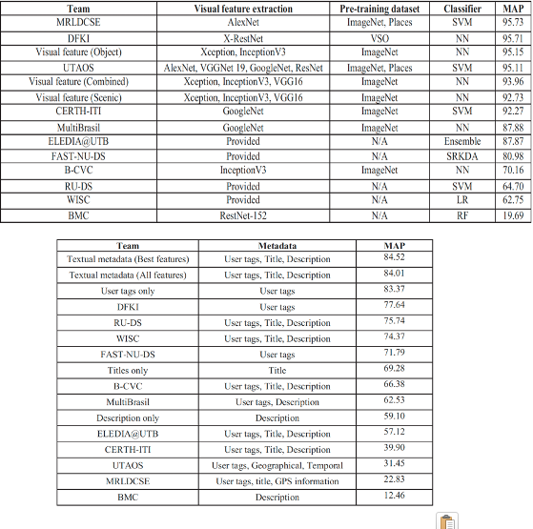

*Note.* Comparison of performance of visual feature and Metadata approaches with MediaEval 2017 participants' approaches using MAP metric. Jony, R. I., Woodley, A., &amp; Perrin, D. (2019). Flood detection in social media images using visual features and metadata. 2019 Digital Image Computing: Techniques and Applications (DICTA).

Montello et al. (2022) say that getting complete information from remote mapping services during natural calamities like floods is very important as there is an impact on lives. However, currently, they are not fully automated and require domain expertise due to the absence of huge, annotated datasets. This would cause difficulty to differentiate flood-prone areas in time using any deep learning models. He urges the importance and needs for multimodal data from various sources to accurately complete the flood delineation task. They have proposed multimodal data called the MMFlood dataset. It consists of SAR satellite images, DEM (Digital Evaluation Maps), hydrography information, and binary annotations. They considered only SAR and DEM as training data and the rest of the data for post-processing tasks. Otsu threshold is defined beforehand. Multiple deep learning models ResNet50 and UNet, ResNet50 and DeepLabV3+, ResNet50 and PSPNet, TResNet and UNet, TResNet and PSPNet, TResNet and DeepLabV3+, EfficientNet and UNet, EfficientNet and DeepLabV3+, EfficientNet and PSPNet, DenseNet121 and PSPNet,and DenseNet121 and UNet have been applied on the data to identify flood which is a combination of encoder and decoder. The deep learning methods have shown great performance in comparison with the defined Otsu threshold. In the experimented baseline models, ResNet has outperformed all models with a mIoU of 0.63. Next in-line is TresNet with an average value of 0.59 mIoU. Efficient and DenseNet did not perform well comparatively. The presence of UNet and DeepLabV3+ has increased performance by 0.63 mIoU. The paper maintains ResNet50 and DeepLabV3+ as the model architecture seeing the performance and simplicity of the model.

Kyrkou and Theocharides (2019) talk about the constraints on UAV (Unmanned Aerial Vehicle) where efficiently classifying the site image (flood, fire, and landslide disaster) on-board in emergencies is quite difficult due to limitations of connectivity, visibility, computing power, and hardware. Though CNN has gained enough popularity through transfer learning, the author says, they are not suitable for those on-board UAVs due to the impediments caused by computational cost and size. They urge to efficiently classify images captured onboard UAVs with the given hardware configuration under adverse circumstances to address emergencies. They have accumulated data from four main disaster events like floods, fire, collapsed buildings, and traffic accidents from various sources and made sure to have both clear as well as unclear data to replicate the images usually collected by UAV. This is basically to evaluate the model performance on such data. They say, first, a CNN referred to as baseNet, is built with fully connected layers towards the edge. Next, the convolutional part is replaced by separable convolution called SCNet, then, full connected layers towards the edge are replaced by convolutional layers called SCFCNet. As the last step, to improve the performance of the model, residual connections are added to each convolutional layer. This is the final model and is referred to as ERNet. They say, at each stage of this model building the performance and accuracy are measured. They also measured the performance of the pre-trained models VGG-16, ResNet50, and MobileNet for comparative study. They observed that VGG-16 (pre-trained network) outperforms all other models with an average accuracy of 91.9%. However, the frame rate is 2 which would not be suitable for real-time in UAV. Out of all custom networks, ERNet outperforms others with an accuracy of 90% and frame rate of 50 which is ideal for real-time classification of images, with a given hardware configuration.

According to Bocanegra and Haddad (2021), frequently traveled roads are impacted by natural disasters, which complicates transport during times of need. They suggest using the information in advance of any natural disaster to organize an efficient front-line response, it is necessary to investigate and discover these damaged sites to avoid commuting during floods. On images and videos taken by Unmanned Aerial Vehicles (UAV), Bocanegra and Haddad (2021) used CNN-based deep learning classification models (AlexNet, GoogleNet, and ResNet50) to classify the type of damage from natural disasters. They then update a virtual map that can be used by first responders. Even with a limited dataset, the network reached an average accuracy of 74.07%.

According to Zhang et al. (2021), significant flooding causes building collapse and severe economic loss, both of which influence a sizable population. They propose that it is necessary to support effective deep learning methods for water body extraction rather than threshold-based ones. They make use of deep-learning models including UNet, FPN, DeepLab3, and MAnet, which employ encoders and decoders with ResNet-101 as the encoder. Their models are contrasted with threshold-based techniques using backscatter coefficients as a measure, such as BTS and OTSU.IoU, F1 Score, and accuracy are the metrics used by Zhang et al. (2021) to quantify the effectiveness of the models. Results from their experiment imply that deep learning models perform better as opposed to threshold-based models. Specifically, the "UNet slightly outperforms other deep learning-based methods on IoU, F1 and Accuracy, but has a significant improvement over threshold-based methods on IoU, F1 and Accuracy by at least 7.9%, 4.2%, and 4.6%, respectively" (Zhang et al., 2021, p. 194). They have employed the metrics IoU, F1 Score, and accuracy to rate the performance of the models. The findings of their experiment suggest that deep-learning models outperform threshold-based models.

Drakonakis et al. (2022) proposed two approaches in their paper. Firstly, to provide the ground data on flood mapping, a dataset named OMBRIA is generated. This consists of the data collected from both Sentinel-1 and Sentinel-2 data. Secondly, they have proposed "OmbriaNet: A novel multimodal and bitemporal CNN designed for supervised image segmentation and change detection" (p. 2342). Experimental analysis is conducted using deep learning architectures based on CNN such as U-Net, Bitemporal OmbriaNet, and Multimodal OmbriaNet on the OMBRIA dataset and compared with the traditional algorithms. The study found that as compared to the traditional thresholding algorithms, machine learning and deep learning methods performed better. The Multimodal OmbriaNet model outperformed the SVM model by 10% in IoU. OmbriaNet provides an efficient flood detection mechanism using supervised learning on multimodal and multitemporal satellite imagery datasets. This can be very useful in flood disaster management and take action accordingly. Figures13-14 lists the comparative analysis of the papers used to solve the research problem.

**Figure 13**

*Model Comparison - I*

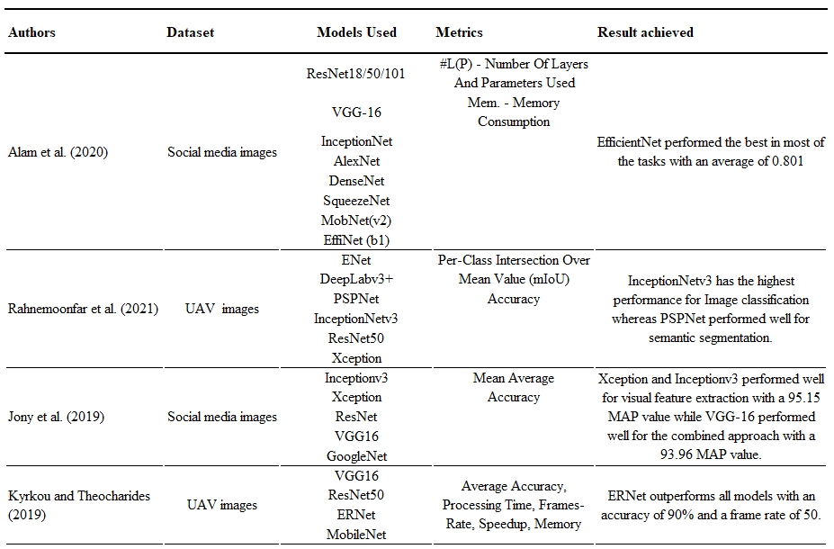

**Figure 14**

*Model Comparison - II*

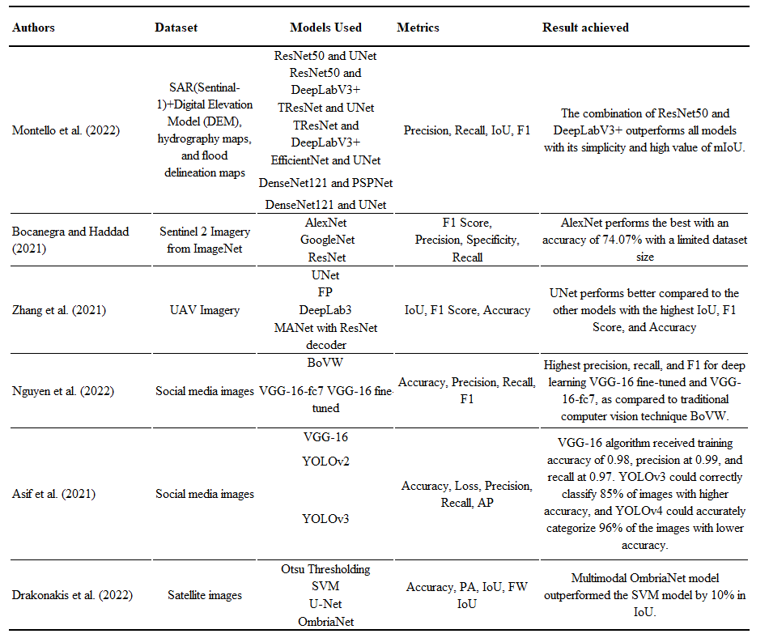

As seen in Figures 13-14, authors in their papers have used multiple different kinds of models and performance metrics to address their problem statement. Irrespective of the source of the data from UAV, SAR, or social media, it is observed that the models popularly used are VGG16, ResNet, GoogleNet, UNet, InceptionNetv3, AlexNet, and MobileNet. It is observed that deep learning models like GoogleNet, ResNet, UNet, etc., perform better as compared to methods like the OTSU threshold. Also, a few researchers like Drakonakis et al. (2022) have proved that deep learning models perform better as compared to traditional machine learning models like SVM.

***1.5 Literature Survey of Existing Research***

In this literature survey, a summary of existing research on the use of various state-of-the-art deep learning models is presented providing a comprehensive overview of current research in this field and highlighting the opportunities and challenges faced.

**Social Media.** Alam et al. (2020) mention that there have been a lot of advancements in recent years in the development of models for disaster management using social media images. Even though there is an abundance of content available online that can be used for identifying disaster types and damage assessment, there is a need for a good amount of labeled data for the models to perform efficiently. The authors used ResNet18/50/101, VGG-16, DenseNet, AlexNet, SqueezeNet, EfficientNet, MobileNet, and InceptionNet for addressing four different tasks disaster identification, the amount of information each image has, which disaster management type it can be allocated to and finally the damage severity incurred. They noticed that even though they can't compare the performance of each model used as they are all different types of tasks and have used different sizes of data, EfficientNet has at an overall level performed better whereas InceptionNet has the least performance. They stress how important it is to get quality data for the models to be trained on and it can help improve the performance of the models.

Jony et al. (2019) mention that though the use of social media images for disaster management has increased over the years, most of the time the metadata that comes along with the images is not considered. In this paper, they have performed the image classification based on 2 different approaches where they employed models like GoogleNet, Xception, ResNet, Inceptionv3, and VGG-16 for the visual feature approach that uses images, and for the Metadata approach, they performed various pre-processing steps like Bag-of-words, stop word elimination, extracting bi-gram features, etc., using the data that comes with the image. They compared the performance of different models and noticed that by combining metadata along with its image, the performance of the model is improved.

Tao et al. (2022), through this paper talk about how important it is to identify the disaster in a short time as it can help disaster management to respond quickly. But as the number of data increases, it might become difficult to identify the disasters efficiently. In this paper, the authors focus on using image monitoring methods to efficiently identify fire-related images, especially those which have small fires as they are difficult to identify. They have proposed an improved GoogleNet model with HSV feature extraction and SVM classification added to the traditional GoogleNet model which reprocesses the wrongly labeled images for better performance. They have compared the results with Traditional GoogleNet and ResNet models and noticed that their proposed model has outperformed the other two.

Valdez and Godmalin (2019) in their paper, talk about the limitation that exists today in classifying different disasters in real-time. To mitigate this they introduce two things, a curated dataset consisting of different natural disaster types, and their severity and also a lightweight two-head convolutional neural network (CNN) to concurrently identify disaster type and severity from the images. They labeled the dataset for disaster type and severity (severe, moderate, insignificant) and implemented MobileNetV3 after analyzing that usage of this network is rarely reported in the current literature. They evaluated the model performance on metrics accuracy, precision, recall, and F1 score on training, validation, and testing set for each of the disaster types which showed promising results under controlled conditions in the joint classification of disaster type and severity. However, they conclude by saying further work would be needed to evaluate how the model behaves under uncontrolled conditions.

Nguyen et al. (2017) address the problem of understanding the level of damage assessment at the time of a disaster from social media images. They cite that despite the advancements in the computer vision field, emergency management relief measures have not relied on image analysis. To identify the severity of the damage as severe, mild, and little-to-no damage, they have used two techniques to compare the performance of CNN-based models vs traditional algorithms. Bag-of-Visual-Words (BoVW), a traditional computer vision technique, and CNN model, a deep-learning technique are used. The VGG-16 model is used in two settings, VGG-16-fc7, and VGG-16 fine-tuned.Their study found that the performance of domain-specific deep learning techniques using VGG-16 outperformed the BoVW model when tested on multiple datasets.

Asif et al. (2021) compared various models used to classify various disaster types and have proposed a novel method by applying cloud-based deep learning algorithms for real-time crisis management using social media images to automate emergency information recognition. They have used the VGG-16 algorithm to classify the type of disaster, while the YOLO algorithms are used to detect the objects for emergency response.

Karteris et al. (2022) have proposed a methodology combining machine learning methods for analyzing Twitter posts about emergencies in real time. They have used a combination of image and text analysis using VGG-16, ResNet50, ResNet50V2, InceptionV3, and MobileNetV2. They could achieve an accuracy of detecting informative posts of over 80% both for text and image classification.

**Satellite Imagery.**Montello et al. (2022) talk about the difficulty to differentiate flood-prone areas in time using any deep learning models because of the absence of fully automated and annotated datasets. They define multimodal data called the MMFlood dataset consisting of SAR satellite images, DEM (Digital Evaluation Maps), hydrography information, and binary annotations. They use multiple deep learning models ResNet50 and UNet, ResNet50 and DeepLabV3+, ResNet50 and PSPNet, etc. to identify floods from the images. They also discuss how ResNet has outperformed all models with a mIoU of 0.63 and how the performance of deep learning models developed in this paper can be further improved using RGB-D, which is a recent work in deep learning.

Drakonakis et al. (2022) have adopted advanced deep learning algorithms such as convolutional neural networks (CNNs) along with computer vision that promises higher efficiency in detecting flood situations. They conclude that OmbriaNet provides an efficient flood detection mechanism using supervised learning on multimodal and multitemporal satellite imagery datasets. This can be very useful in flood disaster management and acting accordingly.

Zhang et al. (2021) have performed an effectiveness analysis of traditional flood intensity measurement techniques and compared them with deep learning techniques. They propose that it is necessary to leverage deep learning methods for water body extraction rather than threshold-based ones that are used in use traditionally when analyzing satellite images.

**UAV Captured Images.**Kyrkou and Theocharides (2019) talk about the constraints on UAV (Unmanned Aerial Vehicle) where efficiently classifying the site image (flood, fire, and landslide disaster) on-board in emergencies is quite difficult due to limitations of connectivity, visibility, computing power, and hardware. They accumulated data of four main disaster events like floods, fire, collapsed buildings, and traffic accidents from various sources and made sure to have both clear as well as unclear data to replicate the images usually collected by UAVs. They developed pre-trained models VGG-16, ResNet50, and MobileNet to compare against the custom model ERNet. They observed that VGG-16 outperforms all other models with an average accuracy of 91.9%. However, the frame rate is 2 which would not be suitable for real-time in UAV. They added that out of all custom networks, ERNet outperforms others with an accuracy of 90% and a frame rate of 50 which is ideal for the real-time classification of images, with a given hardware configuration. They express their curiosity to further research and improve ERNet to detect humans and vehicles using the RGB model which can serve as additional help for people in an emergency.

Rahnemoonfar et al. (2021) observed that the images captured from satellites have low resolution and have duplicates because of recapturing, so it will be challenging to classify the images and identify the disasters. So, to overcome these limitations, they used images captured by Unmanned Aerial Vehicles (UAVs) which have high resolution and can capture even low-lying and difficult-to-access areas. The authors have employed different CNN models like InceptionNetv3, Xception, and ResNet50 for image classification and emergency response. Fully Convolutional network (FCN) algorithms like PSPNet, DeepLabv3+, and ENet have been used for Semantic Segmentation which is the clustering of image parts that belong to the same object class. They observed that out of all the models, InceptionNetv3 has performed better at an overall level for image classification whereas PSPNet has outperformed for semantic segmentation. They noticed that even though the images captured with UAVs have high resolution and low cost, tasks like detection of flooded roads and buildings, and damage assessment have been challenging.

Bocanegra and Haddad (2021) have leveraged the power of deep learning to UAV images to identify and analyze locations impacted by floods. They suggest using this information in advance of any critical situations is essential to organize an efficient front-line response for commuting during floods.

**General Image Classification.**There has been various research done to find which deep learning models are the best suited for image classification. He (2021) has researched existing neural networks like CNN, GNN, and RNN for their viability in image classification. He further states that there is no existing best approach for image classification and hence size, type of the data and expected results should be considered while selecting a model for the required application.

Weerasinghe and Janasena (2020) have explored various deep learning models and have concluded that Fully Convolutional Network (FCN) works better for image classification as there are completely connected layers in CNN and hence it cannot manage varying input sizes.

There have been various research done to find which deep learning models are the best suited for image classification. Researcher He (2021) has examined existing neural networks like CNN, GNN, and RNN for their viability in image classification. He further states that there is no existing best approach for image classification and hence size, type of the data and expected results should be considered while selecting a model for the required application. For flood detection and monitoring, social media, UAVs, and satellite images are generally used as the data source and CNN models are widely used. The research is divided into sections based on the source from where the image is captured, like social media, UAV, and satellite imagery, and tried to compare and contrast the techniques used by each author for the practical application of flood detection and monitoring.

**Social Media.**With the increase in the volume of content posted on social media and its availability, there have been many advances in the development of models for using social media images for disaster detection and management. At the time of the disaster, use of microblogging sites such as Twitter and Flickr are extensively used for posting situational updates. Analysis of the images extracted from these sites is useful for crisis response and management. Researchers have implemented various models such as VGG-16, ResNet, YOLO, and others for image classification.

Alam et al. (2020), Jony et al. (2019), Tao et al. (2022), Asif et al. (2021), and Nguyen et al. (2022) have made use of social media images to address various tasks like identifying disaster type, damage severity assessment by employing various CNN models like ResNet, VGG-16, YOLO, GoogleNet, and DenseNet and compared the performance of the models using metrics accuracy, precision, recall, loss, memory consumption, etc.

In their research paper, Alam et al. (2020) used social media images to classify the images based on the disaster, their informativeness, the humanitarian category it can be allocated to, and the estimation of damage incurred. They discussed the importance of having labeled data for the better performance of the model. While Jony et al. (2019) talk about the importance of metadata that comes along with images and uses various models by combining metadata with visual data to test the performance of the models. Whereas, Tao et al. (2022)through their paper discussed how it is important to identify disasters in a limited period. They mention how challenging it can be to detect fire disaster-related images efficiently that too from images containing small fires. Though all the authors have used social media images only for their models, it is not a fair comparison of one paper with another as the use case is different in each paper and as they have used different models and metrics to test their models.

**Satellite Imagery.** Montello et al. (2022), Bocanegra and Haddad (2021) and Drakonakis et al. (2022) in their research papers make use of Satellite images (Sentinel 1, Sentinel 2) to detect floods. Though the data used is from satellites, all the authors have created a customized dataset for their research. Montello et al. (2022) in their paper use a multimodal dataset which is a combination of SAR (Sentinel-1), Digital Elevation Model (DEM), hydrography maps, and flood delineation maps. Drakonakis et al. (2022) also use a customized dataset that is individually preprocessed and then is then combined. However, when it comes to the research of Bocanegra and Haddad (2021), they just used Sentinel-1 images.

Montello et al. (2022) and Bocanegra and Haddad (2021) make use of multiple models like ResNet50, DeepNetV3+, TResNet and AlexNet, GoogleNet, and ResNet respectively with ResNet being a common model in both the papers. However, Drakonakis et al. (2022) make use of UNet, OmbriaNet, and SVM which are their customized models.

In their research paper, Montello et al. (2022) use multiple combinations of models which is unique from other research papers. However, they think ResNet50 and DeepLabV3+ outperform all models with their simplicity and high value of mIoU. Contrastingly, Bocanegra and Haddad (2021) in their paper say, AlexNet performs better with 74% accuracy with the precondition of limited data size. In the research paper by Drakonakis et al. (2022) they compare their deep learning model OmbriaNet with the traditional machine learning model SVM. They think their deep learning model has 10% greater performance than the traditional model.

Although the authors have used similar metrics like precision, recall, accuracy, and F1 score there are differences in the data that they have used and the models that they have implemented. Hence, it cannot be commented on which of them is better.

**UAV Captured Images.**The advantage of UAV image-based flood detection and monitoring trained solutions is that it doesn't have any complicated additional image pre-processing techniques like satellite images. The low resolution and duplicate images captured by satellites due to the high revisit period can be replaced with high resolution and low altitude images captured by UAVs which also capture images nearby.

Weerasinghe and Janasena (2020) and Rahnemoonfar et al. (2021) have explored various deep learning models like PSPNet, Xception, DeepLabv3+, and ResNet and have concluded that Fully Convolutional Network (FCN) works better for image classification as there are completely connected layers in CNN and hence it cannot manage varying input sizes. Bocanegra and Haddad (2021) have leveraged the power of deep learning to UAV images to identify and analyze locations impacted by floods. They suggest using this information in advance of any critical situations is essential to organize an efficient front-line response for commuting during floods. While, Rahnemoonfar et al. (2021) used UAV images to identify flooded areas, the impact of the damage and mentions how challenging it can be to identify flooded and non-flooded roads, and buildings in areas where it is difficult to capture images even with UAVs.

**2. Data and Project Management Plan**

***2.1 Data Management Plan***

Ideally, images can be extracted from Twitter through Twitter API. Owing to access constraints, the deep learning models are trained and tested using consolidated data that has the exact details of Twitter. The data is the Medic dataset, CrisisMMD dataset, and a subset of the Medic dataset that contains tweets and images unique to floods like those caused by Hurricanes Irma, Harvey, Maria, and Sri Lanka. The Medic dataset comprises tweets and images that are carefully annotated and scraped from Twitter during seven natural disasters that struck the world in 2017 including earthquakes, wildfires, hurricanes, and floods.Figure 15 shows the list of keywords that are utilized to compile the tweets for each tragedy during their respective timespan.

**Figure 15**

*Dataset Details*



*Note:* Dataset details from Twitter adopted from *CrisisNLP*. (n.d.-c). Retrieved November 4, 2022.

The list of tweets and photos that are downloaded from Twitter and afterward filtered, sampled, and annotated for modeling is shown in Figure 16.

**Figure 16**

*Event-wise Data Distribution*

**

*Note.* Data distribution for filtering and sampling for each event is adopted from *CrisisNLP*. (n.d.-c). Retrieved November 4, 2022.

No further limitations or legal constraints are applied. The dataset is published under the CC BY-NC-SA 4.0 license enabling public access, sharing, and adaptation of the data for non-commercial research purposes.

Projects use a variety of storage systems since the amount of data required fluctuates and needs to be scaled up and down depending on the needs of the project. Only a portion of the data is used, thus the project's data, codes, and necessary documentation are uploaded to a private GitHub repository. The project will also use GitHub repositories as its version control system. One team member is designated as the repository's owner, and the other team members are added as collaborators. All team members are sent invitations to collaborate via email, and the GitHub repository is given an MIT license. The repository is not open to the public and whoever wants to access, needs to be invited by email. MIT license is a simple license used for the preservation of copyright and license notices. The MIT license provides permissions for commercial use, distribution, modification, and private use. It doesn't provide liability or warranty. Anyone wishing to access the repository must first receive an email invitation. It is not accessible to the public. The MIT license is a straightforward license that is used to protect copyright and licensing statements. Private usage, commercial use, distribution, and modification are all permitted under the MIT license. It doesn't offer warranties or responsibility. The path for the GitHub repository (https://github.com/DivyaCheerla/A-Deep-Learning-Approach-for-Flood-Detection-from-Social-Media-Imagery) can be seen in Figure 17.

**Figure 17**

*GitHub Repository*

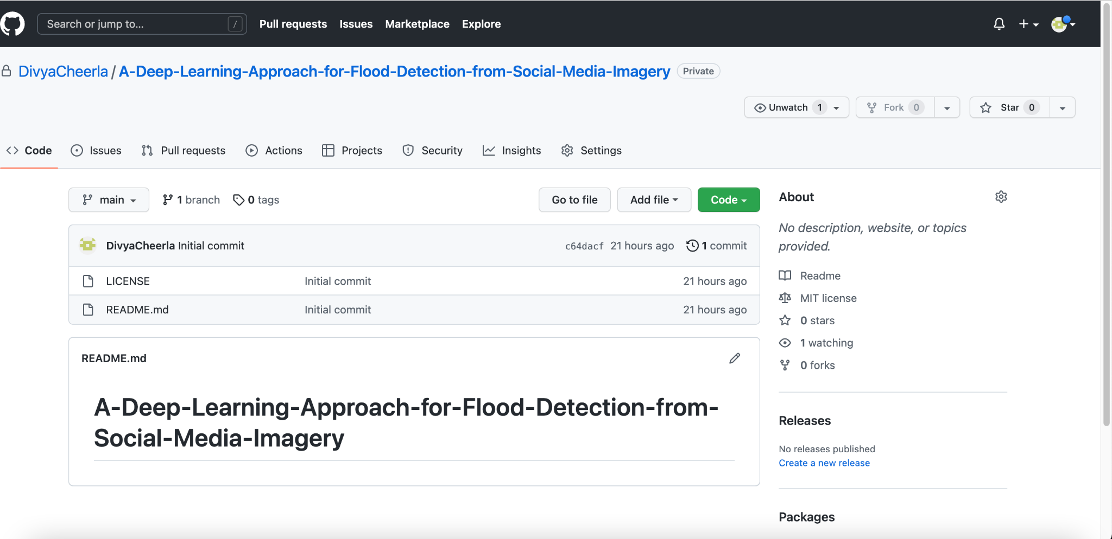

Note. GitHub repository for this project which includes dataset, code, license, and documentation.

IAM roles are enforced in AWS by using a Virtual Private Cloud (VPC), which prevents public access to the bucket and gives the power to limit other users. All team members have been given IAM roles so that they can all access the AWS cloud platform services. The same security restrictions, such as encryptions, permissions, and audit requirements, are configured for both production and backup data. Figure 18 explains details about project collaborators.

**Figure 18**

*Project Collaborator details*

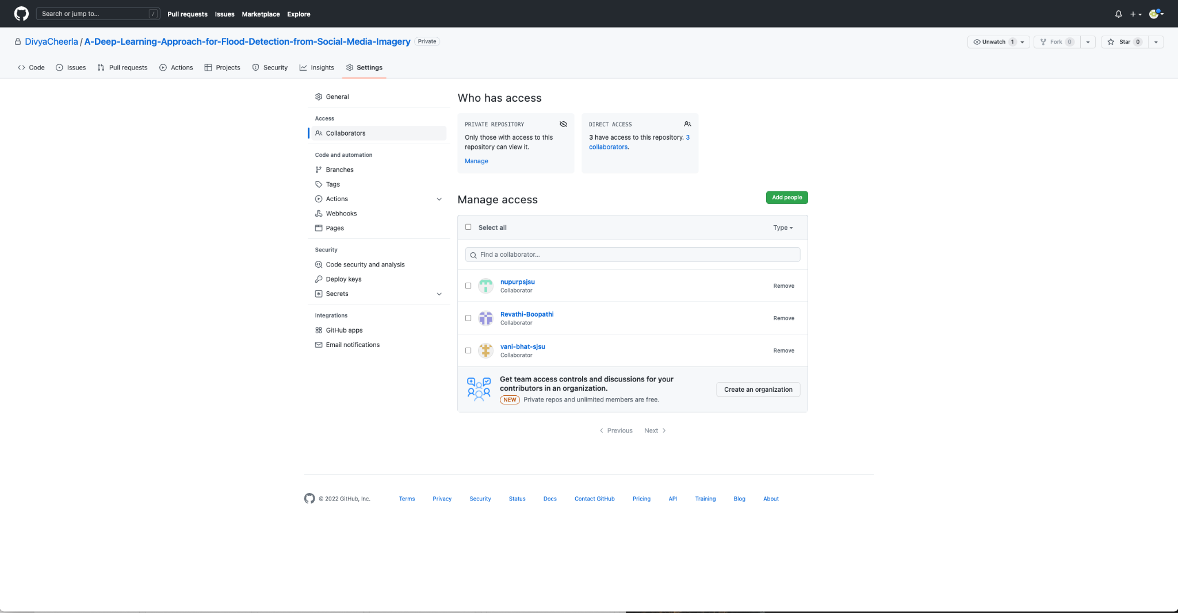

The Medic dataset which is about 10.87 GB is stored locally and the main directory consists of the following folders as mentioned in Figure 19.

**Figure 19**

*Dataset Folder Structure*

**

*Note*. Folder structure details adapted from *CrisisNLP*. (n.d.-c). Retrieved November 4, 2022.

The dataset includes three tab-separated files for training, development, and testing namely MEDIC train.tsv, MEDIC dev.tsv, and MEDIC test.tsv. Rapid and precise identification of the crisis from photographs uploaded on social media is crucial for disaster identification and management utilizing deep learning models. This calls for a sizeable quantity of high-quality labeled data because gathering or labeling data after a disaster could delay the building of the model, which could delay the reaction of disaster management. Therefore, reducing response time by training the model with the labeled data from the CrisisMMD dataset. To aid the pre-processing of the images from the dataset, object detection, dimensionality reduction, picture scaling, management of missing values, and normalization are all used. Figure 20 shows the repository of the Medic dataset.

**Figure 20**

*Medic Dataset Repository*

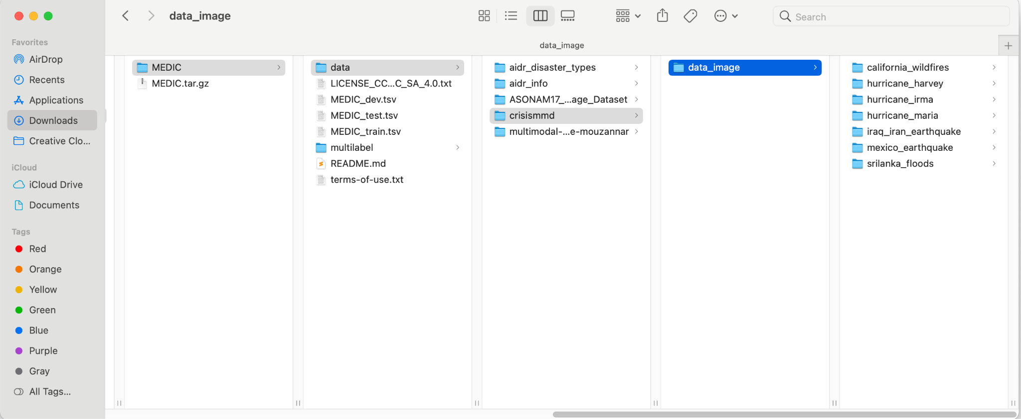

*Note.* The dataset directory distribution and storage path are stored locally.

In the future, the data can be saved by utilizing the AWS Service platform, which allows scaling up for larger datasets. According to the naming protocol, the S3 cloud storage bucket is established with the title "flood detection" and will be produced in numerous places throughout the United States. Since the data is replicated and permanently saved in S3 buckets, it can be used as backup storage. For convenient access, the raw data and processed data might be kept in separate folders.

The metadata of the Medic dataset consists of three different files for training, development, and testing purposes stored in tab-separated format. Figure 21 contains attribute details about each .tsv file used for training, development, and testing. Figure 22 shows the metadata on the images stored.

**Figure 21**

*File Details*

**

*Note*. Details about training, development, and testing files adapted from *CrisisNLP*. (n.d.-c). Retrieved November 4, 2022.

**Figure 22**

*Image Details*

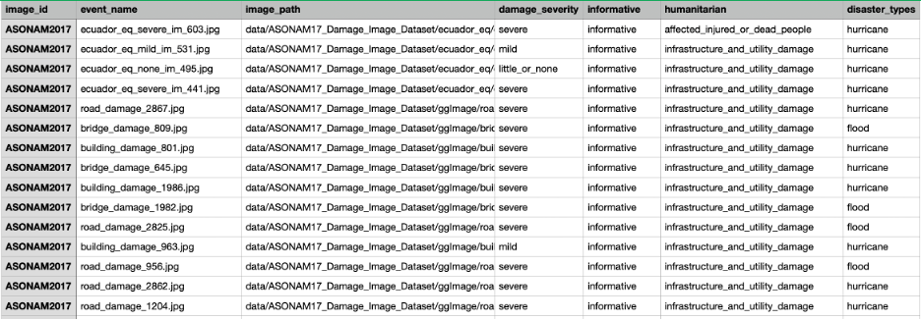

For the project, by leveraging the ClickUp tool, the Gantt chart is created for distributing the tasks and responsibilities across the team members for different phases of the project. Figure 23 provides details on task allocation.

**Figure 23**

*Task Allocation*

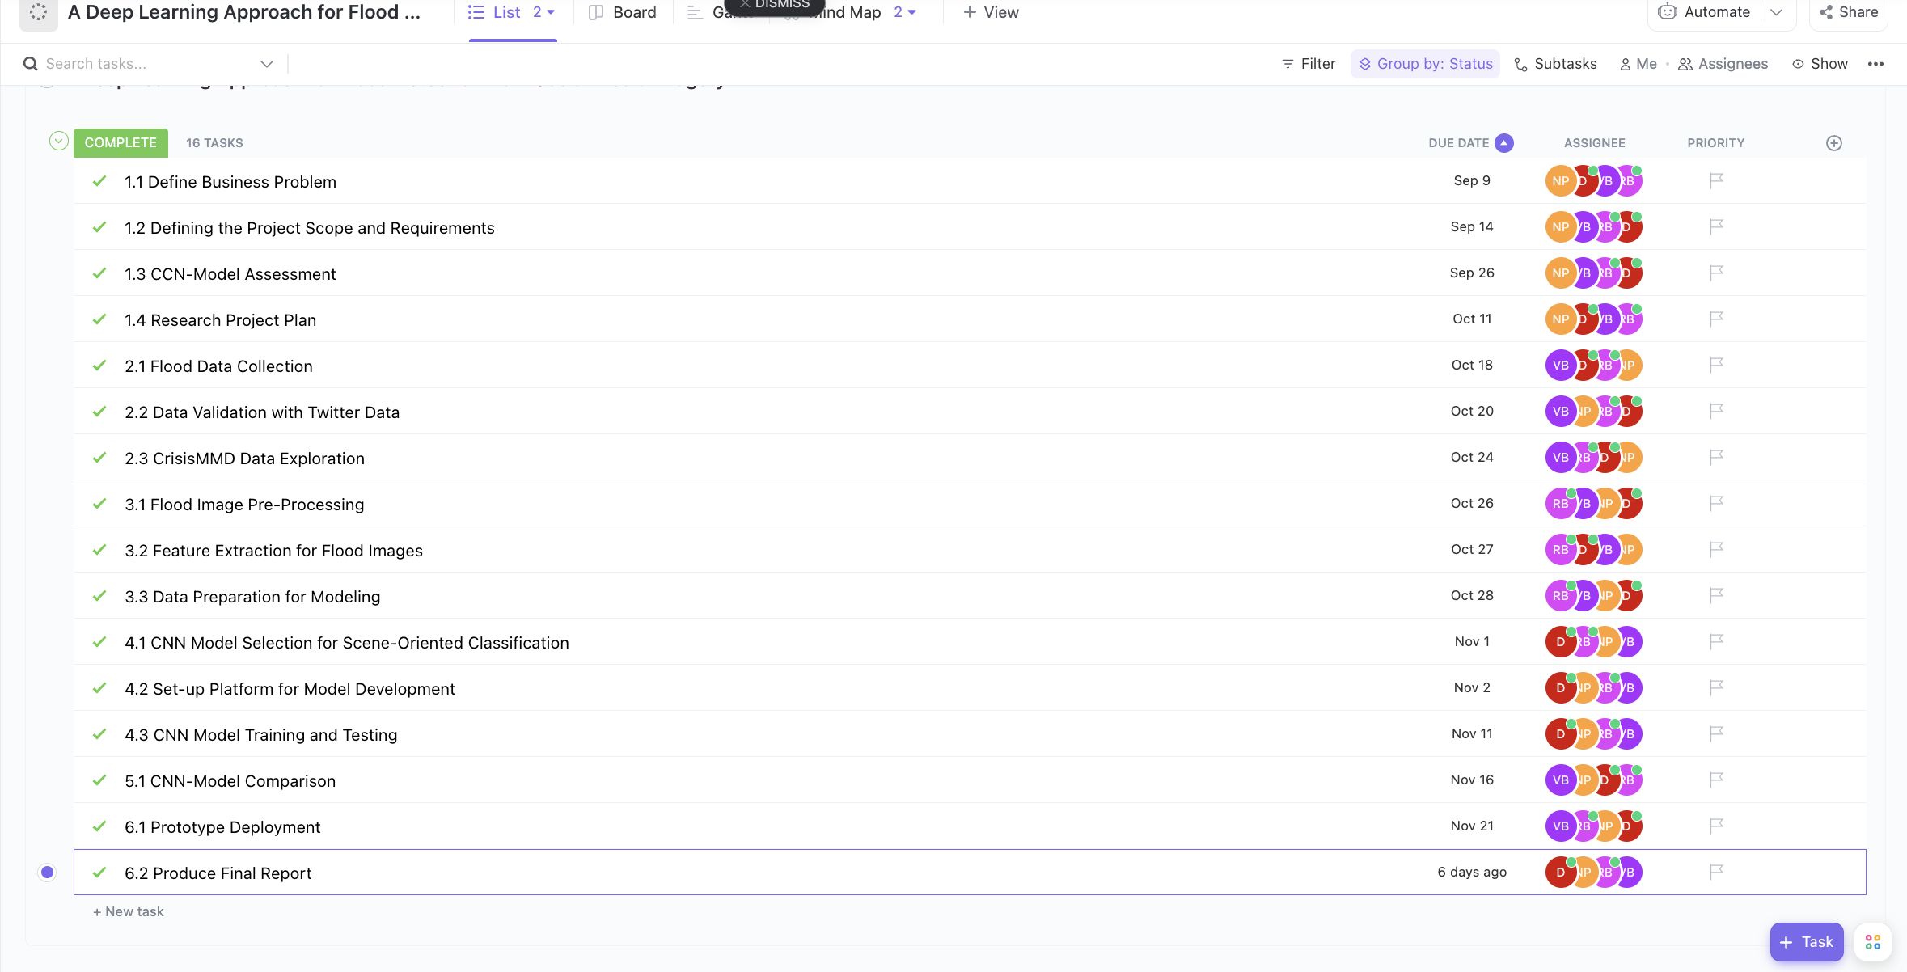

*Note.* Task Allocation among the team members and due dates using the ClickUp tool.

As in Figure 24, the tasks are distributed equally across the team members.

**Figure 24**

*Task Distribution*

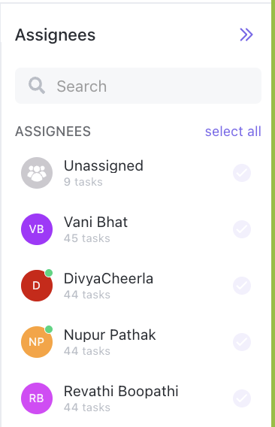

*Note.* Task distribution among the team members using the ClickUp tool.

For the data storage and access, the team members are added as collaborators in the GitHub repository.

***2.2 Project Development Methodology***

For the aim of implementation, CRISP-DM (Cross Industry Process for Data Mining) has been used. The six stages of the CRISP-DM data science life cycle process have been outlined by Saltz (2021). These include modeling, assessment, deployment, and business knowledge as well as data preparation, modeling, and understanding. Due to its wide use and great relevance for the workflow of data science projects, this model is chosen.

The first steps in the Business Understanding phase involve conducting background research and literature reviews on the application of data analytics to disasters brought on by climate change. After studying several disasters, including earthquakes and floods, the focus is shifted to the flood tragedy. Floods' effects have been examined, and remedies can be used to protect both the environment and human lives when a calamity strikes. The difficulty in determining the flood region comes from image segmentation and classification. Sentinel-1 and Sentinel-2 satellites as well as social media are used to gather visual data to identify floods and determine their impact. The project's goal is to create deep learning models that can analyze photographs from social media and flood locations to identify floods. The tools to be utilized and the planned activities for each phase of the project are specified in the project proposal. The study looked at various deep-learning models for image segmentation and classification. According to the measure performance discussed by Jony et al. (2019), the CNN models chosen for scene-oriented classification are VGGNet-19, ResNet, GoogleNet, and AlexNet. The optimum model for this use case will be determined using performance measures to compare the models. A Work Breakdown Structure, PERT chart, and Gantt chart is created to define the research project plan.

Different ways of extracting Twitter photos are investigated throughout the data understanding phase. Various difficulties, such as the cold-start problem encountered while evaluating photos from catastrophe scenes, have been highlighted by Nguyen et al. (2017). Therefore, for the machine learning model to start analyzing damage assessment from the photographs from social media, labeled data is required. It will be helpful to pre-train the model with labeled data from the CrisisMMD Multimodal dataset after analyzing the various data-gathering techniques used in the research publications. The CrisisMMD Multimodal dataset includes pictures from several types of disasters. Data from the storm and flood occurrences will be considered while modeling this and labels are verified in the labeled data. The dataset for the analysis tool will be loaded into Python. The initial evaluation of the data will be made to investigate and confirm the accuracy of the data. Twitter is the source of the photos in the CrisisMMD Multimodal dataset. These photographs will be compared with the images obtained from the Twitter API and the resemblance of the images will be confirmed to confirm that there has not been any image pre-processing performed on these images.

The data will be prepared once the data comprehension is complete. Pre-processing will be applied to the picture dataset loaded from the CrisisMMD Multimodal dataset. Handling missing values, picture scaling, image normalization, and dimensionality reduction operations will all be carried out during the pre-processing stages. Visual features are extracted for object detection. The data is then divided into segments as 60-20-20 for training, testing, and validation in the to prepare it for the model evaluation.

The model will be utilized with the prepared data. The CNN models that have been nominated are VGGNet-19, ResNet, GoogleNet, and AlexNet based on an examination of the models utilized for scene-oriented classification. These models will be used, and the analysis's findings will be tabulated for additional examination.

The models are assessed to see if they achieve the goal of identifying flood situations using the provided visual dataset. Using the pre-set measures like using some of the evaluation metrics like accuracy, precision, recall, and f1 score the model’s performance findings are interpreted. To choose the model that should be deployed, the performance of the models is compared and the model that performs the best is chosen for the prototype deployment. The abstract, project presentation, individual project report, and final group report will all be produced in the final report.

***2.3 Project Organization Plan***

Solid planning is necessary for a project's seamless implementation. The planning process ought to begin at a high level, including all the requirements that must be met, then drill down to each team member's specific operating needs. The involved tasks are high-level outlined in the Work Breakdown Structure (WBS). As indicated in Figure 25-30, the tasks are broken down into 6 phases using a process-oriented WBS and the CRISP.

**Figure 25**

*WBS - Part 1*

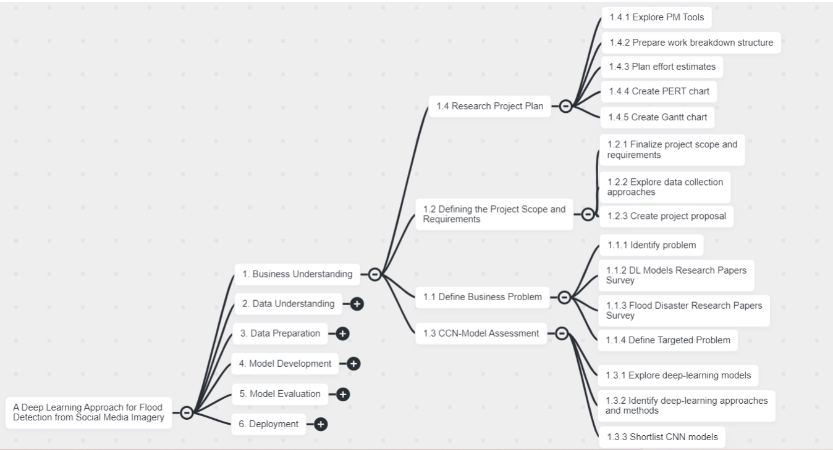

*Note.* Work Breakdown Structure for phase - I of CRISP-DM

**Figure 26**

*WBS - Part 2*

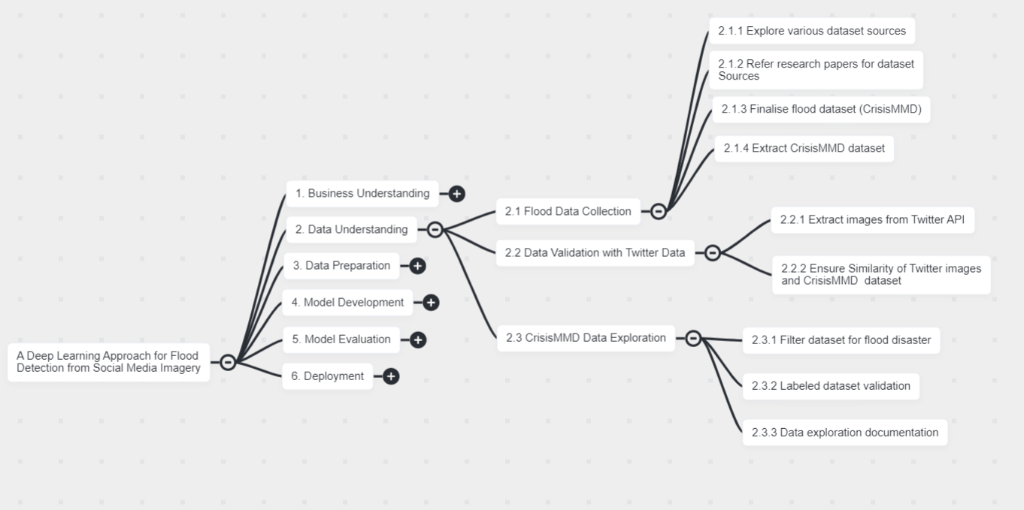

*Note.* Work Breakdown Structure for phase - II of CRISP-DM

**Figure 27**

*WBS - Part 3*

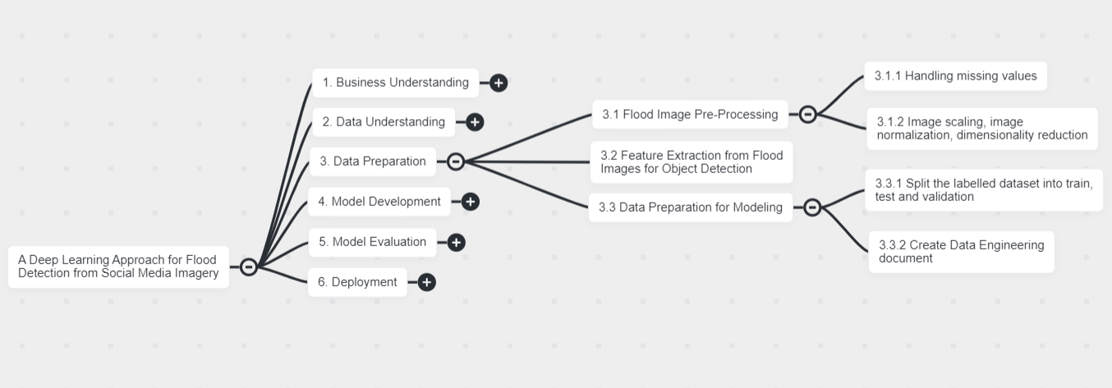

*Note.* Work Breakdown Structure for phase - III of CRISP-DM

**Figure 28**

*WBS - Part 4*

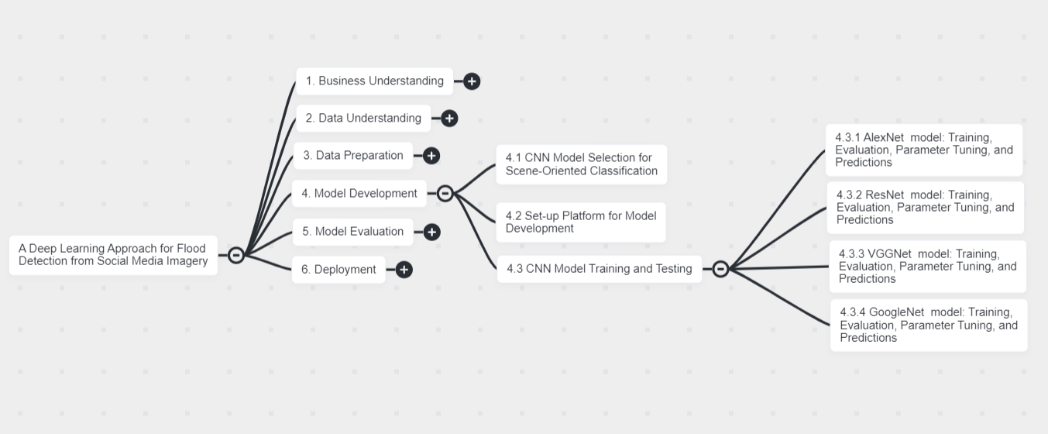

*Note.* Work Breakdown Structure for phase - IV of CRISP-DM

**Figure 29**

*WBS - Part 5*

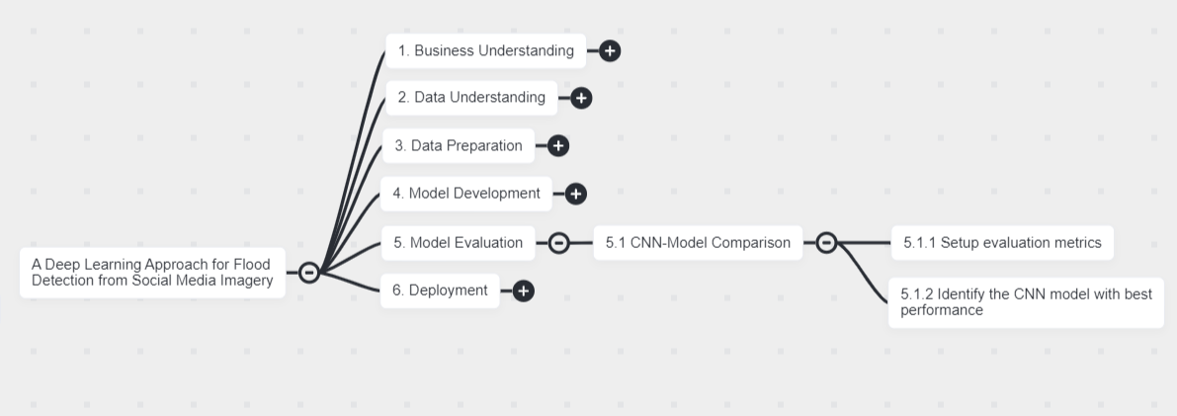

*Note.* Work Breakdown Structure for phase - V of CRISP-DM

**Figure 30**

*WBS - Part 6*

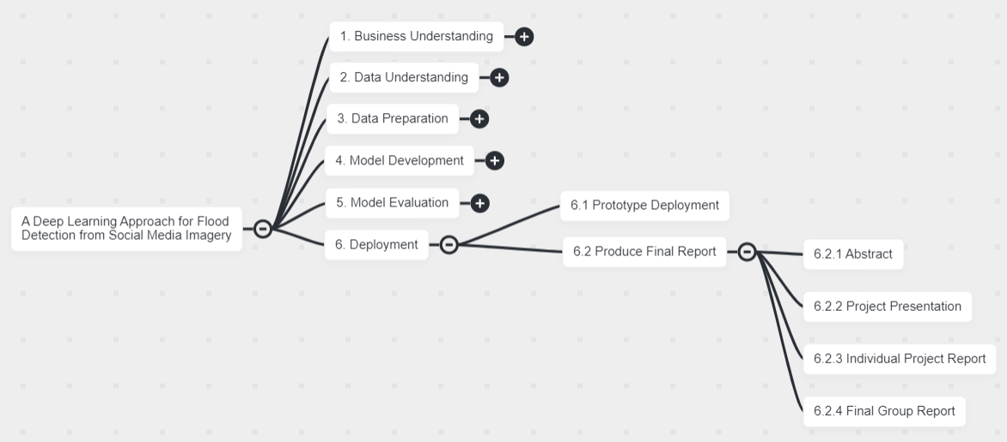

*Note.* Work Breakdown Structure for phase - VI of CRISP-DM

The business understanding phase of the project WBS begins with the definition of the problem to be solved and concludes with the proposal of a research strategy. The next phase is data understanding, is to investigate, verify, and select the dataset for this project. Any pre-processing processes necessary to use the deep learning model are included in the data preparation phase. After that, in the modeling stage, CNN models are employed. Comparing the performance of each model and drawing conclusions about how effectively each model has categorized the flood photographs are both parts of the model evaluation process. The execution of this entire project is part of the deployment phase, which is the last step.

Click up is used as a tool for project management purposes and the mind map feature of the tool showcases the WBS functionality.

***2.4 Project Resource Requirements and Plan***

One of the crucial stages in the project lifecycle is the planning and requirement of project resources. Ideally, the project manager develops a plan during this stage of the project to comprehend the work resources (people who would work on the project and their availability), cost resources (capital expenditure for the project from start to finish), and material resources (hardware, software, tools, and equipment) that would help the project move in the right direction. It's easier to avoid surprises in the middle or near the finish of a project if effort, expense, and material resources have been planned out beforehand.

The research project should consider each of the effort, cost, and material resources as part of the project resource requirements and planning. The parts that follow discuss the specs, costs, and justifications necessary for the overall success of the project's hardware, software, tool, and license requirements.

**Hardware Requirements*.*** Multiple deep-learning models are used in the study’s endeavour to find floods in the photographs. A reliable system and GPU are ideally required to train the deep learning model on the substantial dataset. Any GPU RTX 2060, RTX 2070, or RTX 2080 would be sufficient for most of the deep learning models since NVIDIA is the leading GPU manufacturer. The deep learning model will only be trained using a reduced selection of data in this research study. Therefore, a PC/MAC system with 8 core CPUs, 32 GB RAM, and more than 256 GB of storage space is needed for the size of this project. For more information, see Figure 31.

**Figure 31**

*Hardware Requirements*

**

**Software Requirements*.*** Numerous software programs are required for the accomplishment of all developmental tasks and for the prediction of floods based on image data. The list of software required for the research project is listed below

***Operating System.*** To manage the computer's resources, such as the CPU and RAM, and to offer services for software and the user interface required to achieve outcomes, use Windows OS 11 or macOS Monterey version 12.6.

***Software development.*** An integrated development environment (IDE) platform for scientific computations that aids in the building of deep learning models for the study is the Anaconda distribution package for macOS and Windows with Python version 3.9.

***Python packages/libraries.*** Python software packages and libraries enabling exploratory data analysis of the project's picture collection, including NumPy, Pandas, SciPy, SkLearn, and Matplotlib.

***Python packages/libraries.*** TensorFlow 2 and Keras are two Python libraries for creating and implementing models.

***OpenCV.*** For image pre-processing techniques like dimensionality reduction, normalization, grey scaling, etc., use OpenCV version 4.5.1.

Figure 32 shows details about the software requirements.

**Figure 32**

*Software Details*

**

*Note. Different* Software used for the research project

**Tools and Licenses*.*** In a best-case scenario, the research project will use a Twitter developer account to gather Twitter photos that would serve as a dataset for model training and testing. One such cloud computing platform that can be used to store the gathered data is AWS.

The current research study uses a tiny dataset; thus the plan is to keep it locally. The project will also utilize Jupyter Notebook as a platform for exploratory data analysis (EDA) and the development of deep learning models, and tools for project management like ClickUp to define tasks for each team member with estimated effort levels, track progress, and share metrics, GitHub for version control and the storage of project-related documents and Zoom and Google Meet for team collaboration. More information on each tool that will be used in the project is included in Figure 33, along with information about its licensing and intended usage.

**Figure 33**

*Tools and License Details*

**

*Note.* Different tools to be used for the project

**Project Cost and Justification.** Considering the scale of the research project ‘A deep learning approach for flood detection using social media imagery’, it is imperative that costs associated with hardware and developmental tools would be incurred. Amongst the hardware, software, and tools required for the research project, analysis shows that costs would be incurred for hardware and tools.

In an ideal case scenario for a deep learning project, a need for sturdy hardware and GPU to train the deep learning models on large datasets for better performance is a must. Both the hardware cost significantly accounts for the major expense of the research project. A typical sturdy system with 16GB RAM comes with a minimum cost of $1500 and GPUs also cost between $400-$800. RTX 2060 and RTX 2070 or RTX 2080 would suffice any research which would approximately cost $699 per GPU amounting to ~$3000 for four GPUs. Another area where the project could incur costs is data storage. AWS is the most used cloud storage which approximately costs $0.023 per GB per month. All of these would add up to the total expenditure of the project.

Considering the scale of the current research project where models would be trained on a smaller subset of data, the use of GPU and AWS for data storage would not be needed. The necessary hardware configuration is a MAC/PC 8 Core processor, 32 GB RAM, and >256GB storage space which comes at an approximate cost of $1500. Another area where the cost would be incurred is for the usage of project management tools. Various project management tools (PM Tools) are explored such as ClickUp, Jira, and Monday.com. As these PM Tools are not freely available, ClickUp is selected as it costs $9 per person/month resulting in $36/month for the team.

The rest of the software used for the research project is open source and no expenditure is foreseen toward it. Figure 34 shows more details on different resources, their configurations, time duration, and associated costs used in the research project

The overall goal is to minimize the expenses of the project by proper budget planning towards projected work, cost, and material resources and choosing open-source resources overpaid at the beginning of the project itself. Figure 34 gives details about the resource requirements plan and a summary with the cost incurred alongside justification.

**Figure 34**

*Resource Requirements Plan and Summary with Cost and Justifi*cation

**

*Note.* Different hardware, software, and tools used for the project along with the approximate estimated cost.

***2.5 Project Schedule***

**Gantt Chart.** The Gantt Chart provides the schedule of the project and the tasks identified in each phase of the CRISP-DM methodology. Each task is associated with a start date and end date. The tasks are assigned to individual members of the team. Once the tasks are completed, they are updated in the Gantt Chart and can be seen with a green indicator. The tasks that are yet to do are marked as To Do and can be seen with a blue indicator. The Gantt Chart is created by allocating time for all the phases for the entire duration of the project excluding the weekends.

Phase - I, the business understanding part of the CRISP-DM, spans from August 31, 2022, to October 11, 2022. As this is the first phase, it is not dependent on any other phase in the project. For each task in the given phase, the assignment to the team members, timeline, status, and dependencies are shown in Figure 35.

**Figure 35**

*Phase - I*

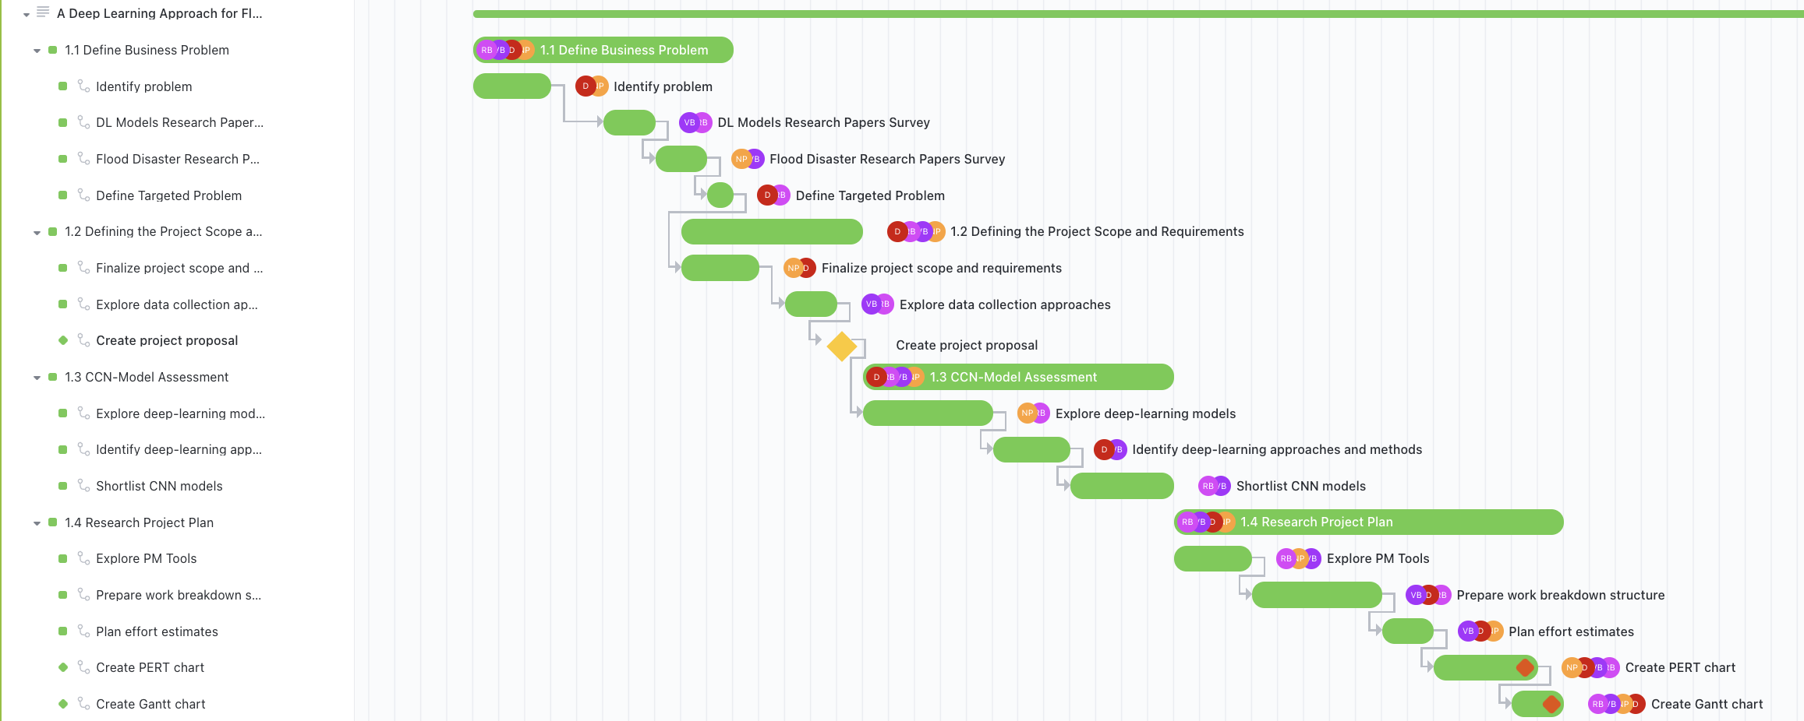

*Note.* Phase - I of the Gantt Chart

In Phase - II, the data understanding part of the CRISP-DM, spans from October 11, 2022, to October 24, 2022. This phase can be started after the completion of the business understanding in Phase - I. For each task in the given phase, the assignment to the team members, timeline, status, and dependencies are shown in Figure 36.

**Figure 36**

*Phase - II*

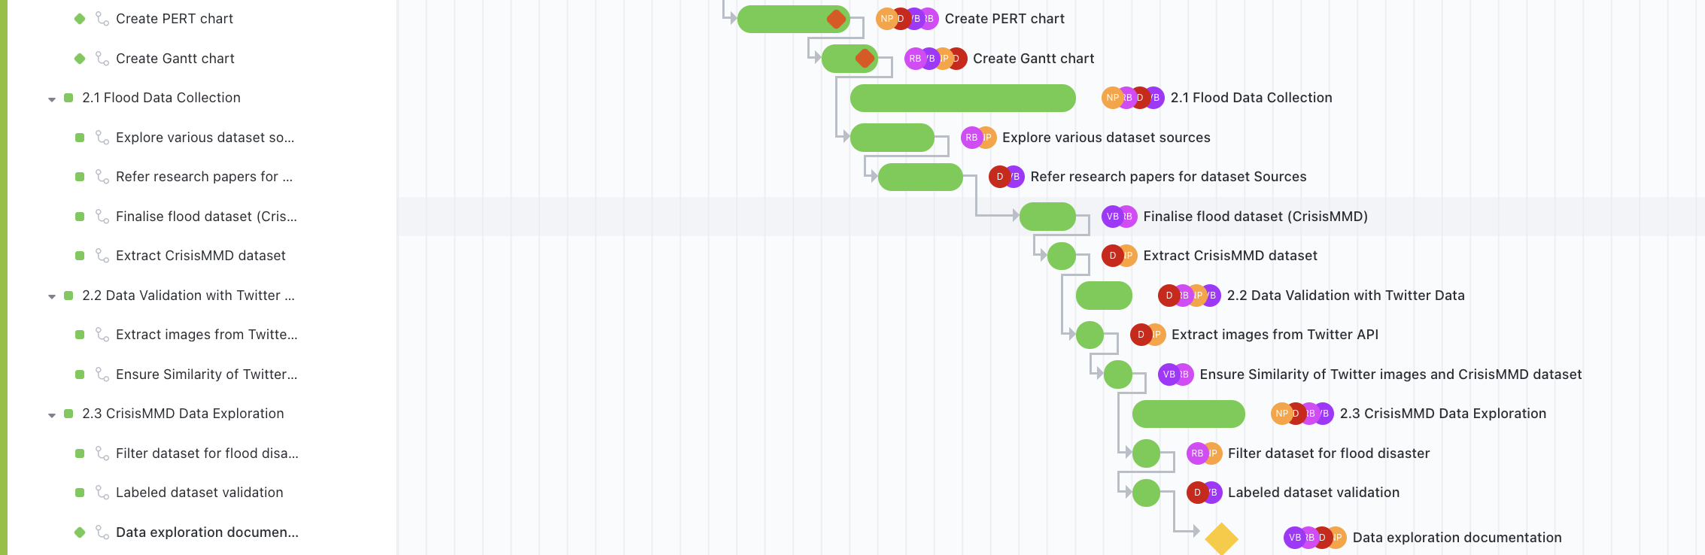

*Note.* Phase - II of the Gantt Chart

Phase - III, the data preparation part of the CRISP-DM, spans from October 24, 2022, to October 28, 2022. This phase can be started after the completion of the data understanding in Phase - II. For each task in the given phase, the assignment to the team members, timeline, status, and dependencies are shown in Figure 37.

**Figure 37**

*Phase - III*

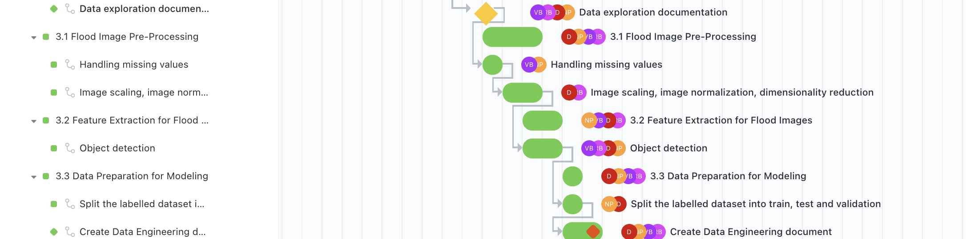

*Note.* Phase - III of the Gantt Chart

In Phase - IV, the modeling part of the CRISP-DM, spans from October 31, 2022, to November 11, 2022. This phase can be started after the completion of the data preparation in Phase - III. For each task in the given phase, the assignment to the team members, timeline, status, and dependencies are shown in Figure 38.

**Figure 38**

*Phase - IV*

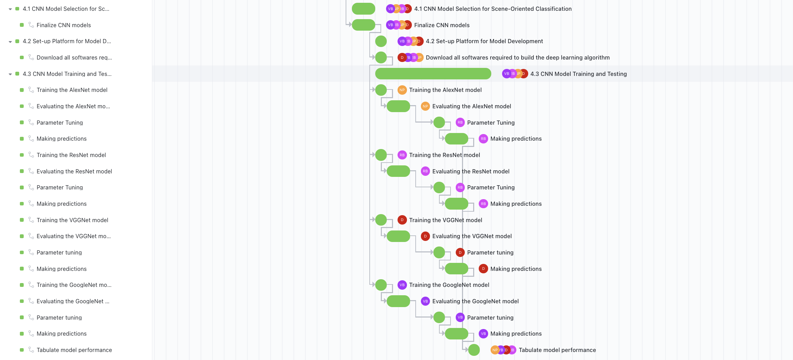

*Note.* Phase - IV of the Gantt Chart

In Phase - V, the evaluation part of the CRISP-DM, spans from November 12, 2022, to November 16, 2022. This phase can be started after the completion of the modeling in Phase - IV. For each task in the given phase, the assignment to the team members, timeline, status, and dependencies are shown in Figure 38.

Phase - VI, the deployment part of the CRISP-DM, spans from November 17, 2022, to December 5, 2022. This phase can be started after the completion of the evaluation in Phase - V. For each task in the given phase, the assignment to the team members, timeline, status, and dependencies are shown in Figure 39.

**Figure 39**

*Phase - V & VI*

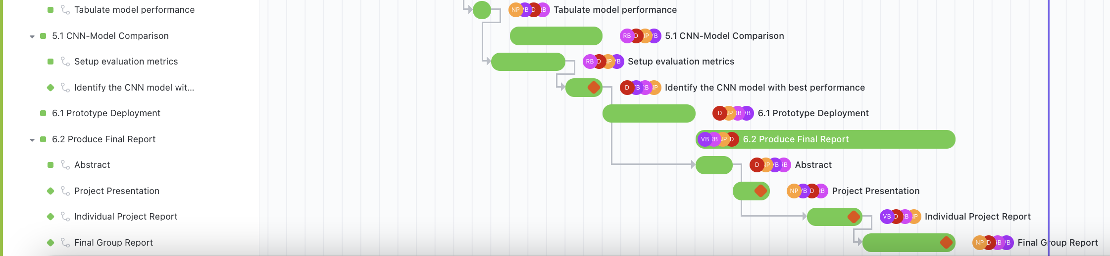

*Note.* Phase - V & VI of the Gantt Chart

**PERT Chart.**The PERT Chart shows the critical path, floating path and activities involved from the beginning to the end of the project. Information about the start date, end date, number of days for each task are depicted. The PERT chart shown below Figure 40 shows the sub-tasks along with the dependencies involved. The dependencies need to be fulfilled for the next task to be initiated.

**Figure 40**

*PERT Chart*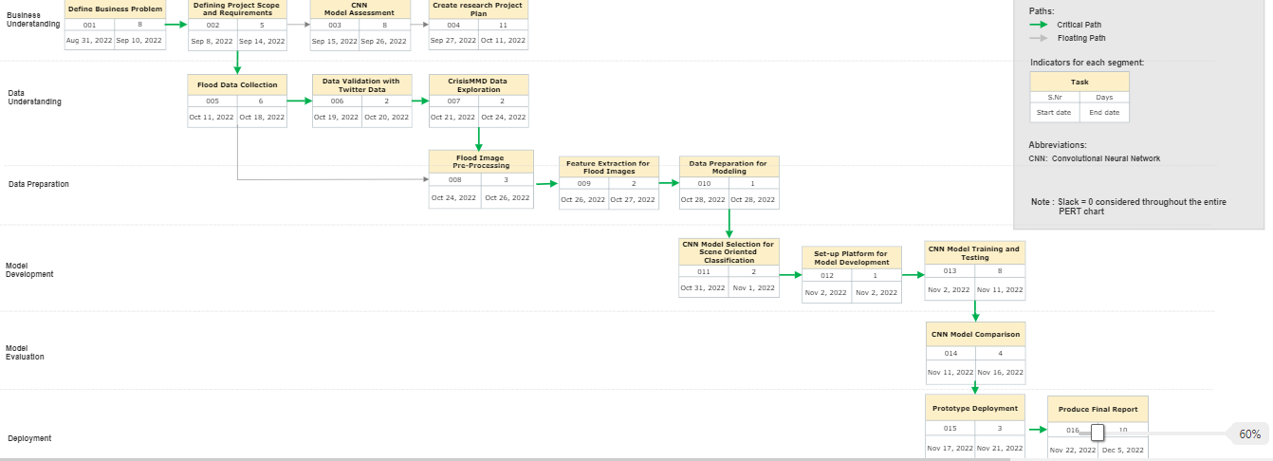

*Note:* PERT Chart depiction through the ClickUp tool

The business understanding phase requires first defining a business problem, scoping the solution, CNN model assessment and finally creating a research project plan. The first 2 tasks are crucial to moving to the data understanding phase. The further steps involve collecting the raw flood image data, validating if the image obtained is the same as the Twitter source data, and eventually performing some exploratory analysis post the source validation. There is also an alternate way to just extract the data and move to phase 3. The data preparation phase involves image pre-processing, feature extraction, and data preparation for modeling. This phase causes all the processes to be critical and nothing can be skipped during the process implementation. In the model deployment phase of the project, CNN model is selected , trained and tested for the classification of flood images. Then, the model evaluation phase where the performance of various selected models will be compared. Then the model performance is quantified, and it is deployed for real-world scenarios. A slack of 0 days is considered while constructing the PERT chart.

**3. Data Engineering**

***3.1 Data Process***

There have been profuse and diverse efforts to detect floods through the data gathered by social media platforms using deep learning. The process flow outlining each step in the flood detection project on images using several deep-learning models can be seen in **Figure 41.** The first prerequisite for employing deep learning models for data analysis is having a substantial volume of data. The information is gathered from Twitter using the Twitter API, and it pertains to seven natural disasters that happened in 2017 such as hurricanes, wildfires, floods, and earthquakes. The final dataset contains about 16,097 tweets with 18,126 images which are about 11 GB in size.

For the project, sample data with images unique to hurricanes and floods are collected. The sampled dataset is 1.57 GB in size and contains roughly 1,000 images that are specific to hurricanes Harvey, Irma, Maria, and the floods in Sri Lanka. The information about images like as the event name, tweet id, original text, attached image, and others are recorded in the CSV format.

**Figure 41**

*Workflow Diagram*

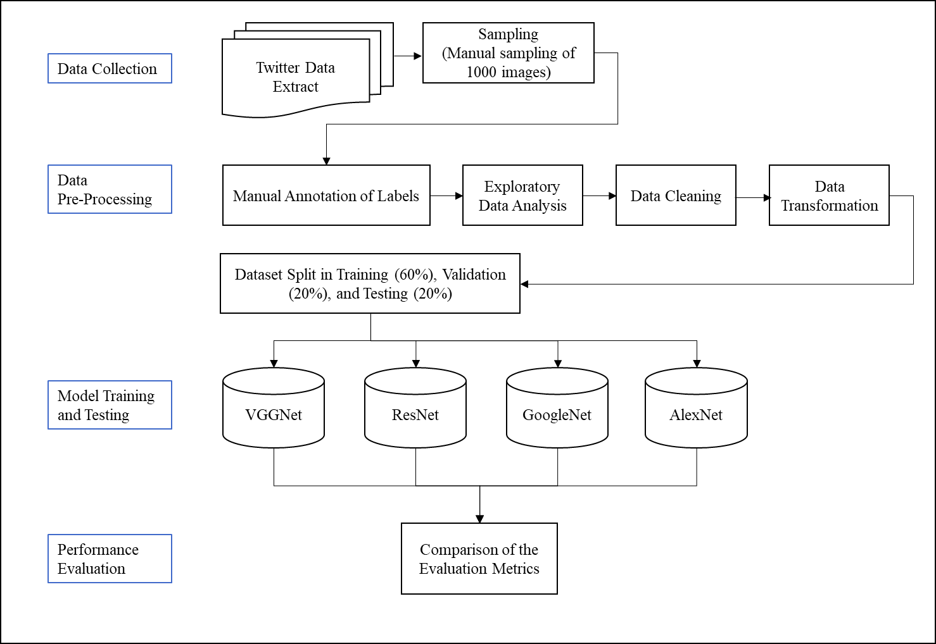

*Note.* Workflow of the processes for disaster image classification. Adapted from Drakonakis, G. I.,Tsagkatakis, G., Fotiadou, K., & Tsakalides, P. (2022). OmbriaNet-supervised flood mapping via convolutional neural networks using multitemporal sentinel-1 and sentinel-2 data fusion. IEEE Journal of Selected Topics in Applied Earth Observations and Remote Sensing, 15, 2341–2356.

The next step is data pre-processing where Exploratory Data Analysis (EDA) is performed. This is used to find data anomalies that need to be treated, such as outliers, inconsistent data, noisy data, etc.Once the EDA is performed, the dataset is then cleaned and transformed so that clean and reliable data is fed to the model. As part of data cleaning, incomplete, missing, inconsistent and noisy data are handled which might have occurred due to errors while collecting the data from the API or while consolidating from multiple data sources. The images posted on Twitter will be in different shapes and resolutions which might affect the performance of the model, so resizing is an important step in pre-processing. The dataset is resized to an optimum size which helps to train the models more quickly and to achieve better performance. The next important step in data pre-processing is image transformation where using techniques like Data Smoothing, Normalization, Regularization and Dimensionality reduction the images are transformed for better model efficiency. Data Smoothing is used to reduce noise data from the images by employing techniques like Averaging, Gaussian filtering, Median filtering, and Bilateral filtering whereas normalization helps in changing the range of pixel intensity values. Data regularization is used to prevent overfitting when it comes to image analysis which can be performed using various techniques like data augmentation, dropout, etc. As the number of images to process increases, the computational speed and system performance are affected so it is always good to reduce the size of the images.

Once pre-processing steps like data cleaning and transformation are completed, the next important step is to prepare the data for model development. For effective model performance, 80% of the data are utilized for training, while the remaining 20% are used for model testing. The data is divided again in a 3:1 ratio from the data split for training, with the first part going to training and the second part going to validation. As a result, the final dataset is divided into three parts for training, validation, and testing: 60%, 20%, and 20%.

***3.2 Data Collection***

For the efficient performance of the models, having a significant amount of data is essential. Images shared on social media sites like Twitter are evaluated for the project to find floods and assess the damage they do. Using Twitter API, the images posted on Twitter are collected for seven natural disasters like hurricanes, wildfires, floods, earthquakes, etc., that occurred in 2017. The tweets are extracted using event-specific keywords and hashtags as parameters. For analysis, the tweets that contain images are mainly required, so all the tweets which do not contain at least one image are removed. The tweets with more than one image are also extracted from the 'extended_entities' section of the API. Along with images, the text associated with images in the form of title or hashtags are retained and tweets with just a single word or hashtag are removed as they do not contain much information and are not helpful for analysis. The tweets which include non-English words are filtered out during the extraction. Finally, by calculating the cosine similarity between each tweet and all the tweets with a similarity score greater than 0.7 are considered duplicates and are filtered. From the filtered dataset, a sample number of tweets which has one or more images are considered for each disaster.

In total, 16,097 tweets and 18,126 images totalling roughly 11 GB make up the final sampled dataset, which considers the possibility that each tweet may have one or more images attached. For flood detection and analysis, a subset of this dataset which contains images specific to floods and hurricanes is considered which is about 1.57 GB. The text associated with the images is collected and stored in a .tsv file which contains information like event name, tweet id, original text, image attached, and others. A typical data collection plan for an ideal case scenario is shown in Figure 42.

**Figure 42**

*Data Collection Plan*

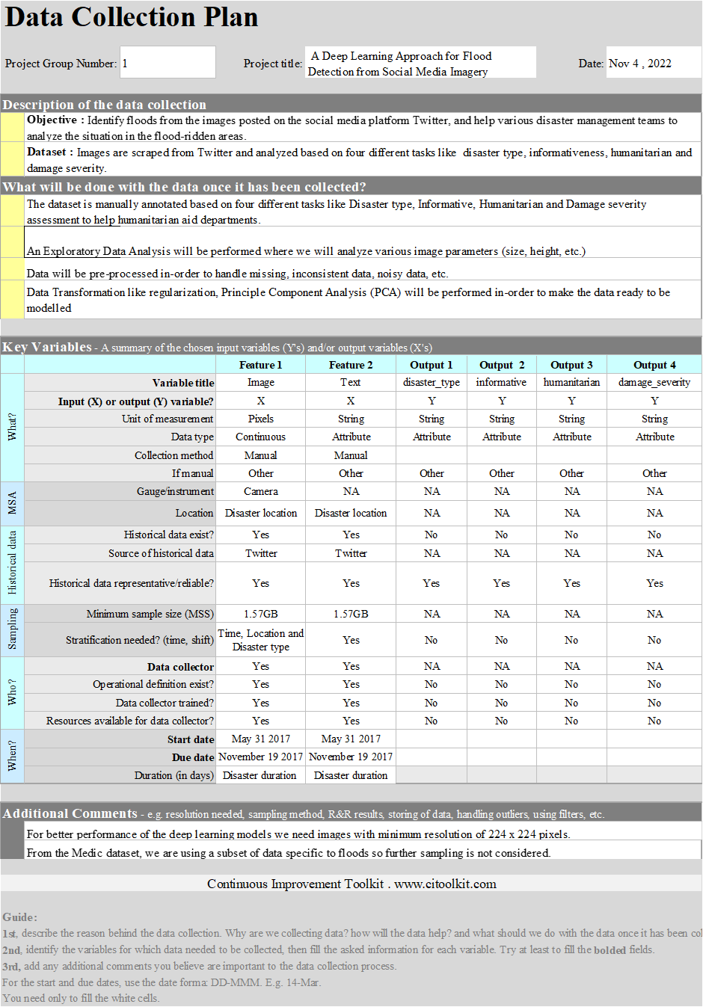

*Note.* The data collection plan is created using a template from the Continuous Improvement Toolkit

For flood detection and analysis, in an ideal case scenario, data is collected using Twitter API and manually label the data in the pre-processing stage and use them for modelling. For the project, the final dataset from the CrisisMMD dataset is created which contains labelled data and images specific to floods and hurricanes which is about 1.57 GB. The details of each image stored in the .csv file are shown in Figure 43 and a sample of image details can be seen in Figures 43- 44. It contains about 1,000 records collected during four disaster events like hurricane Harvey, hurricane_irma, hurricane_maria, and srilanka_floods that occurred in 2017. A few samples of images can be seen in Figure 45.

**Figure 43**

*Image Details*

**

*Note.* Sample images collected from *CrisisNLP*. (n.d.-c). Retrieved November 4, 2022.

**Figure 44**

*Snippets of Image Details*

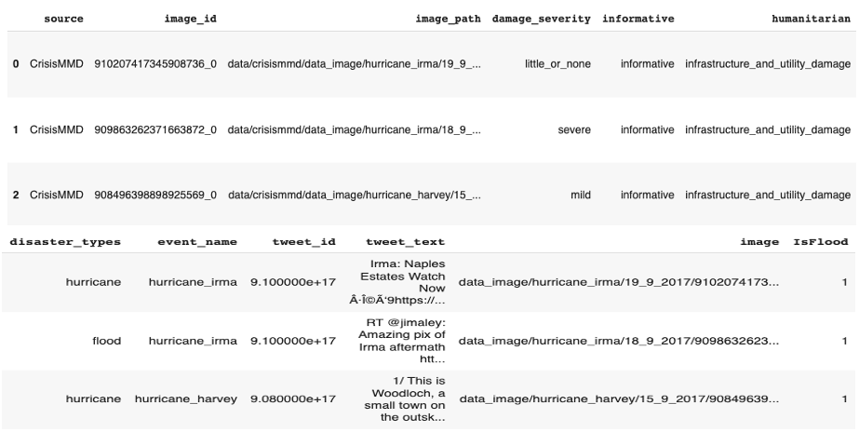

**Figure 45**

*Sample Images*

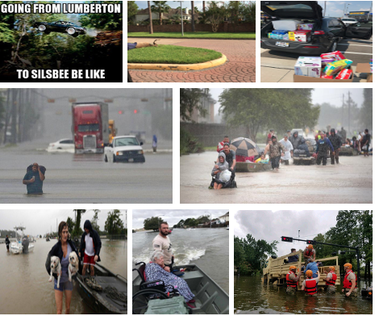

*Note.* Sample images collected from *CrisisNLP*. (n.d.-c). Retrieved November 4, 2022.

Figure 46 shows a description of the.csv file that Jupyter Notebook loaded into the data frame. Each of the 12 columns in the data frame - source, image id, image path, damage severity, informative, humanitarian, disaster types, event name, tweet id, tweet text, picture, and IsFlood has roughly 992 records. The data frame uses more than 100.8 KB of memory and includes data in the object, int64, and float64 data types. The data frame has zero null values details of which can be seen in Figure 46.

**Figure 46**

*Dataset Description*

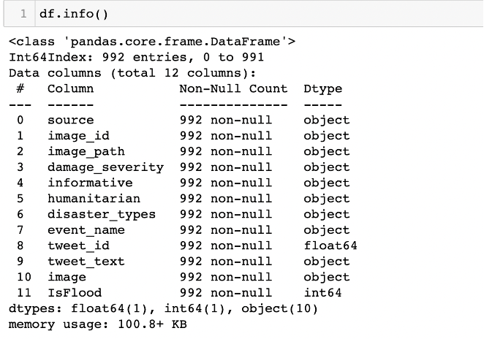

***3.3 Data Pre-Processing***

Exploratory Data Analysis (EDA) is an approach used for analysis to identify patterns in the data. It helps identify anomalies in the data like outliers, inconsistent data, noisy data, etc. Such anomalies can be found and examined to provide insights into the data by learning how, where, and what variables are associated with them. Through the use of graphs in EDA, such as histograms, box plots, quantile-quantile (Q-Q) plots, cumulative distribution functions, scatter plots, correlation analysis, conditional probability analysis (CPA), multivariate approaches, etc., and one can better understand the data and make decisions about the methods and techniques to use on top of it in order to produce insightful results.

For flood identification and analysis, a subset of the image dataset that includes images specifically for floods and storms is chosen. In this subset, four events including Sri Lanka Floods, Hurricane Harvey, Hurricane Irma, and Hurricane Maria are selected and their distribution can be seen in Figure 47.

**Figure 47**

*Instances by Flood Event*

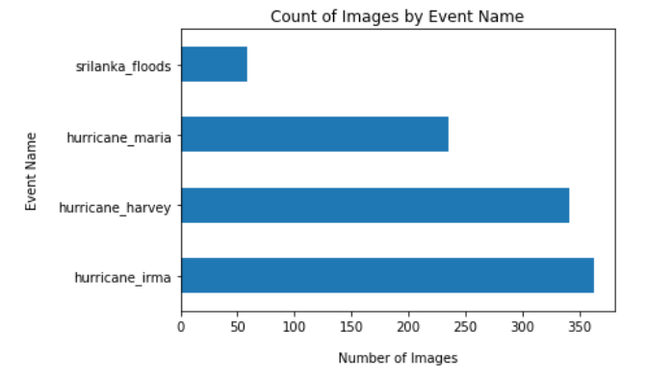

The dataset is then manually annotated based on tasks like Informative, Humanitarian, Damage Severity, and Is Flood assessment. Making a choice on whether a tweet is significant or contains key information needed for emergency relief is crucial because thousands of images are shared on social media sites after a disaster. Therefore, by deleting images that are not informative and labelling the data according to its informativeness, data overload is reduced and the emergency aid departments are provided with the correct information. Images that are both informative and uninformative will be used in the modelling. Recovery efforts after a disaster will be aided by labelling the images with information on those who are hurt or killed, the extent of the damage, etc. This is indicated in the humanitarian label. The Damage Severity label indicates the level of damage at the flood site. Images with flood are identified using the IsFlood label. The distribution of the instances in the dataset for the identified labels can be seen in Figure 48.

**Figure 48**

*Instances by Informative, Damage Severity, Humanitarian, and Flood Image*

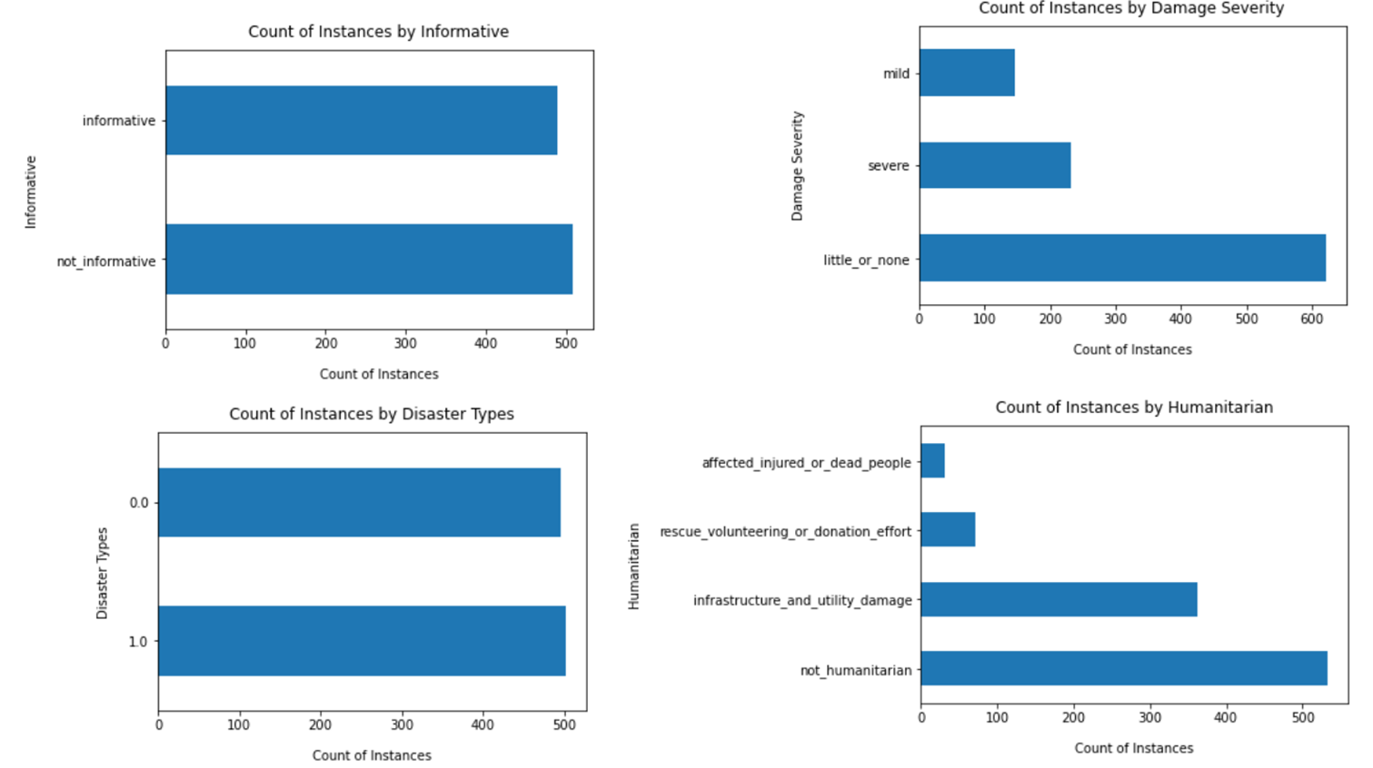

The bar charts in Figure 48 indicate there is a class imbalance for the labels identified. The target label for the model's initial training is "Is Flood." Whether a flood is visible in the image is indicated by this label. The performance of the model may be impacted by the fact that there are very few images with IsFlood set to 1. In order to have a collection of target labels that is balanced, subset of the images is created.

For the project, the image dataset is analysed as part of EDA to determine how the data is dispersed. A small number of images are randomly extracted from the raw dataset, which has about 18,126 images, in order to perform EDA and examine the distribution of the dataset. In order to determine how the images in the dataset are distributed, the images are first evaluated by retrieving information about them such as type, shape, height, weight, and size. A sample data frame in a jupyter notebook after retrieving the details is shown in Figure 49. The newly added shape, width, and height columns contain details of each image’s shape, height, and width. Since each image in the dataset has a varied width and height, it is clear that the images are not all of the same shapes. Information on how many pixels each image has is provided in the size column.

When processing images using machine learning models, the larger the dimensionality of the dataset's images, the simpler it is to find relevant data for such images since black-and-white images occasionally conceal crucial elements of the image. To obtain the dimension data of images, RBG (Red, Green, Blue) values of each image are calculated. Using RGB, the colour of each pixel is determined as a combination of red, green and blue colours in different intensities which are stored at a pixel location in each colour plane. RGB values are in general used for clustering and object identification. For each image, R_Value, G_Value, B_Value, RGB_Max, and RGB_Min are calculated to see the distribution of colours in each image.

**Figure 49**

*Image Details*

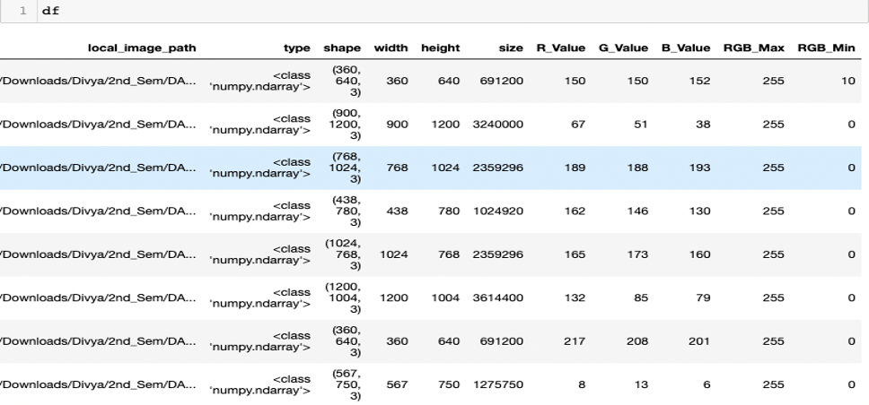

*Note.* Data frame containing image details derived from Jupyter Notebook.

The availability of clean, trustworthy data that can be used for the transformation phase is ensured by the crucial step of data cleaning and pre-processing. This phase involves data discrepancy detection through the use of metadata that contains the data about data to validate the uniqueness rule and null rule in images.

**Handling of Incomplete & Missing data.** Having directories without images, image files without descriptions, etc., indicates that there are missing images because of errors made when obtaining data from the API and saving it in the necessary directories. Low-resolution images and images with only one colour are signs of inadequate data and can be caused by camera malfunctions in the mobile, tablet, and other devices used to take the flood image. It may also happen because of human error when taking the photo, such as accidentally putting fingers on top of the camera. For each of these instances of incompleteness and missing image data, distinct correction techniques are required.

## There are many methods for addressing incomplete or missing data, including manually adding missing numbers, utilizing a global constant value, imputed central tendencies like mean and median, and selecting the value that is most likely (based on the Bayesian framework). Researchers advise utilizing manual imputation and central tendency imputation as reliable methods for restoring missing images in image datasets. A different method for addressing missing data is to eliminate these kinds of images if they have a low proportion. This approach is applied to the project.

## In cases where there are folders with no images, it is checked by computing the size, width, and height of the input image. If either of these numbers is zero, it is assumed that the image is merely a placeholder. Images of this type are immediately removed from the directory. Analyzing single-color images involves looking at the distribution of the pixel values. When the distribution is plotted, images with little color variations appear to have the fewest pixels overall. So, it makes sense to get rid of these kinds of graphics as well. Figure 50 compares the distribution of pixels between a coloured image and an image with just one colour.

**Figure 50**

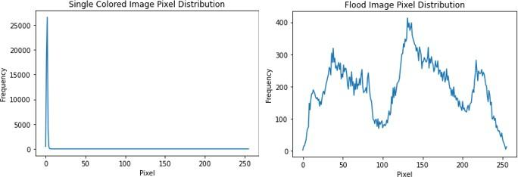*Pixel Distribution of Single-colored and Flood Image*

## **Handling of Inconsistent Data and Data Redundancy.** When data is merged from various data sources into a single coherent repository, inconsistency in the data can result. Since the project involves image data spread over several folders inside a directory, this is a less likely scenario. However, validations will be carried out to make sure there are no duplicates when integrating any metadata that contains information on all image paths as well as annotations.

By appropriately resizing and ensuring that all images are the same size, value conflicts between images can be avoided. Image redundancy may also be a problem, as it may result from errors in the data collection from the API or from a user posting the same image several times on the Twitter network. To find these kinds of duplicate images, open both of them, compare each one to the other images in the directory, and remove any that are duplicates. To identify the same image, other duplicate removal approaches look for correlation and covariance among images.

**Image resizing.** In deep learning, resizing images is a crucial step. It is the process of altering an image's size, which also changes the pixel size. Images are retrieved or created from a variety of sources, including digital and mobile cameras, as well as websites like Google and Twitter. As a result, they are not constant and, depending on the source, their size may fluctuate greatly. A machine learning or deep learning model's input is often reduced because smaller images enable faster training. The Convolutional Neural network (CNN) needs to process four times as many pixels in order to learn from an input image that is twice as big. This raises the need for memory further. Additionally, for greater speed and accuracy, several deep learning model designs require that the input be the same size. Therefore, resizing should always be done before submitting the data to modelling. A few factors to keep in mind when resizing photos include maintaining the aspect ratio of the original image and lowering larger images to smaller ones. Reducing larger images to smaller ones is frequently thought to be preferable to growing tiny images to larger ones.

One might resize the photos using a variety of libraries like Pillow Image Library (PIL), TensorFlow, OpenCV and PyTorch. The resizing of the images has been done for the research project using OpenCV. According to our research, training the CNN models VGG-Net, Res-Net, Alex-Net, and Google-Net would be best with an image resolution of 224 × 224. As a result, every example image has been downsized to 224 x 224 resolution. Each image has an aspect ratio that is closer to 1.33. The image is downsized to 224 by 224 keeping this in mind as well as the resolution required for the models to function correctly.

OpenCV's rcv2.resize function is used to resize the images to the dimension of 224 x 224. A sample of the image before and after resizing is shown in Figure 51. The original image has the shape (900, 1200, 3) indicating height, width, and depth which is reduced to the shape (224, 224, 3).

# Figure 51

# *Sample Resized Image*

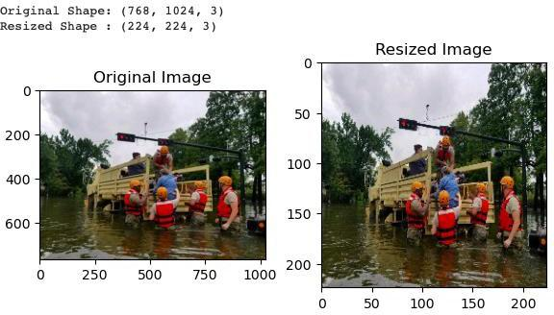

## **Handling noisy data - Image Denoising.** Colour variation in images is referred to as noise. Noise is a random value that is added to the pixels, which make up images. The formula for noisy pixels is a = a0 + n, where a0 is the pixel value and n is the noise that is introduced to the pixel and causes variations in the image's colours.

## At any stage of the image-processing process, from image capture to transmission to processing, noise can be injected. Although there are many other types of noise, Gaussian noise, speckle noise, salt and pepper noise, poison noise, and impulse noise are a few of the most significant ones in the images. The study endeavour focuses on photographs of flood disasters. In this situation, several variables may contribute to the addition of noise to the collected photos. When taking pictures at the disaster source location, noise can be added to the images because of the instrument's (digital camera or cell camera) incorrect settings. As an illustration, different ISO (International Organization for Standardization) settings in a digital camera control the amount of light absorption when the image is being captured. The environmental conditions at the flood catastrophe site could affect the imaging sensor and cause noise to be added to the photos. Depending on the photographer's ability level, noise may also be added to the image. It may also be included when sending photos across a network between two machines. The performance of the deep learning model can be impacted by training it using noisy images. Denoising the pictures is therefore crucial.

## Several denoising methods are available in OpenCV for the images. In this project, the fast Nl Means Denoising for Coloured Images (cv.fastNlMeansDenoisingColored (image, none, h, hForColourComponents, templatewindowsize, searchwindowsize)) method is utilized. Commonly used parameters include h, which determines filter strength and is typically set to 10, hforcolorcomponents, which is typically the same as h, templatewindowsize, and searchwindowsize, which are set to odd numbers seven and 21 respectively. As the value of h increases, more noise is eliminated as well as finer details. The most frequent type of noise found in coloured images, Gaussian noise, is assumed to be present. Figure 52 illustrates an example image before and after denoising so that the difference between the original image and the denoised image can be noticed. This noise is removed using the denoising function.

**Figure 52**

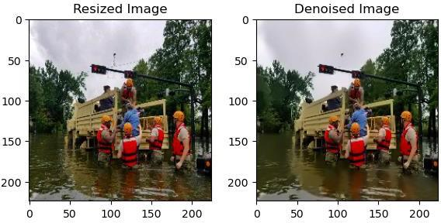*Sample Denoised Image*

Data smoothing is also another image transformation technique popularly used to eliminate noise from the image dataset and is discussed in detail in the data transformation section. It smoothens the image by using the moving average technique where the average or median value of image pixels is used.

## Image Grayscale. Coloured images consist of an array of red, green, and blue values. When coloured images are given to the model, convolution is done on three channels red, green, and blue. This adds to the complexity of the model as convolution is performed on three different arrays. The grayscale image is made of only black and white colour stored as a single array, so convolution needs to be performed on just one array making it computationally very easy and efficient. Hence, grey scaling is done as part of image data pre-processing and grey-scaled images are fed into the model.

An OpenCV function named cvtColor, provides the ability to convert coloured images function to convert it into a grayscale images. The changes in the sample image before and after grey scaling is performed can be seen in Figure 53.

**Figure 53**

*Grayscale Image*

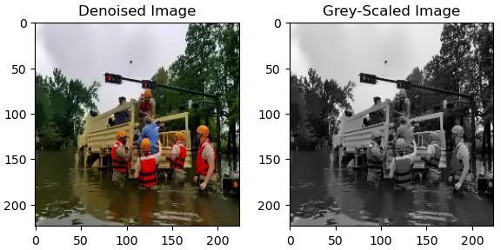

*Note.* Before and after greyscale sample of an image from Jupyter Notebook.

***3.4 Data Transformation***

Image transformation is another important step in image processing where pre-processed datasets are transformed into desired formats as required for the model by employing several tools and scripts. It converts images from one format to another to help identify features that are not easily detected. The transformed image is then analyzed, interpreted, and processed further by using various image processing tasks. For the project, after data cleaning and pre-processing is performed by handling noisy, incomplete, and inconsistency in images, the images in the dataset are then transformed by using techniques like Data Smoothing, Normalization, Regularization, and Dimensionality reduction.

**Data Smoothing.** Data Smoothing is one of the techniques used to reduce noise in the images and produces less pixelated images. Ideally, in the image pre-processing stage all possible image perturbations are removed taking care that too much information is not lost from the image. Smoothing is done by using a low pass filter kernel and convolute the images where it removes the high-frequency content like noise, edges, etc., from the image. Images collected from various sources, might be crisper or sharper or some might have bad edges, such types of images are smoothed or blurred in order to have a clean image to make the image more usable. Various techniques are used to achieve image smoothing like Averaging, Gaussian filtering, Median filtering, and Bilateral filtering. The averaging method is considered for this project where it takes the average of all the pixels under kernel area, and the average is replaced at the central element. A sample of resized image smoothed, its original shape and smoothed image shape can be seen in Figure 54.

**Figure 54**

*Image Smoothing*

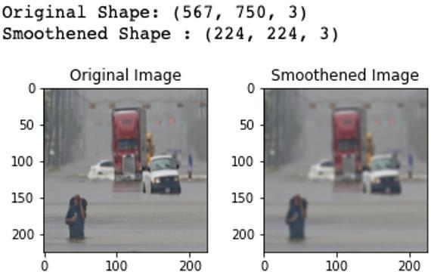

*Note.* Before and after images of image smoothing derived from Jupyter Notebook.

**Image Normalization.** Image normalization is another one of the typical pre-processing steps used in image analysis that helps in changing the range of pixel intensity values. It ensures that every input image has a similar distribution of data so that when training the model's convergence is faster. Data normalization subtracts the mean of each pixel and then divides the result by the standard deviation of the image so that the data distribution of the image resembles the Gaussian curve centered at zero. The normalized image, its shapes before and after can be seen in Figure 55.

**Figure 55**

*Image Normalization*

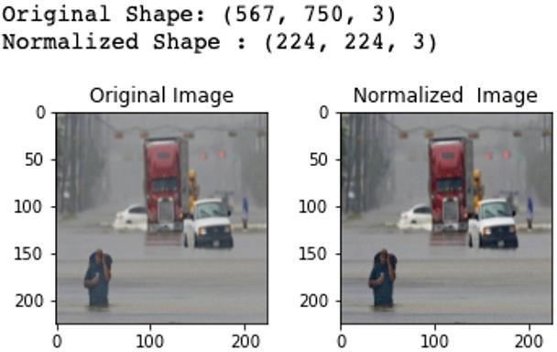

*Note.* Before and After images of Image normalization derived from Jupyter Notebook.

**Data Regularization.** Data Regularization is the process whereby adding information to an ill-posed problem can be solved and is also used to avoid overfitting. There are several types of techniques used to prevent overfitting in image analysis such as data augmentation, dropout etc. Data augmentation is a technique used to increase the number of images by leveraging existing images. In this project, as the data is highly imbalanced with more number of non-disaster images extracted from Twitter, there is a need to augment flood-related images to make it more balanced. Data augmentation techniques can be done by rotating, flipping horizontally or vertically, image cropping, introducing gaussian noise etc. and lots of new images are created from existing images without being duplicated. Figures 56 to 59 show the data augmentation techniques implemented.

## Other techniques like dropout are mostly used in deep learning models to avoid co-adaptation that enables the neurons to learn good features and avoid any dependencies between the neurons.

**Figure 56**

*Image Augmentation through Flipping*

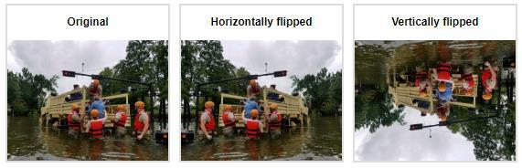

**Figure 57**

*Image Augmentation through Rotation*

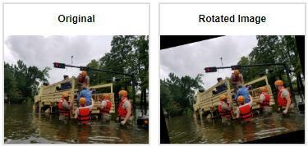

**Figure 58**

*Image Augmentation through Cropping*

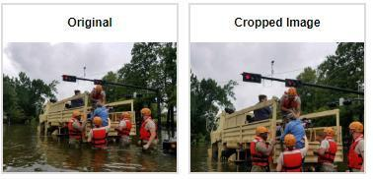

**Figure 59**

*Image Augmentation through Gaussian Noise Introduction*

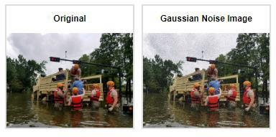

## **Principal Component Analysis (PCA).** It is a linear dimensionality reduction technique applied to datasets with many features. It uses linear algebra concepts to reduce the number of features in the dataset and selects only important features that are required for modelling by maintaining the quality of the data. The main ideology behind this technique is to reduce the correlated variables which mean information is redundant and needs to be eliminated.

In this project, images are classified as flood/non-flood at the end. Images are made of pixels and consume significant bytes so as the number of images to increases, the computational speed and system performance are decreased, and the cost is increased. Hence, it is always ideal to reduce the size of the data which is where PCA comes into the picture. Images are represented matrices with pixel intensity values and PCA is applied to this image matrix to reduce its dimension to much smaller components which are called principal components ( transformed features rich in information). The first few principal components will usually be rich in information, while components at the last have noise and less information. PCA usually eliminates them and retains features with important information.

Step-by-step implementation of the PCA technique is done on the sample grey-scaled image dataset. A sample grey-scaled image considered for PCA can be seen in Figure 60.

**Figure 60**

*Grayscale Image*

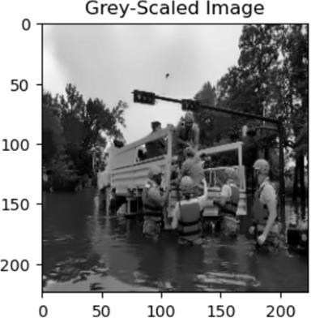

*Note.* Sample image under consideration for PCA.

The shape of the image in Figure 60 is (224, 224, 2) in which 224 represents image height in pixels, 256 represents the width of the image in pixels, and 2 represents the image depth which is typically two for the grayscale image. The grayscale image is then fed as input to further dimensionally reduce the features.

The scree plot is then plotted which indicates the number of components that can be used to explain the 95% variance in each image. For example, let’s consider two variables which are highly correlated. One of the variables can be expressed as a linear combination of other variables. Inherently by calculating Eigenvectors Eigenvalues of the input matrices PCA transfers the second variable’s variance onto the first variable. Grayscale images are fit into PCA by making use of the PCA.fit function and uses PCA.explained_variance_ratio_ to get the cumulative variance and finally a number of components that explains the 95% of the variance is known. The scree plot in Figure 61 clearly shows the cumulative variance and the number of principal components.

**Figure 61**

*Scree Plot*

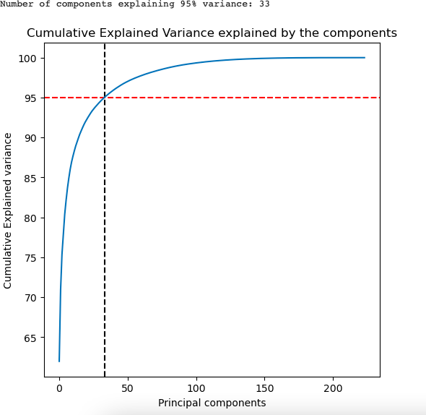

*Note.* Plot explaining the number of components needed to explain 95% of the variance.

As per the plot in Figure 61, 95% of the variance in the image can be explained by 34 components only but not 224 pixels in the original image. The original image is reconstructed with 38 components by using the incremental PCA module inverse transform method and its clarity is verified which can be seen in Figure 62**.**

**Figure 62**

*Reconstructed Image*

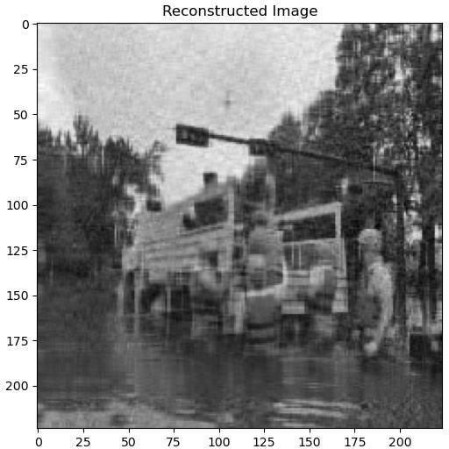

*Note.* Reconstructed image based on the number of components generated by PCA

The reconstructed image has major identifiable elements; however, it has poor visibility and clarity. In this case, the number of components to be used is experimented with by increasing it gradually until the image is clear and captures the finer details which are missing earlier.

For the image in Figure 63, it is observed that images with component 100 have better clarity. When increasing the components above 100, it is noticed that it does not add much to the clarity. Hence, for further processing the image with components 100 is considered that is the original image is compressed to 100 components.

**Figure 63**

*Reconstructed Images with Different Components*

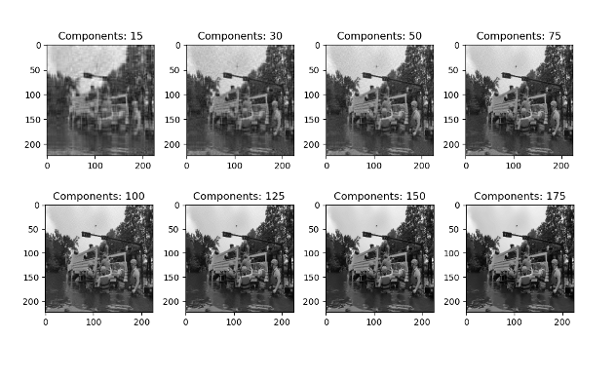

PCA is not the only technique widely used for dimensionality reduction. Other techniques such as Singular Value Decomposition (SVD), PCA, and t- Distributed Stochastic Neighbor Embedding (t-SNE) are also popularly used where each technique has its own disadvantages and trade-offs which are to be noted when making necessary choices.

PCA skips less significant features from the high dimensional data, reducing the size and time making it easier for computation. While SVD retains the unwanted features at the last providing the flexibility to eliminate them. SVD is used to find PCA by truncating the less important features from the original SVD matrix however the computation time is more. Keeping in mind the performance for processing 1,000 images, PCA is chosen to dimensionally reduce data. This is expected to improve the model's performance.

We have explored multiple data transformation techniques. However, for the model development only image resizing, denoising and normalisation have been incorporated as the model has the capacity to dimensionally reduce the image by itself.

***3.5 Data Preparation***

After cleaning and transforming the data in the pre-processing stage, the next step is to prepare the data for modelling. For employing deep learning models, the data needs to be segmented for training, validating, and testing. In general, for the efficient performance of the model, 80% of the data is used for training whereas the remaining 20% is used for testing the models. Sometimes based on the volume of the data present, 20-30 % is considered as the ideal amount used for testing. Once the data is split, the model is fed with the training data to train the model and test data for testing the efficiency of the model. For the project, by leveraging Python’s libraries like pandas, sklearn etc., the data is split as 80 % for training and the remaining 20% for testing. Out of the data split for training, the data is again split in the ratio of 3:1, from which the initial portion is used for training and the latter is used for validation. So, the final dataset is split 60-20-20 for training, validation, and testing. Figure 64 shows the count of data in the training and testing set after data splitting and Figures 65-67 show the sample data frames of the training, validation and testing set. For the project, stratification is not considered as the dataset used is balanced with equal portions of flood and non-flood images.

**Figure 64**

*Dataset distribution after splitting*

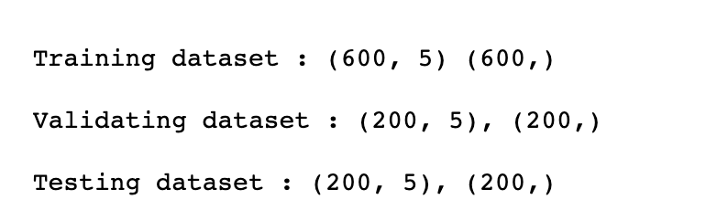

**Figure 65**

*Training dataset*

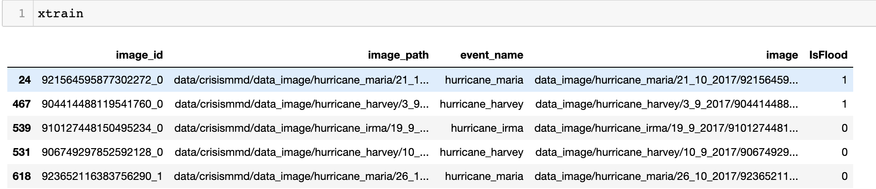

**Figure 66**

*Testing dataset*

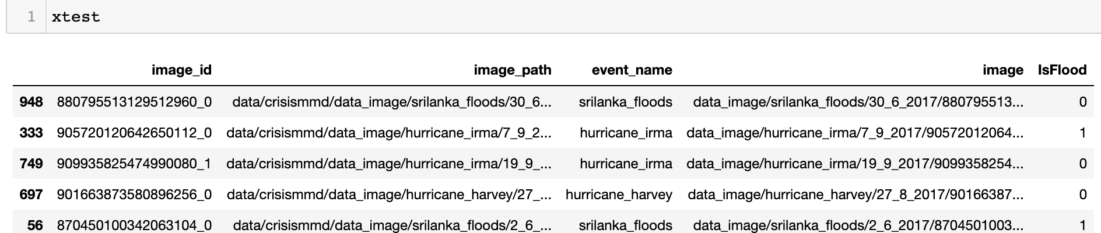

**Figure 67**

*Validation dataset*

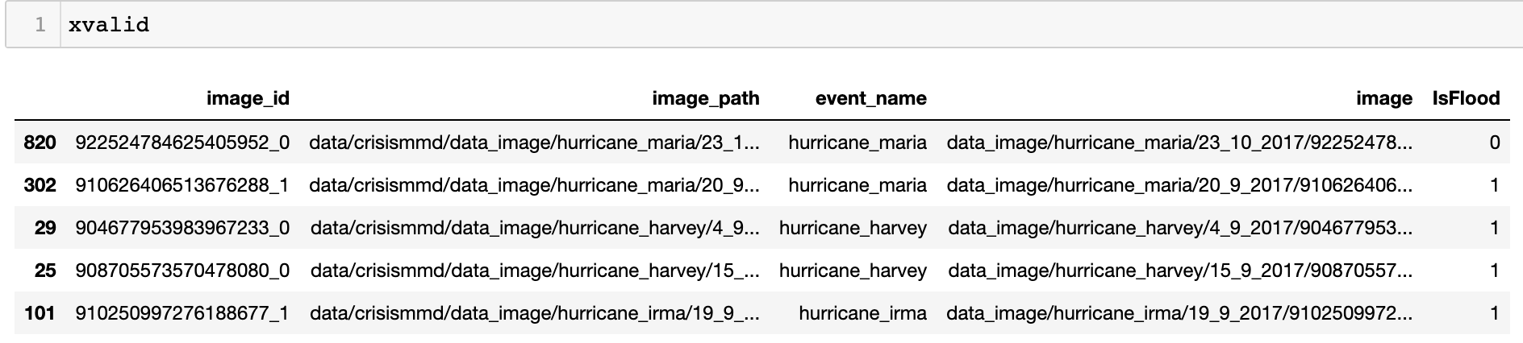

***3.6 Data Statistics***

The research project used an image dataset to detect floods. The statistics with respect to images from data collection to data preparation for modelling is more on the number of images at each phase, size of the images, and shape of images. The raw dataset collected from Twitter is about 11 GB in size with 18,126 images of varied shapes. Due to the constraint on storage and computational efficiency, from the population of 18,126 images, only a sample of 1,000 images which is about 1.57 GB is used.

In the data pre-processing stage, it is observed the dataset does not have any null, incomplete, or missing data. So, the number of images and their characteristics remained the same. While image resizing changed the shape of the image from varied shapes to (224, 224, 3) leading to a decrease in the size of the image, image grey scaling converted the image to two coloured channels from 3 channels. At each and every stage of data cleaning, data pre-processing and data transformation, the properties of the image are changed. Storing the images after each step like null value handling, image resizing, image de-noising etc., requires considerable space and is not needed, so images are not stored after storing images after each intermediate step. After all the pre-processing methods are applied to images and the final transformed images are saved to a folder and to the data frame once they are dimensionally reduced.

Figure 68 shows various pre-processing steps applied to the image dataset and the changes noticed at each step. One can observe that after applying different data pre-processing techniques, the size of the image dataset is drastically reduced from 1.57 GB to 26.8 MB. The PCA reduced images along with its target label ‘is_flood’ is finally used for modelling.

**Figure 68**

*Image Data Statistics*

**

From the distribution of images the changes in the width, height and size after each pre-processing technique applied can be seen from the histograms in Figure 69 – 71. While Figure 69 shows the changes that occurred in the width of the images, Figure 70 shows changes in height of the images, and Figure 71 shows changes that occurred in the size of the images during data pre-processing and the data transformation stages.

**Figure 69**

*Width Changes during Data Pre-processing and Transformation*

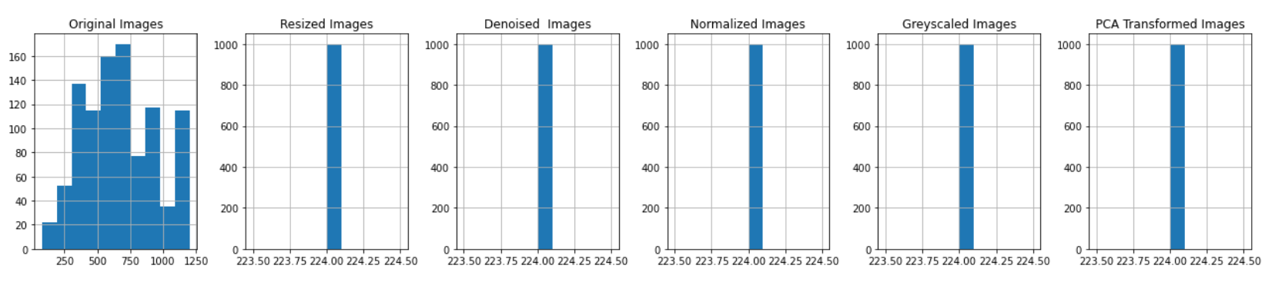

**Figure 70**

*Height changes during Data Pre-processing and Transformation*

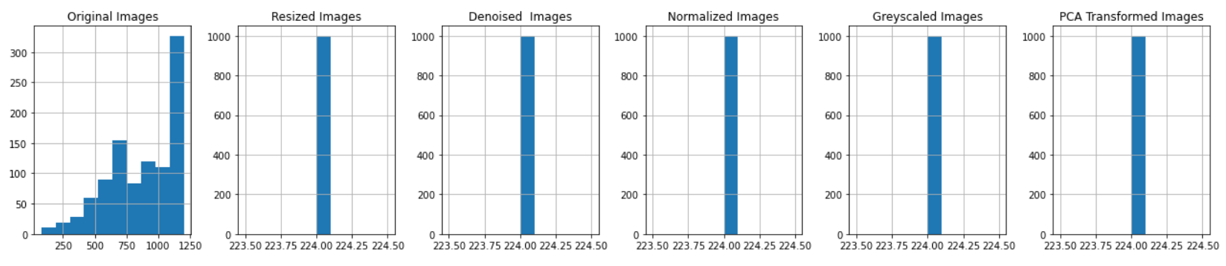

**Figure 71**

*Size Changes during Data Pre-processing and Transformation*

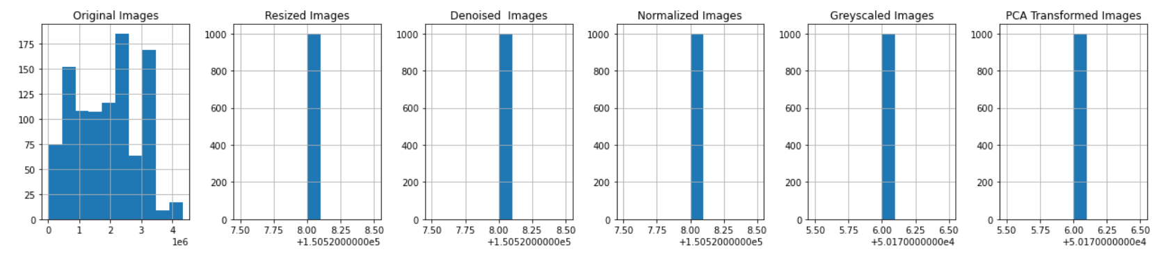

***3.7 Data Analytics Results***

Various big data analytics formats are explored related to image analysis that visualizes the results obtained to post the EDA, data cleaning, and pre-processing phase. The initial analysis involved visualizing the number of images based on their target classes. Pie charts and histograms are considered effective ways to visualize image distribution across target levels. Figure 72 shows the percentage distribution of images across flood and non-flood class types. The key takeaway here is that the dataset is balanced as both classes have 50% of the total number of images. This is cross-checked to compute the final absolute number of images. Figure 73 shows a histogram with the number of images in each of the target categories.

**Figure 72**

*Image Distribution based on Target Class*

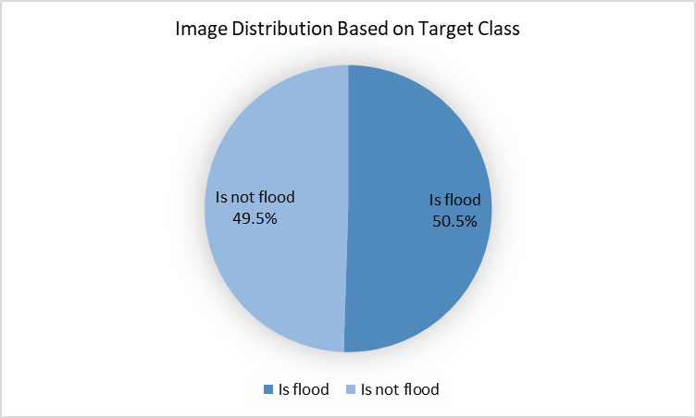

**Figure 73**

*Number of Images based on Target Class*

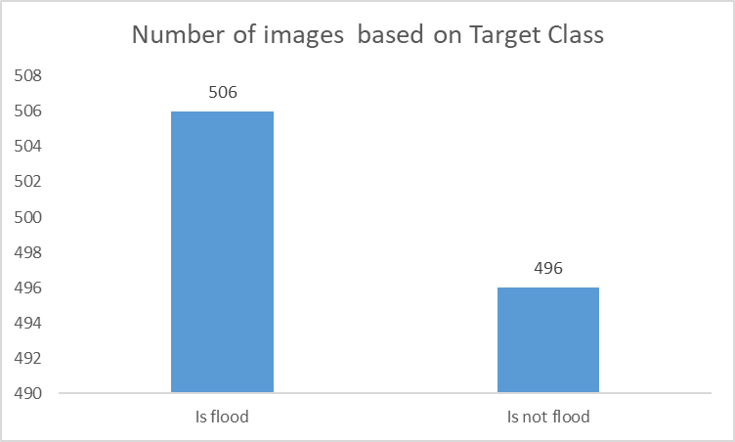

Also, a scatter plot is plotted for bivariate image analysis of various image parameters and is shown in Figure 74. As no clusters exist in the scatter plot, the plot shows an equal distribution for images across different heights and widths.

**Figure 74**

*Height Vs Width Scatter Plot*

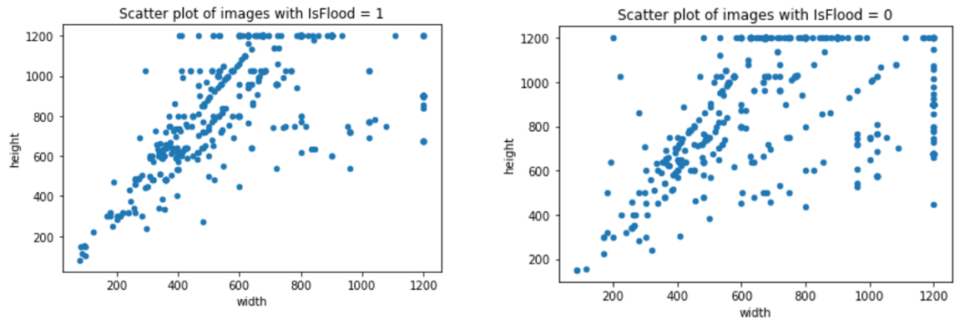

After passing through each stage of data pre-processing the images are plotted and analyzed. In Figure 75, clear transformations in the image after they’re passed through resizing, denoising, normalization, grey scaling, and PCA transformation can be seen and visualized to decide the necessary next steps.

**Figure 75**

*Image Transformation after Pre-processing*

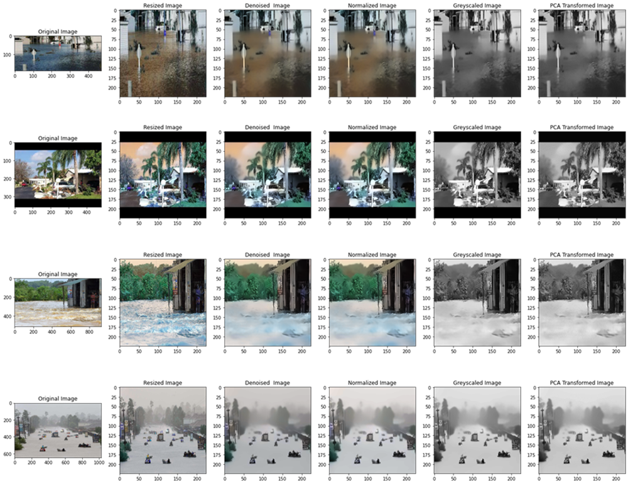

**4. Model Development**

***4.1 Model Proposals***

For efficiently identifying and detecting the flood in the photos, the best model selection for image classification is necessary. The final model should be capable of handling enormous volumes of picture data, processing images, identifying objects and areas within them, and making accurate predictions. Under consideration of the aforementioned circumstances, four potential cutting-edge architecture models - VGG-16, ResNet-50, AlexNet, and GoogLeNet—are presented for the categorization of flood/non-flood pictures. Each of the four proposed picture categorization models is built on the supervised deep learning approach known as the Convolutional Neural Network (CNN).

The complete overview and information flow of the Alex-Net, VGGNet-16, GoogleNet, and ResNet-50 model designs are based on an understanding of the CNN algorithm and the layers in it. In their research work from 2017, Albelwi and Mahmood discuss the design of the CNN algorithm model illustrated in Figure 76. Equations are used to further illustrate the related levels and their roles.

**Figure 76**

*Sample CNN Algorithm Architecture with Convolutional, Pooling, Dense and Output Layers*

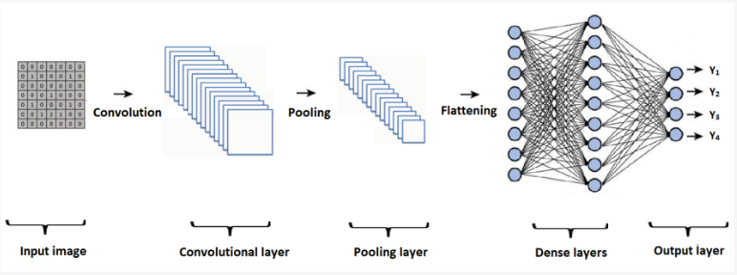

*Note.* Albelwi, S., & Mahmood, A. (2017). A Framework for Designing the Architectures of Deep Convolutional Neural Networks. Entropy, 19(6), 242.

Multiple convolutional, pooling and dense layers make up Alex-Net, VGGNet-16, GoogleNet, and ResNet-50. The layers that make up each of the deep CNN designs are described here, along with the equations and layers that are used to process input as it moves through each layer.

The convolutional layer receives the input image, which is a matrix of numerical values. It includes kernels or filters, another matrix of integers whose primary purpose is to extract the image's features. Convolution is performed by swiping the filter across the input image's height and breadth and by calculating the dot product between the input and the filter. It is given by equation (1)

(1)

$$a . b= \sum_{i=1}^{n}{a_{i}*b_{i}}$$

By repeatedly convoluting the filter with the input image, feature maps or activation maps of the filter's size are produced. Equation (2) below states that the output image has the size (O x O) when an input image of size (I x I) is convolved with a filter of size (F x F), padding (P), and stride (S). The filter size and stride (steps at which convolution should happen) determine the output feature map size.

(2)

$$O=\frac{\left(I-F\right)+2P}{S} +1$$

where padding is P. Equation (3) below states that it is determined by the number of pixels that are added to the boundary of the image during CNN processing in order to cover the image.

(3)

$P= \frac{K-1}{2}$

Early convolutional layers take information about low-level features from the images, whereas later layers gather data on high-level features like lines, forms, and particular objects. To bring non-linearity into the model, Rectified Linear Units (ReLU), a non-linear activation function, are frequently used. If the input is negative, it outputs 0, and if the input is positive, it returns the appropriate value. Equation (4) yields the information as follows. ReLU, as opposed to other activation functions like tanh, sigmoid, etc., generally speeds up training.

(4)

$f\left(x\right)=max⁡(0,x)$

The pooling layer is then given the feature maps produced from the output of the convolutional layer. The input feature maps are divided into various regions with size using pooling (R x R). Each region's output is a single output. The size of the feature map is reduced in dimension by this layer, which also lowered the computing load required for model training. Two types of pooling exist. The maximum value among the inputs included within the filter area is returned by max pooling. The average value of the filter-covered area in the provided feature map is provided via average pooling.

The Fully Connected layers (FC Layers), also known as densely connected layers, receive the output from the pooling layer and transform it linearly using a weight matrix. The output vector is obtained by taking the dot product of the input and weight matrices and then using an activation function to perform the non-linear transformation. The equation below serves as a representation (5).

(5)

$Y_{jk}\left(x\right)=f( \sum_{i=1}^{n_{h}}{w_{jk}}x_{i}+ w_{j0})$

where the activation function f wraps the weight matrix and input, $w_{jk}x_{i}$ is the dot product of the weight matrix, and wj0 is the bias that is imposed. The SoftMax layer is the final layer that is typically utilized in several CNN-based models, including GoogLeNet and Alex-Net. The layer transforms the vector into the target classes' probabilistic distribution. Equation (6) below gives it.

Y(i) = $\frac{e^{z_{i}}}{\sum_{j=1}^{k}{e^{z_{j}}}}$

(6)

All of the cutting-edge models put forth for the research start with CNN as their basic model. The sections below provide a detailed explanation of each proposed model.

**Alex-Net.** AlexNet CNN architecture is developed by Krizhevsky et al. (2017), and the model is trained to utilize two GPUs and a split layer. The AlexNet has eight layers that can be learned. Five convolutional layers with some layers make up its design. Following this are three fully connected layers, three maximum pooling layers, and a 1000-way softmax classifier. Only the kernels from the GPU's preceding layer are connected to the second, fourth, and fifth convolutional layer kernels. In contrast, all of the second layer's kernels are connected to the third layer's kernels. All of the neurons in the completely connected layers are linked to all of the neurons in the layer below. Each fully connected and convolutional layer's output is subjected to a rectified linear unit, often known as ReLU non-linearity. ReLU is a non-saturating nonlinearity method to simulate how a neuron's output (f) changes depending on its input (x), as shown in (1). In comparison to the saturating nonlinearity approach, the ReLu method trains considerably more quickly.

Krizhevsky et al. (2017) noted that generalization benefits from local response normalization. After the first, second, and fifth convolutional layers, response normalization is used. Equation (7) represents the response-normalized activity b for an activity of the neuron

$$b_{x,y}^{i}=a_{x,y}^{i} / {\left(k+α\sum_{j =\left(0,i-\frac{n}{2}\right) }^{\left(N-1, i+\frac{n}{2}\right) }{}{\left(a_{x,y}^{j}\right)}^{2}\right)}^{β} (7)$$

**VGG-Net-16.** In their study, Asif et al. (2021) addressed the importance of emergency response in preserving lives and property after disasters. By utilizing cloud-based deep learning algorithms, they have presented a novel technique to assist crisis management in real-time using social media photographs. They suggested using algorithms like VGG-16 and You Only Look Once (YOLO) algorithms to analyse disaster-related photos and identify the different sorts of disasters. The YOLO algorithms like YOLOv3 and YOLOv4 are used to identify the objects for an emergency response while the VGG-16 algorithm is used to determine the type of disaster. They found that YOLOv3 correctly recognized 85% of the photos, whereas YOLOv4 correctly classified 96% of the images. The VGG-16 algorithm has a training accuracy of 98%.

Since VGG16 is a pre-trained CNN model that has previously been optimized to perform well on a variety of image recognition tasks, it may not require additional optimization just for flood detection. One way to increase performance is to retrain the model on a dataset relating to floods in order to fine-tune it and assist it to learn the features necessary for the task of flood detection. The model's hyperparameters, which are used to set it and include the learning rate and layer count, can also be optimized. Additionally, changes are made to the existing layers or add new ones to the model. To determine the model's ideal configuration, the majority of these optimization activities necessitate some experimentation and trial and error.

**GoogleNet.** A breakthrough in categorization and object detection is first made by Szegedy et al. (2015b) at the ImageNet Large-Scale Visual Recognition Challenge 2014 (ILSVRC14). When compared to earlier models AlexNet and ZF-Net, which won the ILSVRC in 2012 and 2013, respectively, GoogLeNet has significantly reduced the error rate, which is lower than the error rate by VGG (2014 runner-up). Since then, the approach has been applied by other academics to a range of categorization issues. We've highlighted a handful of them below.

In their publication, Szegedy et al. (2015b) discuss how the GoogLeNet architecture decreased the computational operations within the network by expanding and deepening while maintaining a fixed computational budget. They said that growing the network's breadth, or the number of units at each level, as well as its depth, or the number of levels, is the simplest approach to improve network performance. However, when working with a constrained amount of labelled datasets, this might increase the network's susceptibility to overfitting and demand additional computational power. So, even inside the convolution blocks, they advise using sparsely linked architecture as opposed to a completely connected design. Even though there is a rise in the number of units at each stage, they claim that the architecture is excellent at handling the computational capacity. GoogleNet is referred to as Inception or Inception V1.

In their study, Bocanegra and Haddad (2021) employed Convolutional Neural Network (CNN) models AlexNet, GoogLeNet, and ResNet50 on images captured by Unmanned Aircraft (UAV) to categorize all the many forms of damage brought on by natural disasters. In times of crisis, they advise using this information to guide travellers away from the routes. Additionally, they discuss the many measures they used to compare the results of the different networks they selected, including precision, recall, and F1 score for the picture classification task.

In their article, Alam et al. (2020) divide the photographs into four categories of disasters: fire, earthquake, floods, and others. They employed the deep learning models SqueezeNet, InceptionNet, MobileNet, ResNet18, ResNet50, and ResNet101 to conduct categorization on both individual data and data from AIDR, Bing Google, Flicker, and Instagram. In their conclusion, they claim that EfficientNet performs better than all other models and that consolidated datasets offer greater efficiency.

By repeatedly utilizing various CNN layers, the GoogLeNet architecture is a deep CNN-based architecture created on top of it. The 22 layers of GoogleNet are made up of 9 inception blocks made up of convolutional, maximum pooling, and average pooling layers, as well as five fully linked / dense layers, five pooling layers, and two SoftMax activation layers. It employs over 100 layers in total for object identification and classification.

It can be very challenging to define and develop the model architectures because there are so many different design alternatives. The perfect model design that could produce the best outcomes or forecasts cannot be known. It all comes down to adjusting and experimenting with a few key factors on which the model depends a lot, and then observing the model's behaviour. For further deployment, the parameters for which the model performs best can be employed. These parameters, known as hyperparameters, are used to regulate how the model learns. Given that GoogLeNet is a CNN model, most of the hyperparameters that apply to CNN also apply to it. However, there are two groups of appropriate hyperparameters for Google Neural Network. Hyperparameters for the network structure include kernel size (filter size), stride, padding, activation functions, and hidden layer. Batch size, momentum, learning rate, and the number of epochs are trained to network parameters. To determine the optimal parameters, one can conduct many hyperparameter experiments. The best parameters can then be used to train the model. Table 1 below lists many hyperparameters that can be utilized to enhance the Google Neural Network model.

**Table 1**

*Sample table showing hyperparameters for GoogLeNet model*

|  |  |  |
| --- | --- | --- |
| Hyperparameter | Abbreviation | Range |
| Kernel size | kernel_size | Anything suitable |
| Stride | strides | Anything suitable |
| Padding | padding | [‘same’, ’valid’] |
| Activation function | activation | [‘relu’, ’lrelu’, ‘sigmoid’, ’softmax’] |
| Optimiser | optimiser | ['Adam', 'SGD', 'Adam', 'SGD'] |
| **Hyperparameter** | **Abbreviation** | **Range** |
| Learning rate | learning_rate | [0.001, 0015, 0.002, 0.003] |
| Momentum | momentum | [0.9, 0.95, 0.99] |
| Number of epochs | epochs | Anything suitable |
| Batch size | batch_size | [32, 64, 128, 256] |

*Note.* Table shows hyperparameters and their approximate range for the GoogLeNet model.

**ResNet-50.** With its ResNet152, which is created by a group of Microsoft experts at Bing and has extremely deep layers, the model just won the 2015 ImageNet challenge. The ResNet50 model, a scaled-down version of the ResNet152, is used for the flood classification task. According to He et al. (2016), the strategy has significantly helped in overcoming the issue of disappearing gradients, which frequently occurs as a deep neural network goes deeper. Khan et al. (2018) also assessed and looked at the performance of several ResNet models for two different kinds of datasets. Figure 77 shows the basic building block of a residual network shown by researcher He et al (2016). which explains the split connection between the input and output which helps in reducing the vanishing gradient and helps in faster convergence.

**Figure 77**

*Residual Network Building Block*

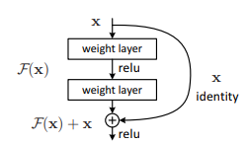

*Note.* Building block of ResNet adopted from He, K., Zhang, X., Ren, S., & Sun, J. (2016). Deep Residual Learning for Image Recognition.

2016 IEEE Conference on Computer Vision and Pattern Recognition (CVPR).

He et al. (2016) studies state that the ResNet50 model building block is "defined as y=F (x, Wi) + x" (p. 772), where x is the input vector and y is the output vector (2016). F represents the residual mapping that needs to be learned. A split connection, a condensed connection path, is also included in this. There are layers for the maximum pool and average pool in addition to the 48 convolutional layers with various kernel sizes that make up the model. The model's extraordinarily low error rate for the ImageNet dataset, on top of which it is first launched, is well known.

In their research, Jafar and Myungho (2020) have made recommendations for how to make ResNet models perform better. One of the key hyperparameters that determine how effectively a model will be trained and back-propagated between its layers is the epoch. This will guarantee the model's suitability for the training set of data. The learning rate, a different hyperparameter, controls how quickly model parameters are updated. The ResNet50 classifier's batch size hyperparameter controls how many training samples are trained simultaneously.

***4.2 Model Supports***

In order to minimize overall costs, the model's end-to-end implementation requires the appropriate selection of hardware, software, and other tools. When modeling, the model is created, trained, tested, and evaluated using the dataset.

Strong hardware, such as a MAC system or a Personal Computer (PC) with a Central Processing Unit (CPU) and Random Access Memory, is required for the research project's model creation phase (RAM). It would also require a few software programs, including Google Collab, which functions as an IDE because it offers a Graphics Processing Unit (GPU) and RAM that can be used to train, test, and validate the developed model as well as to maintain computational efficiency, and Mac Operating System (OS) Monterey version 12.6 or Windows OS 11 with Python version 3.9. Project management and faculty cooperation need the use of tools like ClickUp and Zoom, respectively. Figure 78 lists the different hardware, software, and tool requirements as well as how to use them.

**Figure 78**

*Hardware, Software and Tool Requirements for Model Development*

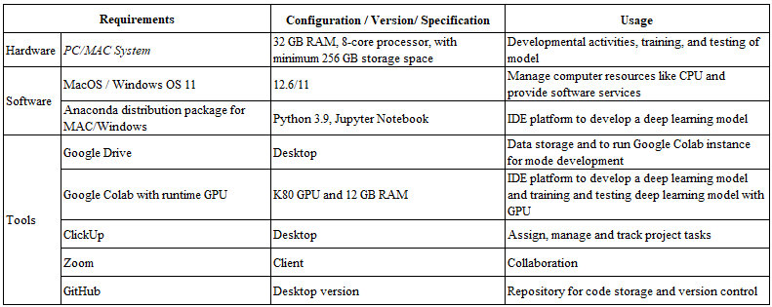

For the implementation of the deep learning model in Jupyter Notebook / Collab, the research makes use of multiple libraries and packages which are provided in detail in Figure 79.

**Figure 79**

*Libraries/Methods and their Usage in Model Development*

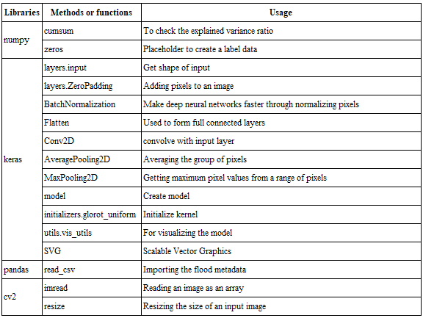

**AlexNet.** AlexNet's architecture is seen in Figure 80. Given that the conventional implementation of the AlexNet architecture employs two GPUs and that earlier GPUs have memory limitations and a high number of model parameters, this is necessary. Distributing the models across many GPUs is not necessary, though, as this is no longer the case. Only one layer of the model has been used.

**Figure 80**

*AlexNet Architecture*

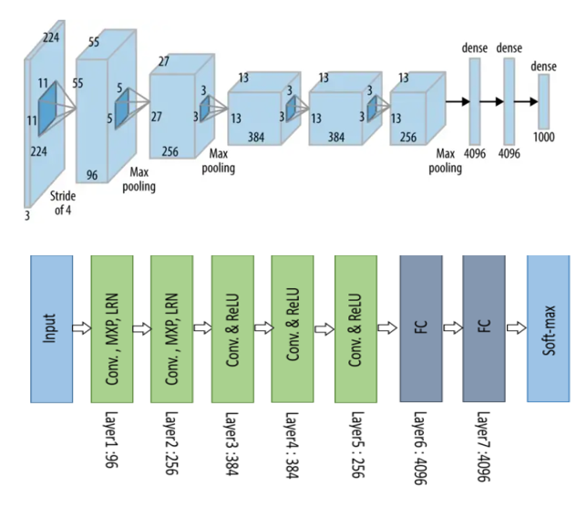

*Note.* AlexNet architecture with convolution (Conv), max-pooling (MXP), LRN, and fully connected (FC) layer. Adapted from Anwar, A. (2022b, July 13). Difference between AlexNet, VGGNet, ResNet, and Inception.

The AlexNet model receives a set of 224x224x3 RGB pictures with 96 feature maps as input. The input image for the first convolutional layer comprises filters of 11x11 pixels and a stride of 4, which reduces the image's size to 54x54x96. This is sent to the highest pooling layer, which produces a picture with dimensions of 26x26x96 with a filter size of 3x3 and a stride of 2. A convolutional layer with 256 feature mappings makes up the second layer. These feature maps have a 5x5 filter and a 1 stride. A maximum pooling layer with a filter size of 3x3 and a stride of 2 follows. The third, fourth, and fifth layers, which are convolutional layers with filter sizes of 3x3 and stride 1, are fed the output picture, which has dimensions of 13x13x256. While the third and fourth layers each have 384 feature maps, the fifth layer only has 256. The output of the convolutional layer is flattened in the sixth layer, which is a fully linked layer with 9216 feature maps, each measuring 1x1. The seventh and eighth layers, which each include 4096 units, are fully connected layers. To create the output distribution over the class labels for flood and no-flood, the output from the fully connected layer is fed into a 10-way softmax. The input and output specifics for each layer of AlexNet are shown in Figure 81.

**Figure 81**

*Structural details of AlexNet CNN Architecture*

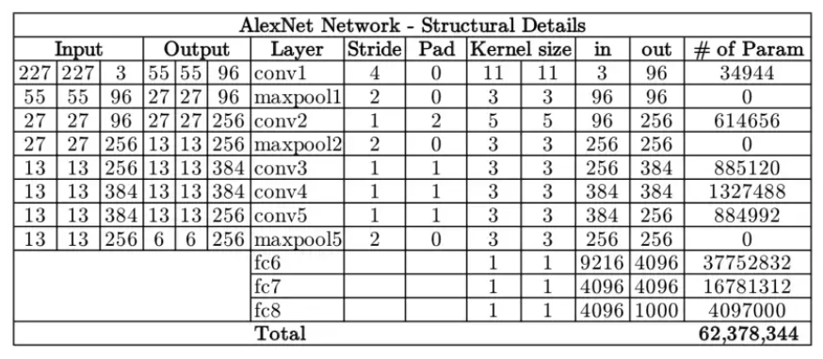

*Note.* Structural details of the AlexNet architecture with the details on parameters at each layer. Adapted from Anwar, A. (2022c, July 13). Difference between AlexNet, VGGNet, ResNet, and Inception. Medium.

**VGGNet-16.** One of the deep convolutional neural networks Karen Simonyan and Andrew Zisserman proposed in 2014 is the VGG16. One of the greatest computer vision network models is this one. It is frequently applied to picture categorization and object detection. Figure 82 depicts the architecture of the VGG16 model.

**Figure 82**

*VGG16 Model Architecture*

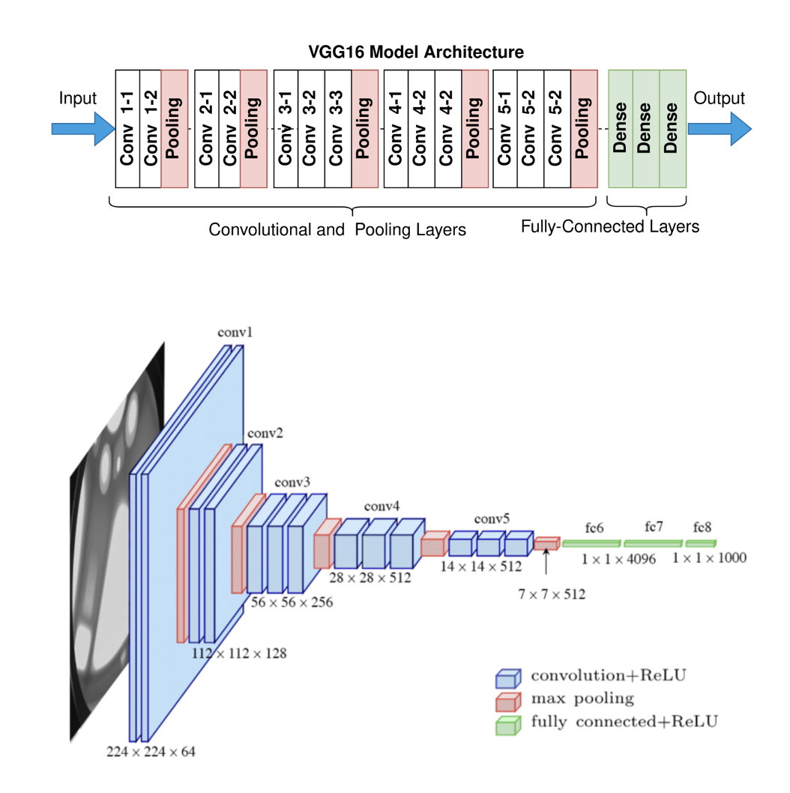

*Note.* Model architecture adopted from projects, Contributors to Wikimedia. *Wikimedia Commons*, Wikimedia Foundation, Inc., 1 Dec. 2022.

A series of convolutional layers are followed by max-pooling layers in the architecture of VGG16. It has twenty-one layers total of eleven convolutional layers, five layers of Max pooling, and three layers of density but only sixteen of those layers have weights. The network comprises around 138 million parameters, and the 16 in VGG16 refers to 16 weighted layers that are incorporated in its architecture. The fundamental units of CNN models are convolutional layers, which need a feature map, filters, and input data. These layers have padding that increases the number of zeros at the image's edges, making it simple to read the edge features and produce results that are similar to the input image. They are used to process photos, such as blurring, sharpening, enhancing, and embossing them. The introduction of max pooling layers, which functions as a regularisation parameter and minimize the size of the feature maps, helps prevent overfitting. They aid in the extraction of low-level characteristics such as edges, points, etc., which decreases the number of parameters utilized and speeds up the calculation. The feature present in the feature maps produced by the convolutional layers is summarized by the pooling layer. While the thick layers aid in categorizing the images based on the convolutional layer output. They have neurons that aid in determining the input's weighted average, which is subsequently fed to a nonlinear function known as the activation function. It is applied to increase the nonlinearity of the output. A few popular activation functions in convolutional neural networks include the ReLu, Sigmoid, and Tanh functions (CNN).

The data flow in the VGG16 architecture can be seen in Figure 83.

**Figure 83**

*VGG16 Model Dataflow*

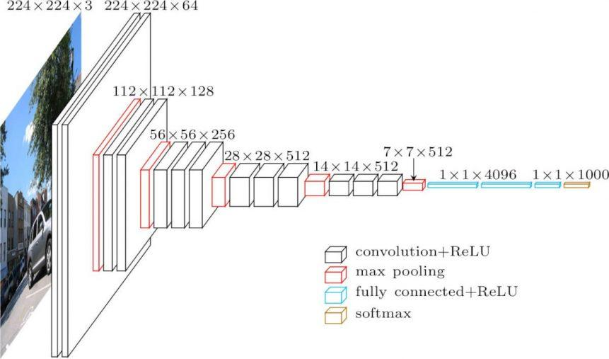

*Note.* Model Data Flow diagram adopted from S. Mascarenhas and M. Agarwal, "A comparison between VGG16, VGG19 and ResNet50 architecture frameworks for Image Classification," 2021 International Conference on Disruptive Technologies for Multi-Disciplinary Research and Applications (CENTCOM), 2021, pp. 96-99.

As previously mentioned, the architecture consists of 16 levels, each of which serves a certain purpose in the model. The model can be given an input tensor with R, G, and B channels that is 224 × 224 in size. The input is run through the first two convolutional layers, each of which has 64 channels, a 3 x 3 filter, and the same padding. As a result, the spatial resolution is maintained, and the dimensions of the output activation map are similar to those of the input image. The Max pooling layers of stride 2 x 2 are then fed the activation maps, which decreases the size of the activations to half, or 112 x 112 x 64. The second stack of two convolutional layers has a filter size of 3 x 3 and a max pooling layer, which reduces the size to 56 x 56 x 128. The activations are then fed to this layer. The output size is changed to 28 x 28 x 256 by adding another stack of three convolution layers with 512 channels, followed by a max pool layer. In order to alter the output to 7 x 7 x 512, the output is then fed to another stack of three convolutional layers, each having 512 filters. Three fully connected layers with a flattening layer in between continue this series of convolutional and max pooling layers. Each of the first two layers has roughly 4,096 neurons, and the output layer's final layer has 1,000 neurons. A SoftMax activation layer that is used for categorization is typically placed near the final output layers.

The approach requires pre-processing modules to prepare the image for use as input to the model. These operations include loading, cropping, resizing, and turning the image to an array. The "GlobalAveragePooling2D ()" function is frequently used in the VGG16 architecture to reduce the output dimensions from the last convolutional layer, which aids in preventing overfitting and model generalization. When this function is applied to the last convolutional layer's output, the result is a one-dimensional vector that is then given to additional layers to enable predictions based on the input data's learnt features. Another regularization technique called the "Dropout ()" function decreases the model's reliance on any one feature by randomly reducing some of a layer's activations to zero during training. This technique is frequently used to prevent overfitting. Along with functions that specify the percentage of activations that should be set to zero, the dropout rate is mentioned. The output layer, the last fully linked layer, is in charge of translating the learnt features into the final predictions. It has two units and employs the 'sigmoid' activation function, which causes the output layer to generate two probabilistic values between 0 and 1. The predicted class of the input data is established by these probabilities.

Several arguments that define the optimizer, loss function, and various metrics are utilized during the model training process to monitor and assess the performance of the model. While the loss function is used to assess the model's performance on training data, the optimizer is in charge of adjusting the model's weights based on the estimated gradients. One of the most popular loss functions for classification jobs involving many classes is the categorical cross-entropy loss function. The loss is determined based on the discrepancy between predicted probabilities and the actual probabilities of the input data, and it is done by training the model to predict the probabilities of input data pertaining to each of the classes. By changing the model's weights to more closely reflect the actual probabilities, the loss of the model can be decreased. Another optimization method is the Adam optimizer, which typically modifies the model's weights in accordance with the calculated gradients by employing an adaptive learning rate. The learning rate can be changed for each parameter based on the parameter's historical gradient. It specifies the step size that the optimizer will use to optimize the model's weight. Usually, a default learning rate of 0.0001 is utilized, and an increase or reduction in that amount will, respectively, speed up or slow down model training.

**ResNet-50.** Microsoft currently owns it, and in 2015, its more sophisticated version, ResNet150, took first place in the ImageNet challenge. Due to the activation functions, it incorporates, the model is nonlinear. It has 48 convolutional layers, which are the layers that combine the input from each step of the filter with the filter output to form the foundation for the image classification issue. Additionally, it has 1 max pool layer, which aids in decreasing the input data's dimension after convolution. By calculating the average of each patch, the single average pool layer reduces the dimensionality as well. A thorough architecture design of the ResNet-50 neural network is shown in Figure 84.

**Figure 84**

*ResNet Architecture*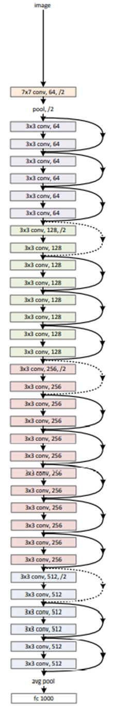

The residual network is a particular style of architecture used in this concept. By taking into account the block's limit, the max pool layer initially dimensions down the seven-by-seven kernel size to three by three. Convolutional layers then enter the picture and filter the picture for each layer to find edges and forms in the training picture. The average of the pixels in the layer input is then calculated by the average pooling layer. The inputs are flattened and combined into a single output that helps with image recognition in the final layer, which is fully coupled. A skip link is shown across each output layer that aids in preventing the vanishing gradient problem by introducing an identity block that produces the same output as the input. According to He et al. (2016), this lessens the vanishing gradient problem that is certain to arise as the neural network gets deeper.

**GoogleNet.** Understanding the architecture and data flow of the proposed model GoogLeNet requires knowledge of the base model as well as the resources required for model development. This model is developed utilizing a distinct sort of architecture that facilitates the extension of the network's width and depth while maintaining its processing capability. It can detect about 1,000 different types of objects. The condensed GoogLeNet architecture is seen in Figure 85. The appendix section displays the elaborate architecture Szegedy et al. (2015b) suggested.

**Figure 85**

*Simplified GoogLeNet Architecture*

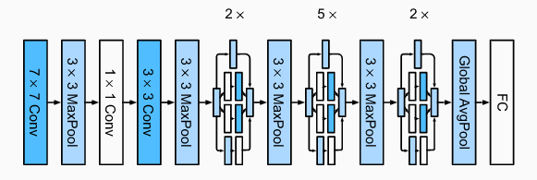

*Note.* Dive into Deep Learning — Dive into Deep Learning 1.0.0-alpha1.post0 documentation.(n.d.).

The image has to be 224 x 224 x 3 (height x width x number of channels) in order to fit the model, which is done as part of data pre-processing and transformation. Each image is read from the pre-processed data stored in Google Drive and used as input for the model. A convolutional layer with 64 filters of kernel/filter size 7x7, the stride of 2, and padding as "same" convolve the input, which is 224 x 224 x 3 in size. The following is a sample calculation that demonstrates how the output is produced using equation (1) and equation (2).

((224 -7 + 2(3)) /2) + 1 output picture size.

This layer's output would be 112 x 112 x 64 with one depth. The first convolutional layer employs a 7 x 7 filter, which is significantly larger than any other filter in the whole network. The objective is to decrease the image's dimension or size without losing any feature data. This is used as an input for the max pooling layer, which features a filter with the dimensions 3 x 3, stride 2, and "same." The output of the maximum pooling layer would be 56 x 56 x 64 with a depth of zero using a calculation identical to equations (1) and (2). Batch normalizing this output, it is concurrently fed through a 1 x 1 convolutional layer with 64 filters and a 3 x 3 convolutional layer with 192 filters to produce an output with picture dimensions of 56 x 56 x 192 and a depth of 2. The input feature map is dimensionally reduced and the computational load for model training is reduced by passing it through the max pooling layer with a 3 x 3 filter and a stride of 2. At this point, the output measures 28 by 28 and contains 192 feature maps (28 x 28 x 192). The image size has already been scaled down by a factor of eight before arriving at the inception module. The goal of GoogLeNet architecture is to move the output to the inception module after that. Figure 86 below depicts the network's inception module.

**Figure 86**

*Inception Module with Dimensionality Reduction Feature***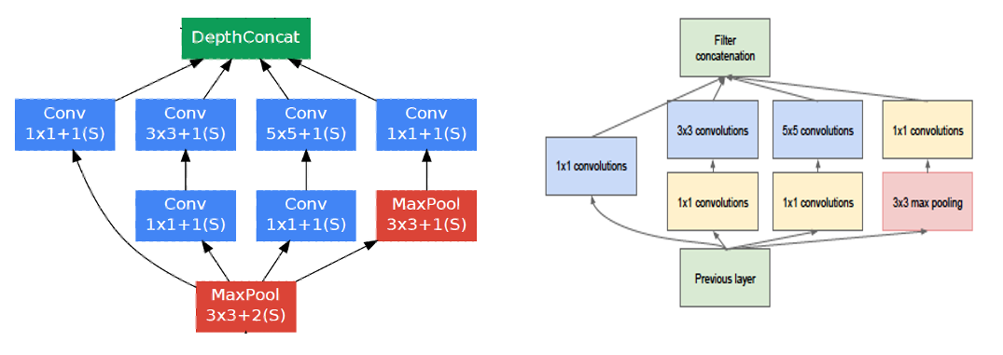**

Overfitting may become a problem as the network gets deeper as a result of more parameters. Szegedy et al. (2015b) used filters of multiple sizes that could be operated at the same level in their architecture to resolve this issue. As a result, the network becomes wider rather than deeper. The inception module uses two 1 x 1 convolution to reduce the network's weights and biases (parameters), which in turn substantially reduces the number of operations before 3 x 3 and 5 x 5 expensive convolutions are carried out, leading to computational efficiency.

The output of size 28 x 28 x 192 from the max pool layer is passed through two inception blocks (3a) and (3b) and is then again through the max pool layer with the filter of 3x3 and stride 2 to get them out the size of 14x14x480. The details on the size and the parameter at each stage are given in the shown in Figure 88. The output then passes through seven more inception blocks (4a), (4b), (4c), (4d), (4e), 5(a) and 5(b) with a max pooling layer between 4(e) and 5(a).

As the network gets bigger, another problem is they suffer from a vanishing gradient problem. To tell it in layman's terms, during training, the network just stops learning. To avoid this, auxiliary classifiers are added to the network to inception 4(a) and 4(b). The auxiliary block from the GoogLeNet architecture is shown in Figure 87.

**Figure 87**

*Auxiliary Block from Inception Module*

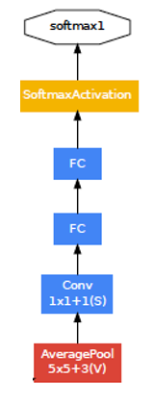

Two completely linked layers, an average pooling layer, a convolution layer, and a softmax activation layer make up the accessory blocks. Only training instances are used, and validation/testing instances are never used. The auxiliary classifier's job is to do classification based on inputs in the network's midsection and contribute the training-related loss back to the total loss of the network.

The global average pooling layer receives the output of the inception (5b) module, which has an image size that has been dramatically decreased to 7 x 7 x 1024, along with a filter size of 7 x 7 and a stride of 1. Once more averaging the output to 1 x 1, reduces the trainable parameters to 0 and raises accuracy. The input is then turned into a vector using linear transformation in a fully linked layer after that. The softmax activation layer, which uses the softmax activation function, is then passed across it. Its purpose is to assign probabilities to the input according to the research project's aim class, which is flood or non-flood. The output size, depth, parameters, and a number of operations at each layer of the network are shown in detail in Figure 88 as the data flow from one layer to the next.

**Figure 88**

*Detailed Architecture, Parameter, and Output details at Each Stage of GoogLeNet*

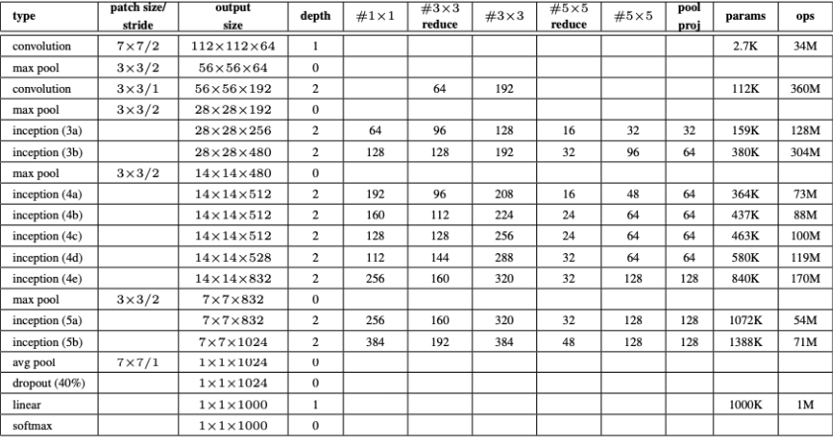

***4.3 Model Comparison and Justification***

For the purposes of picture classification and object detection, numerous techniques have been employed. AlexNet, VGG-16, GoogleNet, and ResNet-50 are the chosen CNN and are well known. Figure 89 summarizes the comparative analysis of the models. All the models support large datasets and have computational requirements to process large image datasets.

**AlexNet.** AlexNet is an 8-layer deep convolutional network having 5 convolutional layers along with 3 fully connected layers. With 62 million parameters, it has a deeper network. ReLu, dropout, and overlap pooling layers are employed. The strength of the model, according to Mao et al. (2022), who created AlexNet, is that it requires the least amount of computational time and, thus, the least amount of money. The vanishing gradient issue is also made easier by the model while accuracy levels are maintained. The dropout layers also prevent overfitting problems. The model's weakness is that it performs poorly in terms of accuracy when compared to other models.

**VGG-16.** VGG-16 is a 16-layer deep convolutional network having 13 convolutional layers along with 3 fully connected layers. The kernel network has 138 million parameters and is fixed in size. This model has the benefit of having respectable accuracy while requiring less computing time. Small-sized kernels and a homogenous topology are features of VGG-16. Maximum parameters are employed in this model. VGG-16 has a drawback since it employs completely connected layers, which are computationally expensive, according to Khan et al. (2020).

**GoogleNet.** With 21 convolutional layers and 1 fully connected layer, GoogleNet is a 22-layer deep neural network. It has 6.4 million parameters and is a wider-panel network. The benefit of GoogleNet is that it can be used for a variety of data kinds, including tabular datasets, audio, video, and images. However, because of its intricacy, this model needs more time to train. According to Khan et al. (2020), the GoogleNet model has flaws because its representation could result in the loss of important data. Customising parameters is difficult because of the varied topology.

**ResNet-50*.*** A 50-layer deep convolutional network ResNet-50 consists of 48 convolutional layers and 1 fully connected layer. With 25.5 million parameters, it is a kernel network shortcut connection.

It identifies mapping and has residual learning from the skip connections. According to Mao et al. (2022), ResNet uses skip connections referred to as residuals to address the problems of saturation and deteriorating accuracy. Among all models, this one has the highest accuracy (95.51%). ResNet-50 requires a lot of training time. ResNet has been shown by Khan et al. (2020) to be more effective at addressing the vanishing gradient problem, although it suffers from a complex architectural design, information deterioration from feed forwarding, and over adaptation caused by hyper-parameters.

**Figure 89**

*Model Comparison*

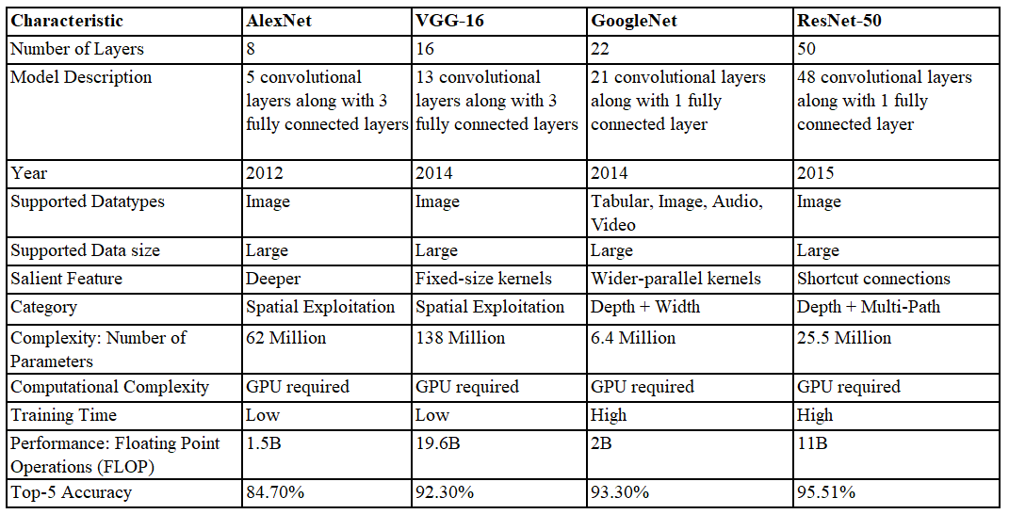

*Note.* Model comparison adapted from the source Anwar, A. (2022, July 13). Difference between AlexNet, VGGNet, ResNet, and Inception. Medium.

***4.4 Model Evaluation Methods***

Once the model has been created, it is crucial to assess how it is functioning and whether it is making very poor predictions or appropriately identifying the images. Depending on the model type being trained and the particular task it is being used for, machine learning and deep learning utilize a variety of evaluation metrics to measure the performance of the model. The measures that are used to assess the created classification model have already been set by researchers. According to Bocanegra and Haddad (2021), accuracy, f1-score, precision, and recall are standard measures used to assess the Alex-Net, VGGNet-16, GoogLeNet, and ResNet-50 models. The majority of the metrics above may be understood using a confusion matrix for a binary classifier. Figure 90 shows the confusion matrix with relevant terminologies.

**Figure 90**

*Confusion Matrix for classification model results*

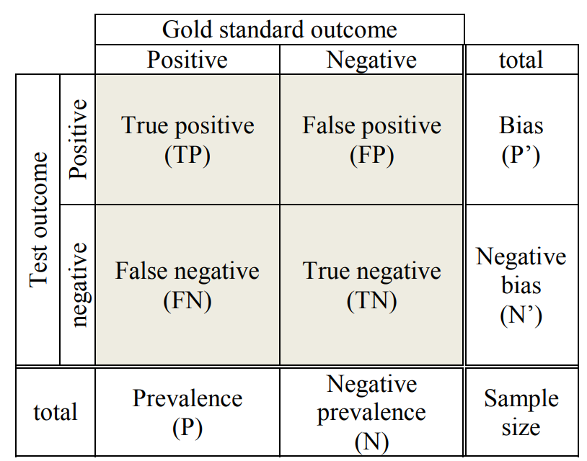

*Note.* Confusion matrix adopted from O’Reilly, C., & Nielsen, T. (2013b). Revisiting the ROC curve for diagnostic applications with an unbalanced class distribution. 2013 8th International Workshop on Systems, Signal Processing and Their Applications (WoSSPA).

If the image with the flood has been identified as a flood, the data point is True Positive (TP). If the image with the non-flood has been identified as non-flood, the data point is True Negative (TN). If the prediction is made as non-flood when it is actually a flood, the data point is False Negative (FN). Type 1 errors are another name for it. When a flood is anticipated but doesn't really occur, the data point in the confusion matrix is labelled False Positive (FP). The confusion matrix can be used to calculate accuracy, F1 score, precision score, and recall.

**Accuracy.**It is one of the elementary metrics popularly used for model evaluation in classification tasks. It represents the percentage of correct predictions and is defined as the count of correct predictions divided by the total count of predictions. The formula for accuracy can be seen in equation(8)

$Accuracy= \frac{TP+TN}{TP+TN+FP+FN}$ (8)

**Precision.** Precision is the ratio of the number of images correctly classified as a flood to all images predicted to be a flood. This metric is important where importance to False Positives is needed rather than False Negatives. It is given by as in the below equation (9)

$Precision= \frac{TP}{TP+FP}$ (9)

**Recall.** It is also referred to as sensitivity is defined as the ratio of positive predictions identified correctly to the total count of instances that should be identified as positive. It provides how correctly the model identified true positives. It is given by as in the below equation (10)

$Recall= \frac{TP}{TP+FN}$ (10)

**F1-Score.** It can be defined as the combination of precision and recall and can be calculated by taking the harmonic mean of the two. It gives information on how precise the model is predicting and gives values in the range of 0 to 1. It takes both precision and recall into account. It is given by as in the below equation (11) and equation (12).

$F-Score=\frac{2*Precision*Recall }{Precision*Recall}$ (11)

$F-Score= \frac{TP}{TP+ \frac{1}{2}*(FP+FN)}$ (12)

**Loss.**Themodel makes use of the categorical loss entropy function to calculate Cross Entropy Loss (CEL) between predictions and labels. It is used when the target has two or more labels like flood/non-flood in this case. It is a representation of a model’s misclassification for a specific example. The loss of the model is zero if the model can predict accurately; otherwise, the loss is higher. The entire goal of training the model is to find suitable weights and biases to be added to the input such that the overall loss of the model is low. Easy-to-classify images may have a considerable impact on the CEL's loss function value and, consequently, govern the gradient that restricts learning from challenging images. The CEL is given by equation 13 as below.

$CEL= \sum_{i=1}^{n}{log⁡(p_{i}})$ (13)

Where pi is the probability of ith class and log is a log to the base 2 or ln ().

Using the defined metrics above, model accuracy, precision, recall, F1 and loss curves can be plotted and can be compared for training and validation data during each epoch.

***4.5 Model Validation and Evaluation Results***

After deciding which metrics are essential for the flood classification application, it is vital to compute the metrics by the decision. The recall is considered to be the most important parameter because it is inevitable that the model would detect the flood disaster as it happens. Therefore, it is inevitable that a model will be able to accurately anticipate the positive flood occurrence. A model with a greater recall is better for flood detection applications since recall measures the proportion of properly predicted positive occurrences out of all actual flood occurrences. Even other parameters, such as precision, accuracy, F1 score, and loss, are assessed and collected.

The results are continuously measured using a batch size of 5, which has been determined to be the ideal hyperparameter. Figure 91 shows the evaluation metrics observed for the validation set.

**Figure 91**

*AlexNet, VGG-16, GoogleNet and ResNet-50 Model comparison*

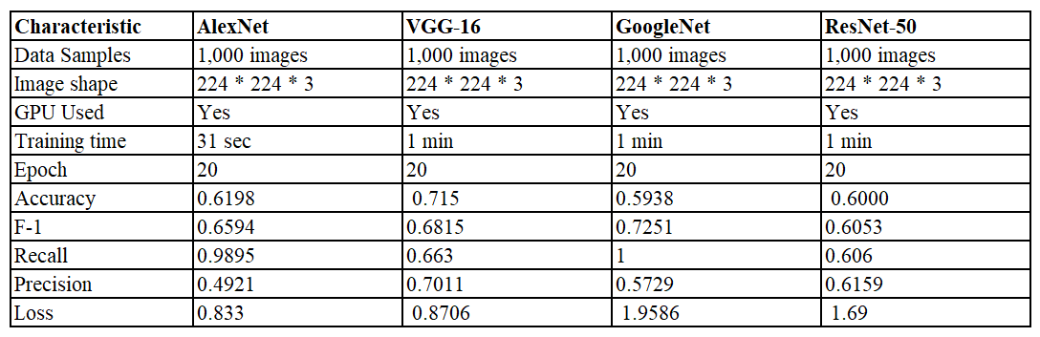

Comparing the outcomes of all the deep learning models used for this project, it can be seen that the VGG16 deep learning model regularly beats the others in terms of classification accuracy and other metrics.

On tuning the hyperparameters, it is seen that the classification metric performance increases. Additionally, it has been noted that PCA data reduction reduces the categorization metrics. This might be the case since object detection would be a better use for PCA than scene-oriented classification, like flood classification. To validate an ideal epoch setting, the metrics are seen after the results are observed and the hyperparameters are changed. Additionally, it is indicated how quickly a model may be learned. Higher batch sizes are found to dramatically boost training classification metrics while decreasing validation metrics. This is a result of the data being overfitted since numerous image data sets are analyzed simultaneously.

As the neural network would need to be trained 20 times in both the forward and backward directions for the images to be effectively trained, it can be argued that 20 epochs could be specified for this dataset. Additionally, a batch size of 10 is chosen for this case to process images in batches rather than all at once to increase computing performance.

The critical parameter recall is tested and compared across all of the CNN models under consideration in terms of the training and validation sets. The comparison of several models for training and validation data is shown in Figure 92.

**Figure 92**

*Recall Across Training and Validation Sets for Various Models*

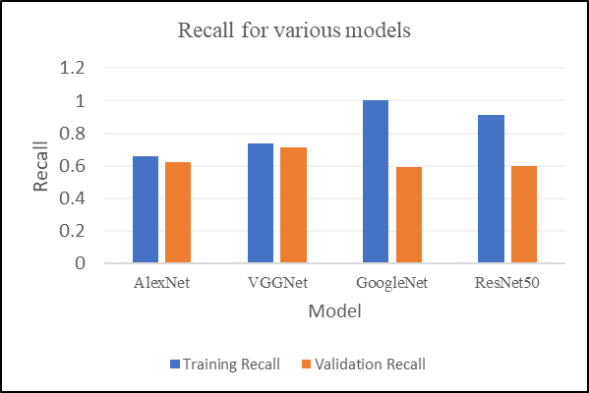

The final results of classification metrics for training data and validation data are plotted across various epochs for all four deep learning models are shown in Figure 93. It depicts how accuracy, F1, recall, precision and loss vary across training and validation data samples.

**Figure 93**

*Model Performance Comparison Graphs*

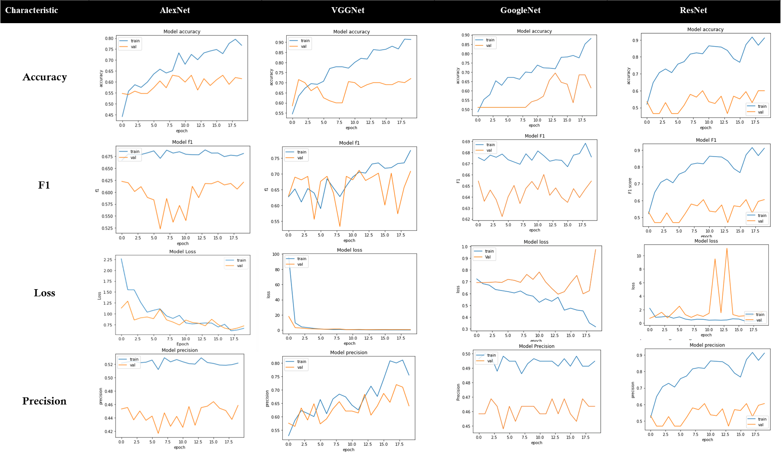

Figure 94 shows a sample image classification from the top-performing VGGNet-16 model where images are classified as flood/non-flood.

**Figure 94**

*Classified image samples*

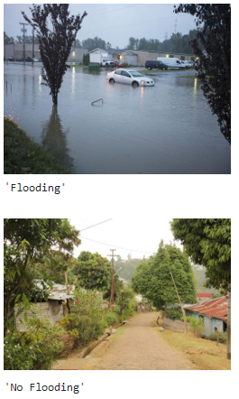

**References**

Ahmad, K., Konstantin, P., Riegler, M., Conci, N., & Holversen, P. (2017). *CNN and GAN*

*Based Satellite and Social Media Data Fusion for Disaster Detection*. https://doi.org/https://www.researchgate.net/publication/319774098_CNN_and_GAN_Based_Satellite_and_Social_Media_Data_Fusion_for_Disaster_Detection

Alam, Firoj, et al. “Deep Learning Benchmarks and Datasets for Social Media Image

Classification for Disaster Response.” *2020 IEEE/ACM International Conference on Advances in Social Networks Analysis and Mining (ASONAM)*, 2020, https://doi.org/10.1109/asonam49781.2020.9381294.

Alam, Firoj, et al. “Medic: A Multi-Task Learning Dataset for Disaster Image Classification.”

*Neural Computing and Applications*, 2022, https://doi.org/10.1007/s00521-022-07717-0.

Alam, Firoj, et al. “CRISISMMD: Multimodal Twitter Datasets from Natural Disasters.”

*ArXiv.org*, 2 May 2018, https://arxiv.org/abs/1805.00713.

Alam, F., Ofli, F., Imran, M., Alam, T., & Qazi, U. (2020). Deep Learning Benchmarks and

Datasets for Social Media Image Classification for Disaster Response. *2020 IEEE/ACM International Conference on Advances in Social Networks Analysis and Mining (ASONAM)*. https://doi.org/10.1109/asonam49781.2020.9381294

Alarfaj, F. K., Malik, I., Khan, H. U., Almusallam, N., Ramzan, M., & Ahmed, M. (2022).

Credit Card Fraud Detection Using State-of-the-Art Machine Learning and Deep Learning Algorithms. *IEEE Access*, *10*, 39700–39715. https://doi.org/10.1109/access.2022.3166891

Albelwi, S., & Mahmood, A. (2017). A Framework for Designing the Architectures of Deep

Convolutional Neural Networks. Entropy, 19(6), 242. https://doi.org/10.3390/e19060242 Network Models for Practical Applications.

Alfredo Canziani, Adam Paszke, & Eugenio Culurciello. (2016). An Analysis of Deep Neural

Network Models for Practical Applications. *ArXiv: Computer Vision and Pattern Recognition*.

Ali, A. (2022, January 23). *OpenCV normalize images*. Delft Stack. Retrieved November

4, 2022, from https://[www.delftstack.com/howto/python/opencv-normalize/](http://www.delftstack.com/howto/python/opencv-normalize/)

Asif, A., Khatoon, S., Hasan, M. M., Alshamari, M. A., Abdou, S., Elsayed, K. M., &

Rashwan, M. (2021). Automatic analysis of social media images to identify disaster type and infer appropriate emergency response. *Journal of Big Data*, *8*(1). https://doi.org/10.1186/s40537-021-00471-5

Aszemi, N. M., & Dominic, P. (2019). Hyperparameter Optimization in Convolutional

Neural Network using Genetic Algorithms. *International Journal of Advanced Computer Science and Applications*, *10*(6). https://doi.org/10.14569/ijacsa.2019.0100638

“Basic CNN Architecture: Explaining 5 Layers of Convolutional Neural Network.” *UpGrad*

*Blog*, 3 Oct. 2022, https://www.upgrad.com/blog/basic-cnn-architecture/.

Bhatt, D., Patel, C., Talsania, H., Patel, J., Vaghela, R., Pandya, S., Modi, K., & Ghayvat, H.

(2021). CNN Variants for Computer Vision: History, Architecture, Application, Challenges and Future Scope. *Electronics*, *10*(20), 2470. https://doi.org/10.3390/electronics10202470

Bocanegra, Maria Gonzalez, and Rami J. Haddad. “Convolutional Neural Network-Based

Disaster Assessment Using Unmanned Aerial Vehicles.” *SoutheastCon 2021*, 2021, https://doi.org/10.1109/southeastcon45413.2021.9401928

Brownlee, J. (2019, July 5). Best practices for preparing and augmenting image data for cnns.

Machine Learning Mastery. Retrieved November 4, 2022, from https://machinelearningmastery.com/best-practices-for-preparing-and-augmenting-image- data-for-convolutional-neural-networks/

C. O'Reilly and T. Nielsen, "Revisiting the ROC curve for diagnostic applications with an

unbalanced class distribution," 2013 8th International Workshop on Systems, Signal Processing and their Applications (WoSSPA), 2013, pp. 413-420, doi: 10.1109/WoSSPA.2013.6602401.

*Damage Identification in Social Media Posts Using Multimodal Deep Learning*.

https://www.researchgate.net/publication/325386740_Damage_Identification_in_Social_Media_Posts_using_Multimodal_Deep_Learning.

Dey, V. (2021, August 20). *Guide to image reconstruction using principal component*

*analysis*.Analytics India Magazine. Retrieved November 4, 2022, from https://analyticsindiamag.com/guide-to-image-reconstruction-using-principal- component- analysis/*Dive into Deep Learning — Dive into Deep Learning 1.0.0- alpha1.post0 documentation*. (n.d.). https://d2l.ai/index.html

Drakonakis, G. I., Tsagkatakis, G., Fotiadou, K., & Tsakalides, P. (2022).

OmbriaNet—supervised flood mapping via convolutional neural networks using multitemporal sentinel-1 and sentinel-2 data fusion. *IEEE Journal of Selected Topics in Applied Earth Observations and Remote Sensing*, *15*, 2341–2356. https://doi.org/10.1109/jstars.2022.3155559

Environmental Protection Agency. (n.d.). EPA. Retrieved November 4, 2022,

from https://[www.epa.gov/caddis-vol4/exploratory-data-analysis](http://www.epa.gov/caddis-vol4/exploratory-data-analysis)

F. K. Alarfaj, I. Malik, H. U. Khan, N. Almusallam, M. Ramzan and M. Ahmed, "Credit Card Fraud Detection Using State-of-the-Art Machine Learning and Deep Learning Algorithms," in IEEE Access, vol. 10, pp. 39700-39715, 2022, doi: 10.1109/ACCESS.2022.3166891.

He, Z. (2020). Deep learning in image classification: A survey report. *2020 2nd International*

*Conference on Information Technology and Computer Application (ITCA)*. https://doi.org/10.1109/itca52113.2020.00043

Hui, Jonathan. “Machine Learning - Singular Value Decomposition (SVD) &amp; Principal

Component Analysis (PCA).” Medium, Medium, 8 Feb. 2022, https://jonathan-hui.medium.com/machine-learning-singular-value-decomposition-svd-principal-component-analysis-pca-1d45e885e491#:~:text=What%20is%20the%20difference%20between,PCA%20skips%20less%20significant%20components.

Ichim, L., &amp; Popescu, D. (2020). Segmentation of vegetation and flood from aerial

images based on decision fusion of Neural Networks. *Remote Sensing, 12*(15), 2490. https://doi.org/10.3390/rs12152490

*Image compression using principal component analysis (PCA)*. (n.d.). Retrieved November 4, 2022, from https://towardsdatascience.com/image-compression- using-principal- component-analysis-pca-253f26740a9f

*Image data pre-processing for Neural Networks - medium*. (n.d.). Retrieved November 4, 2022, from https://becominghuman

Image denoising. OpenCV. (n.d.). Retrieved November 4, 2022, from

https://docs.opencv.org/3.4/d5/d69/tutorial_py_non_local_means.html.ai/image-data-pre-processing-for-neural-networks-498289068258

*ImageStat module*. ImageStat Module - Pillow (PIL) examples. (n.d.). Retrieved November 4,

2022, from https://hhsprings.bitbucket.io/docs/programming/examples/python/PIL/ImageStat.html

*Introduction to principal component analysis (PCA)*. OpenCV. (n.d.). Retrieved November 4,

2022, from https://docs.opencv.org/3.4/d1/dee/tutorial_introduction_to_pca.html

Kumar, R. (2021, July 9). *CV2 normalize() in python explained with examples*. Python Pool.Retrieved November 4, 2022, from https://[www.pythonpool.com/cv2](http://www.pythonpool.com/cv2)-normalize/

Jafar, A., & Myungho, L. (2020). Hyperparameter Optimization for Deep Residual

Learning in Image Classification. 2020 IEEE International Conference on Autonomic Computing and Self-Organizing Systems Companion (ACSOS-C). https://doi.org/10.1109/acsos-c51401.2020.00024

Jony, R. I., Woodley, A., & Perrin, D. (2019). Flood detection in social media images using

visual features and metadata. 2019 Digital Image Computing: Techniques and Applications (DICTA). https://doi.org/10.1109/dicta47822.2019.8946007

Karteris, A., Tzanos, G., Papadopoulos, L., Demestichas, K., Soudris, D., Philibert, J. P., &

Gómez, C. L. (2022). A methodology for enhancing emergency situational awareness through social media. *Proceedings of the 17th International Conference on Availability, Reliability and Security*. https://doi.org/10.1145/3538969.3544418

Khan, A., Sohail, A., Zahoora, U., & Qureshi, A. S. (2020). A survey of the recent architectures

of deep convolutional Neural Networks. *Artificial Intelligence Review*, *53*(8), 5455–5516. https://doi.org/10.1007/s10462-020-09825-6

Khan, R. U., Zhang, X., Kumar, R., & Aboagye, E. O. (2018). Evaluating the Performance of

ResNet Model Based on Image Recognition. Proceedings of the 2018 International Conference on Computing and Artificial Intelligence - ICCAI 2018. https://doi.org/10.1145/3194452.3194461

Krizhevsky, A., Sutskever, I., & Hinton, G. E. (2017). ImageNet classification with deep

convolutional Neural Networks. *Communications of the ACM*, *60*(6), 84–90. https://doi.org/10.1145/3065386

Kyrkou, Christos, and Theocharis Theocharides. “Deep-Learning-Based Aerial Image

Classification for Emergency Response Applications Using Unmanned Aerial

Vehicles.” *2019 IEEE/CVF Conference on Computer Vision and Pattern Recognition*

*Workshops (CVPRW)*, 2019, https://doi.org/10.1109/cvprw.2019.00077

Lendave, V. (2021, September 22). *A guide to different types of noises and image denoising*

*methods*. Analytics India Magazine. Retrieved November 4, 2022, from https://analyticsindiamag.com/a-guide-to-different-types-of-noises-and-image-denoising- methods/

Lyashenko, V. (2022, July 21). *Data Augmentation in python: Everything you need to know*.

neptune.ai. Retrieved November 4, 2022, from https://neptune.ai/blog/data-augmentation- in-python

Madhugiri, D. (2022, April 22). *Learn image augmentation using 3 popular python*

*libraries*. Analytics Vidhya. Retrieved November 4, 2022, from https://www.analyticsvidhya.com/blog/2022/04/image-augmentation-using-python- libraries

Maeda-Gutiérrez, V., Galván-Tejada, C. E., Zanella-Calzada, L. A., Celaya-Padilla,

J. M., Galván-Tejada, J. I., Gamboa-Rosales, H., Luna-García, H., Magallanes-Quintanar, R., Guerrero Méndez, C. A., & Olvera- Olvera, C. A. (2020). Comparison of Convolutional Neural Network Architectures for Classification of Tomato Plant Diseases. *Applied Sciences*, *10*(4), 1245. <https://doi.org/10.3390/app10041245>

Mahardi, I. -H. Wang, K. -C. Lee and S. -L. Chang, "Images Classification of Dogs and

Cats using Fine-Tuned VGG Models," 2020 IEEE Eurasia Conference on IOT, Communication and Engineering (ECICE), 2020, pp. 230-233, doi: 10.1109/ECICE50847.2020.9301918.

M. Sahrial Alam, M. S. Rahman, M. I. Hosen, K. A. Mubin, S. Hossen and M. F.

Mridha, "Comparison of Different CNN Model used as Encoders for Image Captioning," 2021 International Conference on Data Analytics for Business and Industry (ICDABI), 2021, pp. 523-526, doi: 10.1109/ICDABI53623.2021.9655846.

Mao, J., Harris, K., Chang, N. R., Pennell, C., & Ren, Y. (2020). Train and Deploy an Image

Classifier for Disaster Response. *2020 IEEE High Performance Extreme Computing Conference (HPEC)*. https://doi.org/10.1109/hpec43674.2020.9286248

*Medic dataset*. CrisisNLP. (n.d.). Retrieved November 4, 2022, from

https://crisisnlp.qcri.org/medic/

Mirzarahim. (2019, September 9). *Introduction to PCA: Image compression example*. Kaggle.

Retrieved November 4, 2022, from https://[www.kaggle.com/code/mirzarahim/introduction-to-pca-image-compression-](http://www.kaggle.com/code/mirzarahim/introduction-to-pca-image-compression-) example/notebook

Montello, F., Arnaudo, E., & Rossi, C. (2022). MMFlood: A Multimodal dataset for flood

delineation from satellite imagery. *IEEE Access*, *10*.

https://doi.org/10.1109/access.2022.3205419

Nantasenamat, C. (2022, January 14). *The data science process*. Medium. Retrieved September 21, 2022, from https://towardsdatascience.com/the-data-science-process- a19eb7ebc41b

Nguyen, Dat T., et al. “Damage Assessment from Social Media Imagery Data during

Disasters.” *Proceedings of the 2017 IEEE/ACM International Conference on Advances in Social Networks Analysis and Mining 2017*, 2017, https://doi.org/10.1145/3110025.3110109.

N. Mikhailov, M. Shakeel, A. Urmanov, M. -H. Lee and M. F. Demirci, "Optimization of

CNN Model for Breast Cancer Classification," 2021 16th International Conference on Electronics Computer and Computation (ICECCO), 2021, pp. 1-3, doi: 1 0.1109/ICECCO53203.2021.9663847.

N. Ojha and A. Kumar, "A Comparison Based Breast Cancer High Microscopy Image Classification Using Pre-trained Models," 2020 IEEE Students Conference on Engineering & Systems (SCES), 2020, pp. 1-6, doi: 10.1109/SCES50439.2020.9236708

N. Zakaria, F. Mohamed, R. Abdelghani and K. Sundaraj, "VGG16, ResNet-50, and

GoogLeNet Deep Learning Architecture for Breathing Sound Classification: A Comparative Study," 2021 International Conference on Artificial Intelligence for Cyber Security Systems and Privacy (AI-CSP), 2021, pp. 1-6, doi: 10.1109/AI- CSP52968.2021.9671124.

projects, Contributors to Wikimedia. *Wikimedia Commons*, Wikimedia Foundation, Inc., 1 Dec. 2022, https://commons.wikimedia.org/wiki/Main_Page.

*Operations with images*. OpenCV. (n.d.). Retrieved November 4, 2022, from

https://docs.opencv.org/3.4/d5/d98/tutorial_mat_operations.html

Peng, M. L. (2018, May 15). *Improving neural networks by preventing co-adaptation of*

*feature detectors*. Medium. Retrieved November 4, 2022, from https://medium.com/@lipeng2/dropout-is-so-important-e517bbe3ffcc

Praveen. (2020, July 28). *How to find HSV range of an object for computer vision*

*applications?*Medium. Retrieved November 4, 2022, from https://medium.com/programming- fever/how-to-find-hsv-range-of-an-object-for-computer-vision-applications-254a8eb039fc

*Principal component analysis: In-depth understanding through image ...* (n.d.). Retrieved

November 4, 2022, from https://towardsdatascience.com/principal-component-analysis-in- depth-understanding-through-image-visualization-892922f77d9f

Rahnemoonfar, M., Chowdhury, T., Sarkar, A., Varshney, D., Yari, M., & Murphy, R. R. (2021).

FloodNet: A high resolution aerial imagery dataset for post flood scene understanding. *IEEE Access*, *9*, 89644–89654. https://doi.org/10.1109/access.2021.3090981

Rambour, C., Audebert, N., Koeniguer, E., Le Saux, B., Crucianu, M., & Datcu, M. (2020).

Flood detection in time series of optical and SAR Images. *The International Archives of the Photogrammetry, Remote Sensing and Spatial Information Sciences*, *XLIII-B2-2020*. https://doi.org/10.5194/isprs-archives-xliii-b2-2020-1343-2020

Rausch, D. (2021, April 15). *EDA for image classification*. Medium. Retrieved November 4,

2022, from https://medium.com/geekculture/eda-for-image-classification-dcada9f2567a

Russakovsky, O., Deng, J., Su, H., Krause, J., Satheesh, S., Ma, S., Huang, Z., Karpathy, A.,

Khosla, A., Bernstein, M., Berg, A. C., & Fei-Fei, L. (2015). ImageNet Large Scale Visual Recognition Challenge. *International Journal of Computer Vision*, *115*(3), 211–252. https://doi.org/10.1007/s11263-015-0816-y

Saltz, J. S. (2021). CRISP-DM for data science: Strengths, weaknesses and potential next

steps. *2021 IEEE International Conference on Big Data (Big Data)*. https://doi.org/10.1109/bigdata52589.2021.9671634

Sony, S., Dunphy, K., Sadhu, A., & Capretz, M. (2021). A systematic review of

convolutional neural network-based structural condition assessment techniques. *Engineering Structures*, *226*, 111347. https://doi.org/10.1016/j.engstruct.2020.111347

S. Mascarenhas and M. Agarwal, "A comparison between VGG16, VGG19 and ResNet50

architecture frameworks for Image Classification," 2021 International Conference on Disruptive Technologies for Multi-Disciplinary Research and Applications (CENTCON), 2021, pp. 96-99, doi: 10.1109/CENTCON52345.2021.9687944.

*Smoothing images*. OpenCV. (n.d.). Retrieved November 4, 2022, from https://opencv24-python-

tutorials.readthedocs.io/en/latest/py_tutorials/py_imgproc/py_filtering/py_filtering.h

Szegedy, C., Wei Liu, Yangqing Jia, Sermanet, P., Reed, S., Anguelov, D., Erhan, D., Vanhoucke, V., & Rabinovich, A. (2015a). Going deeper with convolutions. *2015 IEEE Conference on Computer Vision and Pattern Recognition (CVPR)*. https://doi.org/10.1109/cvpr.2015.7298594

Tammina, S. (2019). Transfer learning using VGG-16 with Deep Convolutional Neural

Network for Classifying Images. *International Journal of Scientific and Research Publications (IJSRP)*, *9*(10), p9420. https://doi.org/10.29322/ijsrp.9.10.2019.p942

Tao, L., Wang, L., Shen, X., & Liu, C. (2022). Research of fire identification method based

on convolutional neural network. *2022 7th International Conference on Intelligent Computing and Signal Processing (ICSP)*. https://doi.org/10.1109/icsp54964.2022.9778338

Team, G. L. (2021, April 6). *Introduction to image pre-processing: What is image*

*pre-processing?* GreatLearning Blog: Free Resources what Matters to shape your Career! Retrieved September 28, 2022, from https://www.mygreatlearning.com/blog/introduction-to-image-pre-processing/

Team, K. (n.d.). *Keras documentation: Losses*. https://keras.io/api/losses/

Thanapol, P., Lavangnananda, K., Bouvry, P., Pinel, F., & Leprevost, F. (2020). Reducing

Overfitting and Improving Generalization in Training Convolutional Neural Network (CNN) under Limited Sample Sizes in Image Recognition. 2020 - 5th International Conference on Information Technology (InCIT). https://doi.org/10.1109/incit50588.2020.9310787

Utku Evci, Fabian Pedregosa, Aidan N. Gomez, & Erich Elsen. (2019). The Difficulty of Training Sparse Neural Networks. ArXiv: Learning.

Valdez, D. B., & Godmalin, R. A. (2021). A deep learning approach of recognizing natural

disasters on images using convolutional neural network and transfer learning. *Proceedings of the International Conference on Artificial Intelligence and Its Applications*. https://doi.org/10.1145/3487923.3487927

V. Tiwari, C. Pandey, A. Dwivedi and V. Yadav, "Image Classification Using Deep Neural Network," 2020 2nd International Conference on Advances in Computing, Communication Control and Networking (ICACCCN), 2020, pp. 730-733, doi: 10.1109/ICACCCN51052.2020.9362804.

Vujovic, E. (2021). Classification Model Evaluation Metrics. *International Journal of Advanced Computer Science and Applications*, *12*(6). https://doi.org/10.14569/ijacsa.2021.0120670

Weather-related disasters increase over the past 50 years, causing more damage but fewer

deaths. World Meteorological Organization. (2021, September 9). Retrieved September 21, 2022, from https://public.wmo.int/en/media/press-release/weather-related-disasters-increase-over-past-50-years-causing-more-damage-fewer

Weerasinghe, I. D. T. T., & Jayasena, K. P. N. (2020). Multimedia Big Data Platform with a

deep learning approach for flood emergency management. *2020 5th International Conference on Information Technology Research (ICITR)*. https://doi.org/10.1109/icitr51448.2020.9310903

X. Wu, T. Tanprasert and W. Jing, "Image classification based on multi-granularity convolutional Neural network model," 2022 19th International Joint Conference on Computer Science and Software Engineering (JCSSE), 2022, pp. 1-4, doi: 10.1109/JCSSE54890.2022.9836281.

Yessou, H., Sumbul, G., & Demir, B. (2020). A Comparative Study of Deep Learning Loss Functions for Multi-Label Remote Sensing Image Classification. *IGARSS 2020 - 2020 IEEE International Geoscience and Remote Sensing Symposium*. https://doi.org/10.1109/igarss39084.2020.9323583

Ying-bin Kang, & Gui-mei Chen. (2011). The flood impact assessment on Xiaohe Bridge.

2011 International Symposium on Water Resource and Environmental Protection. https://doi.org/10.1109/iswrep.2011.5893068

Y. K. Saheed, M. A. Hambali, M. O. Arowolo and Y. A. Olasupo, "Application of GA Feature Selection on Naive Bayes, Random Forest and SVM for Credit Card Fraud Detection," 2020 International Conference on Decision Aid Sciences and Application (DASA), 2020, pp. 1091-1097, doi: 10.1109/DASA51403.2020.9317228.

Zhang, F., Fleyeh, H., Wang, X., & Lu, M. (2018, December 24). *Construction site*

*accident analysis using text mining and Natural Language Processing Techniques*. Automation in Construction. Retrieved September 28, 2022, from https://www.sciencedirect.com/science/article/pii/S0926580518306137

Zhang, Z., Liu, D., Liu, Z., Qiao, Y., Zheng, C., & Gan, Y. (2021). Deep learning based

methods for water body extraction and flooding evolution analysis based on sentinel-1 images. *2021 7th International Conference on Hydraulic and Civil Engineering & Smart Water Conservancy and Intelligent Disaster Reduction Forum (ICHCE & SWIDR)*. https://doi.org/10.1109/ichceswidr54323.2021.9656266

**Appendix B**

Project Data Source and Management Store

B1. Importing necessary libraries

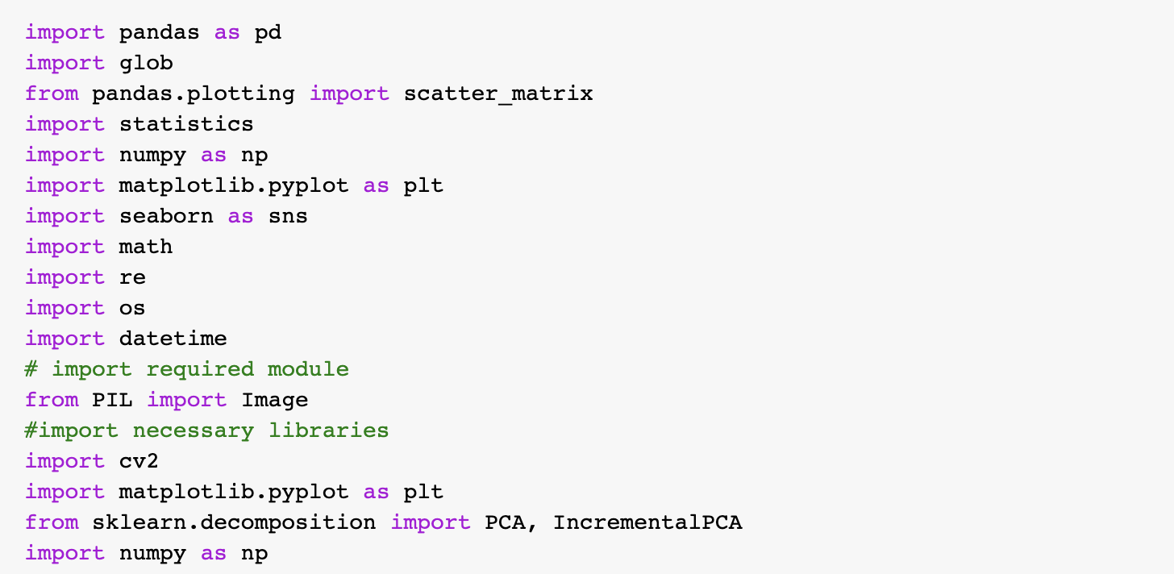

B2. Reading data into data frame

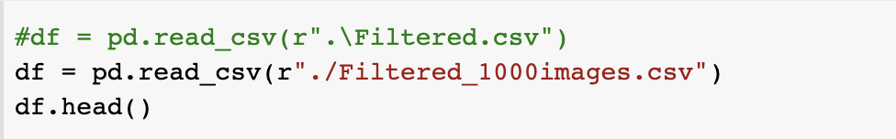

B3. Finding the properties of the images

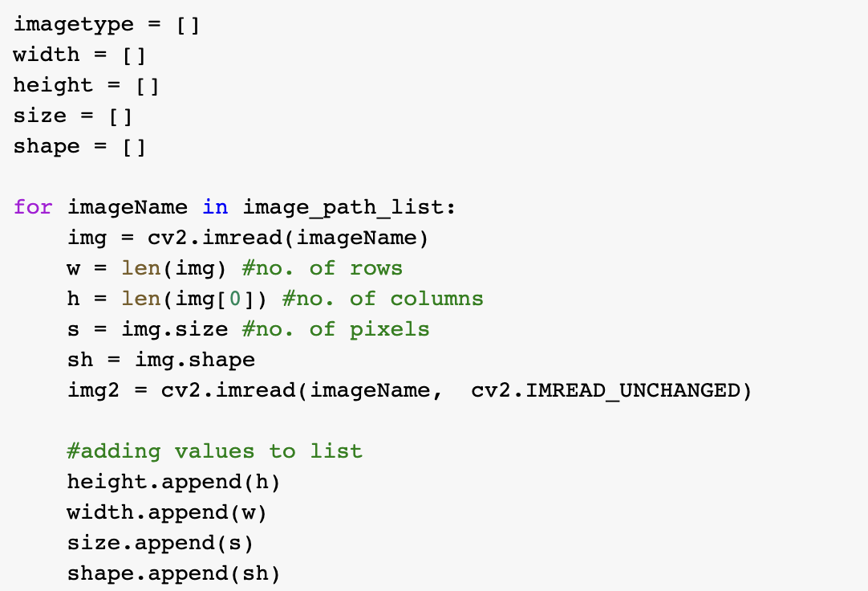

B4. Removing missing values

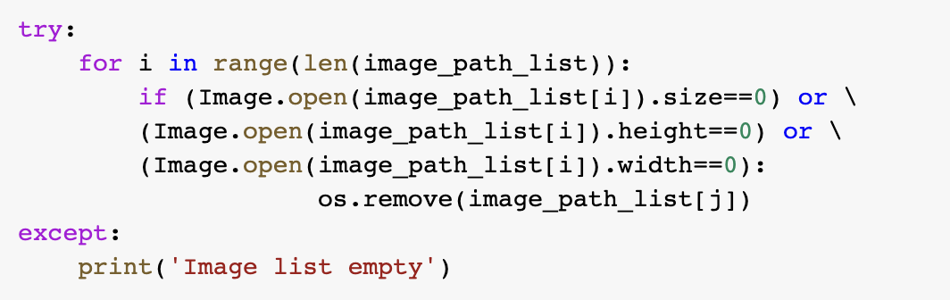

B5. Resizing images

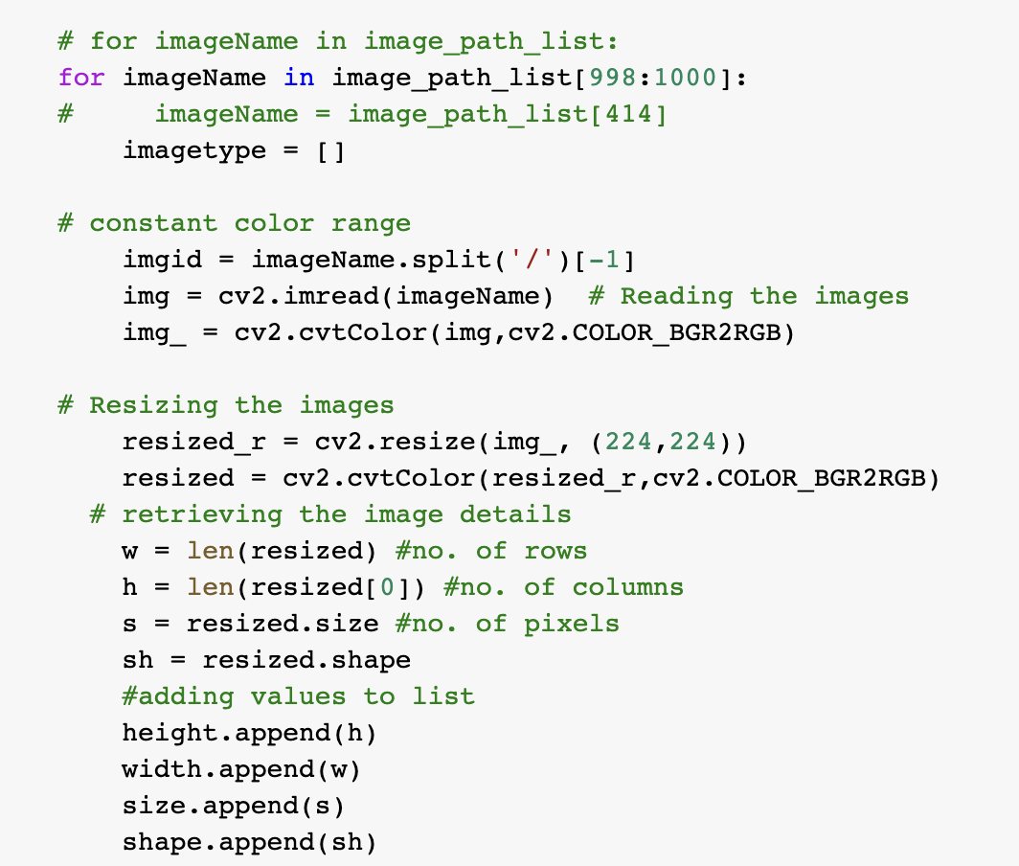

B6. Denoising images

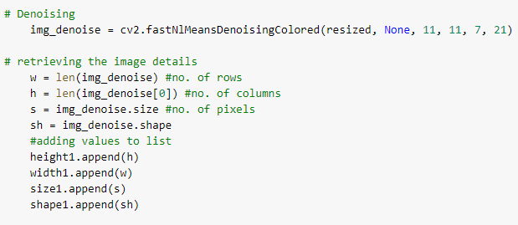

B7. Applying normalizing filter

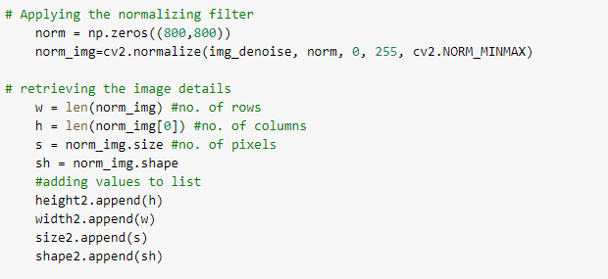

B8. Greyscaling

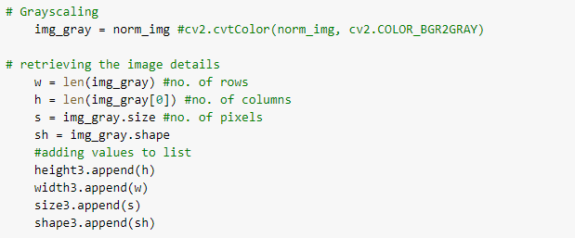

B9. Storing the images after preprocessing

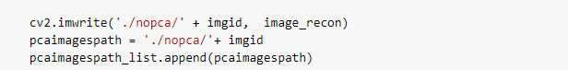

B10. AlexNet Model Implementation:

B10.1. Importing the required libraries and connecting with Google Colab to import the pre-processed images

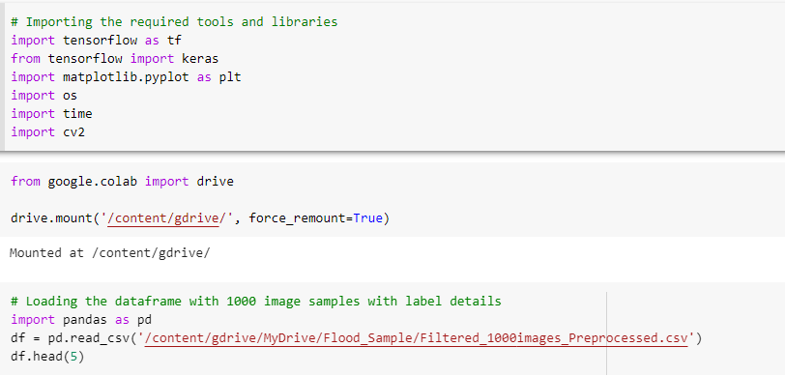

B10.2. Listing the characteristics of the target label

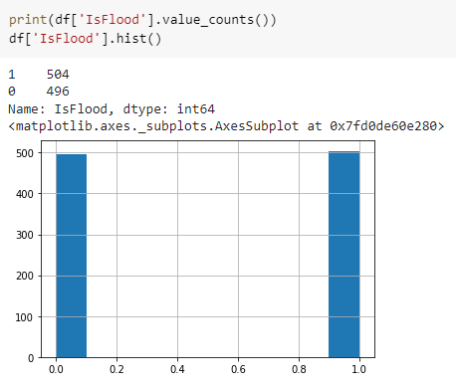

B10.3. Loading the image and converting to array for processing

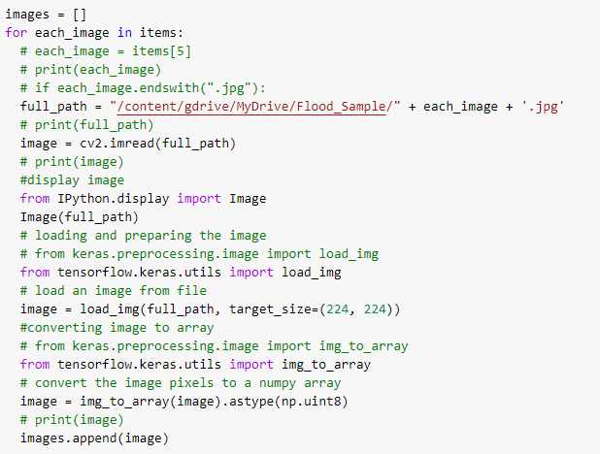

B10.4. Plotting the image

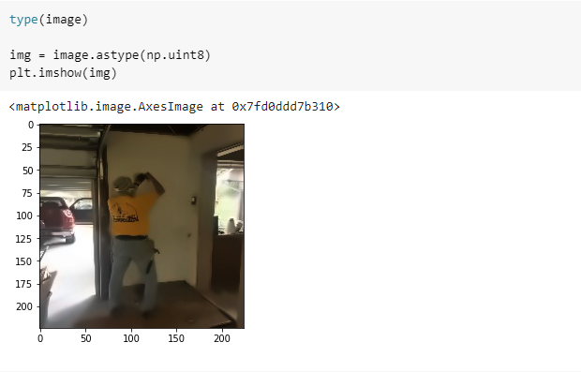

B10.5. Splitting the image data into training, validation, and testing

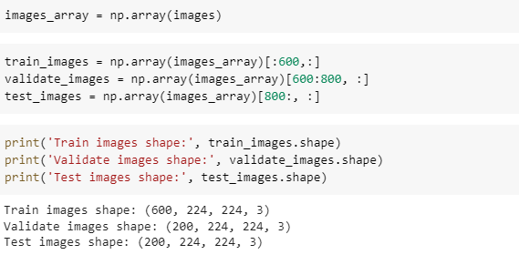

B10.6. Storing the output target labels

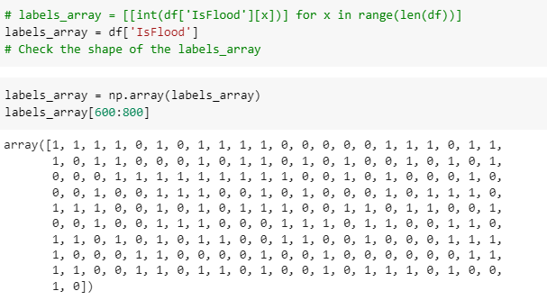

B10.6. Splitting the labels into training, validation, and testing

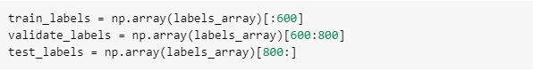

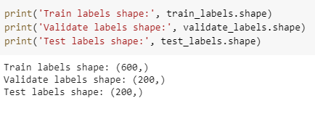

B10.7. Converting the data in the required format



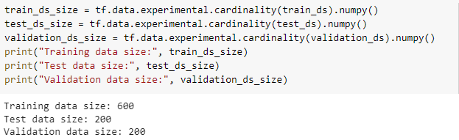

B10.7. Map, shuffle, and batch for processing

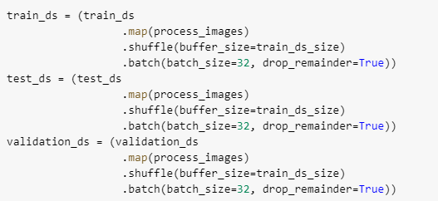

B10.8. Defining the model for AlexNet

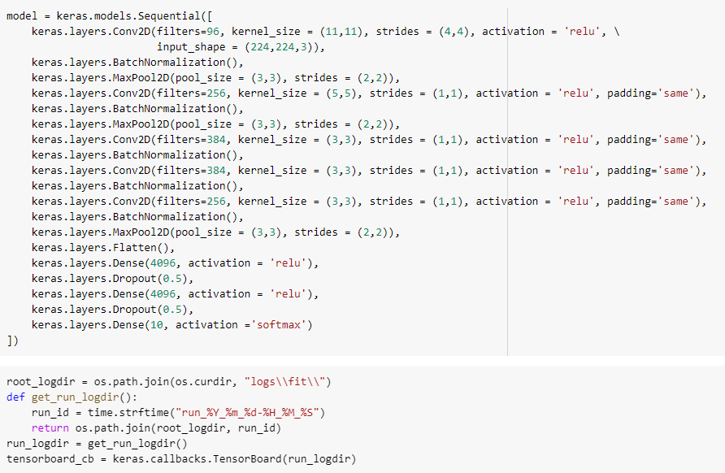

B10.9. Defining the metrics for evaluation

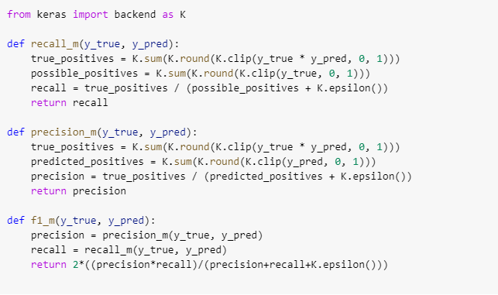

B10.10. Model compilation and summary

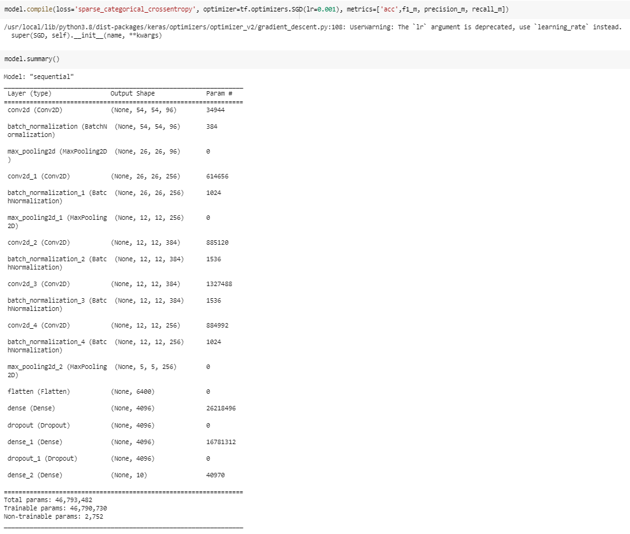

B10.11. Model fit for 20 epochs

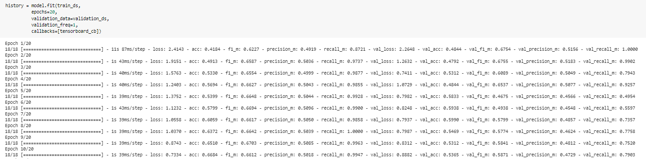

B10.12 Model Performance Metrics

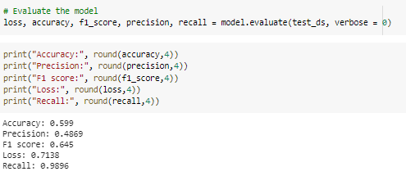

B10.13 AlexNet Model Accuracy (the plots are slightly different for each run)

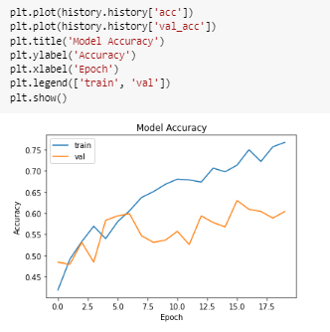

B10.14 AlexNet Model F1

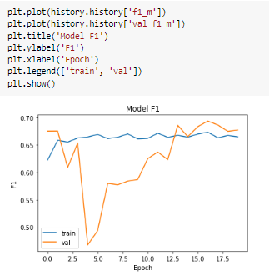

B10.15 AlexNet Model Precision

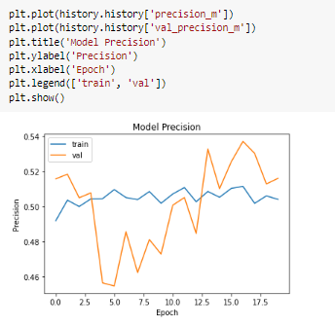

B10.16 AlexNet Model Loss

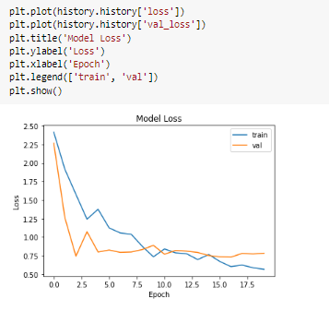

B10.17 AlexNet Model Recall

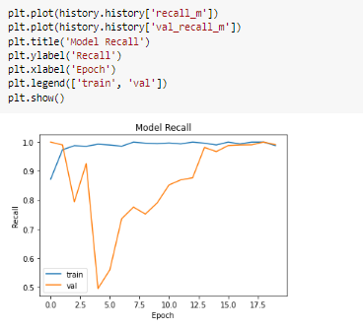

B10.18 AlexNet Model Plot



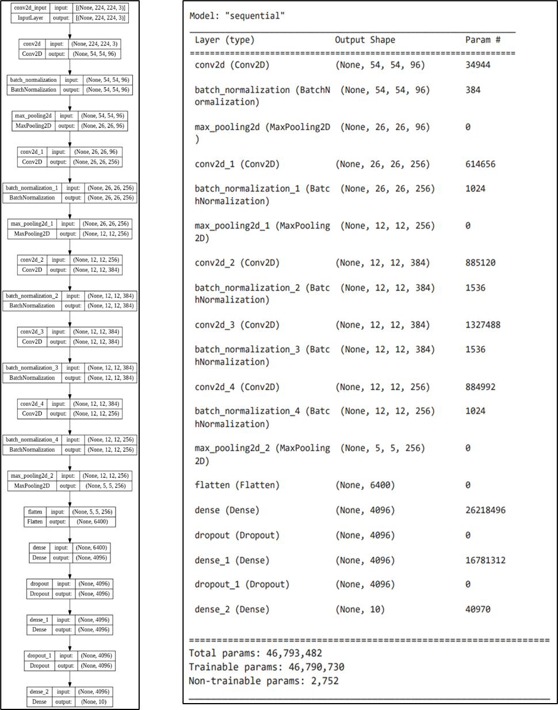

B11. GoogleNet Model Implementation:

B11.1 Importing the required libraries from tensorflow and keras

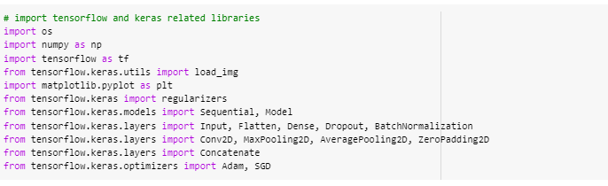

B11.2 Creating the model

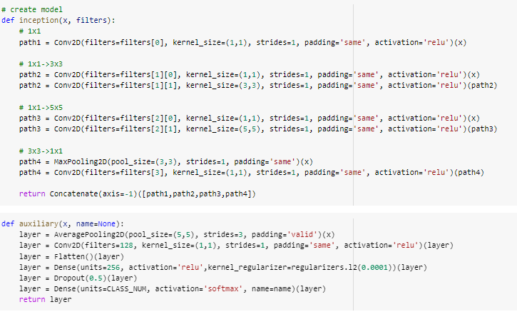

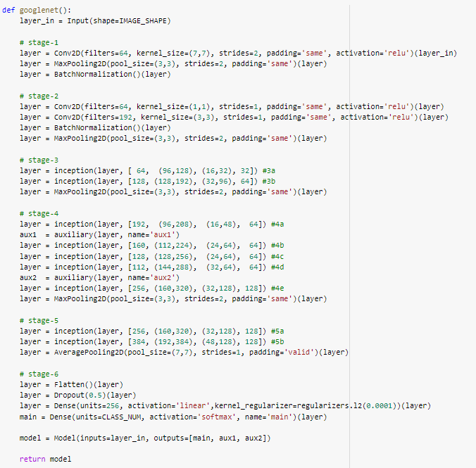

B11.3. Defining the parameters and calling the function for the model

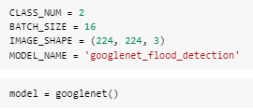

B11.3. Defining the evaluation metrics

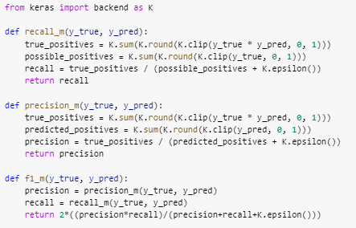

B11.4 Model compilation and printing the summary

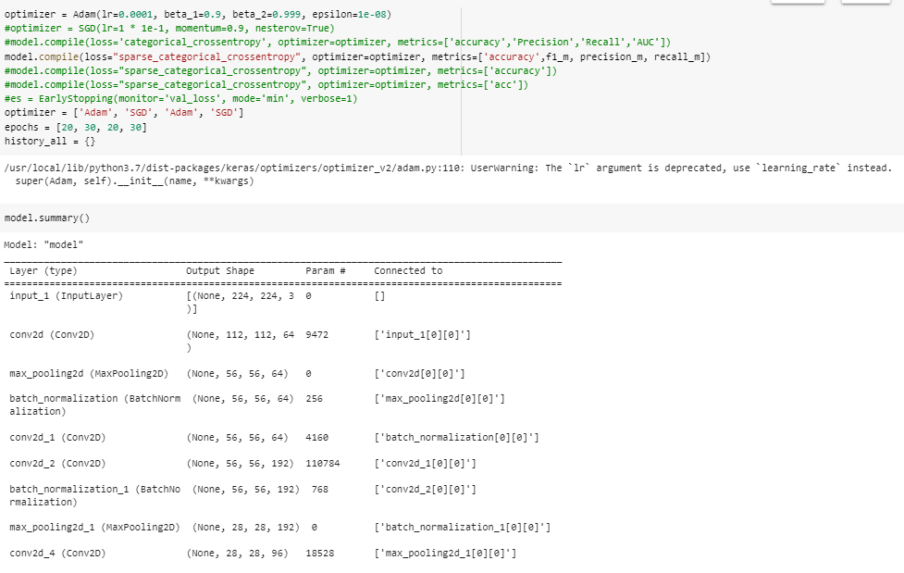

B11.5 Model fit

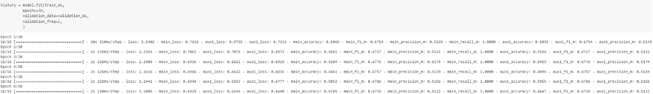

B11.6 Printing the evaluation metrics

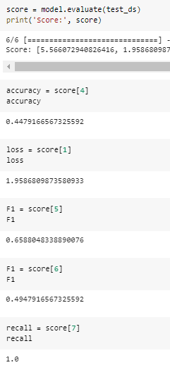

B11.7 GoogleNet Accuracy

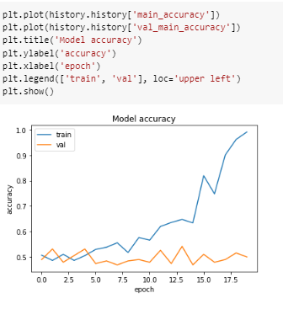

B11.8 GoogleNet Loss

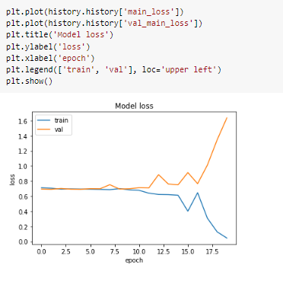

B11.9. GoogleNet F1

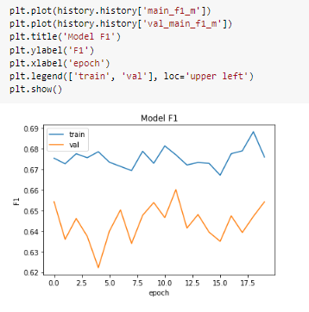

B11.10 GoogleNet Recall

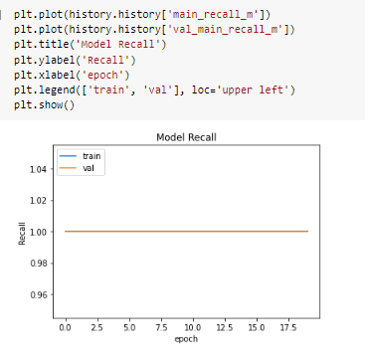

B11.11 GoogleNet Precision

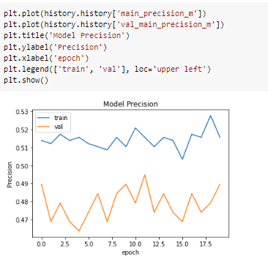

**Detailed architecture of GoogLeNet in order**

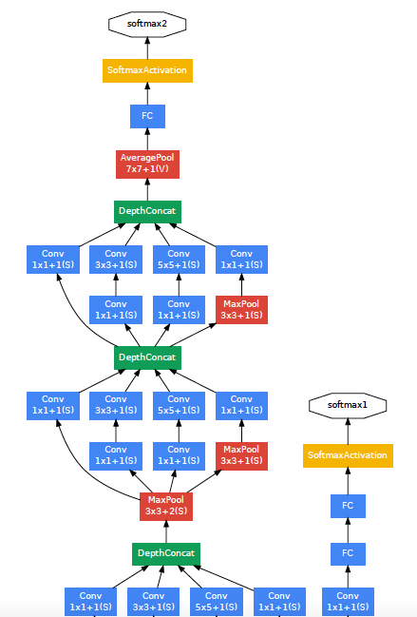

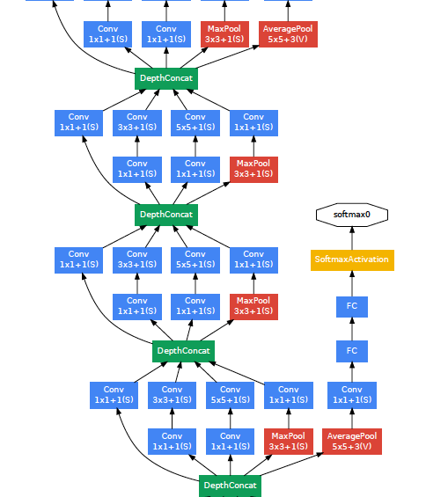

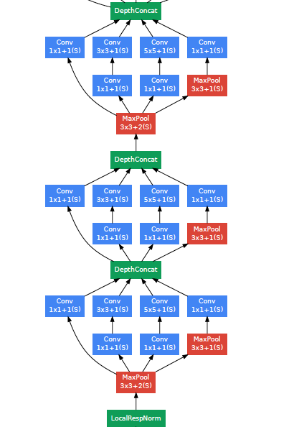

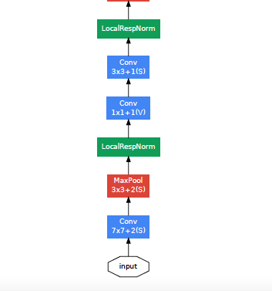

B12. VGG16 Model Implementation

B12.1. Loading the data

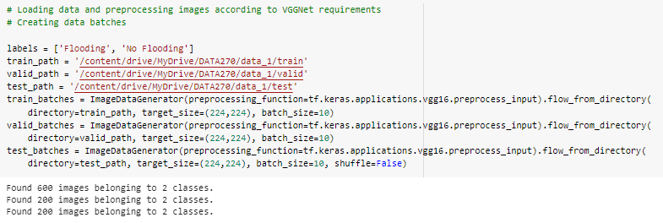

B12.2. Calling the pre-trained model

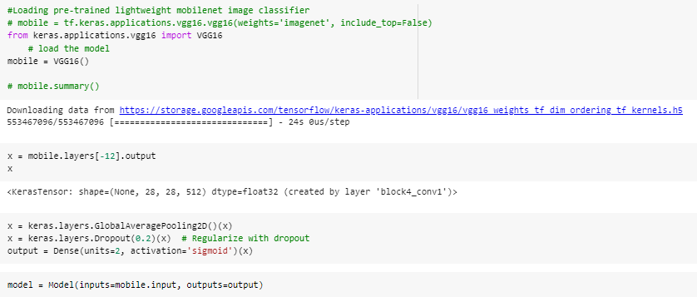

B12.3. Printing model summary

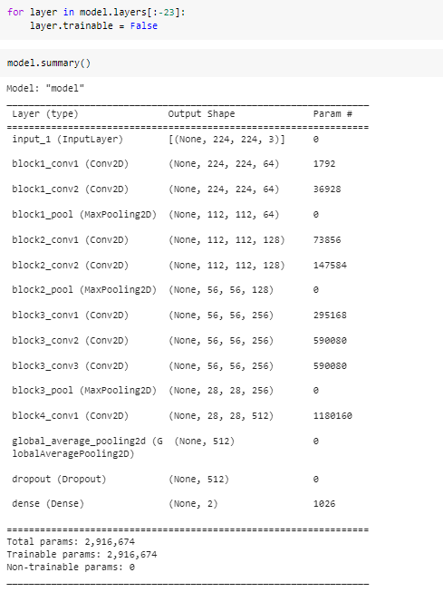

B12.4 Defining the evaluation metrics

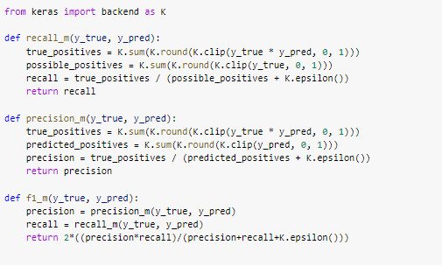

B12.5. Compiling the model

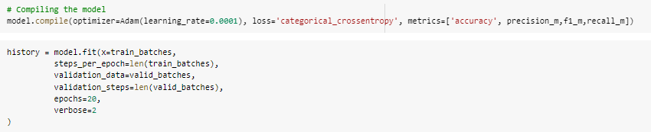

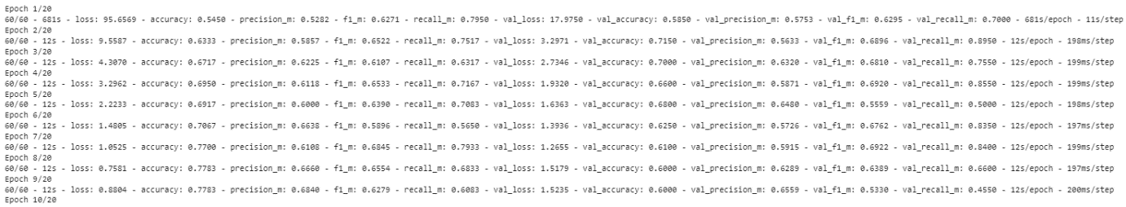

B12.6. VGG-16 Model Accuracy

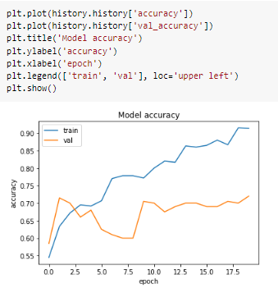

B12.6. VGG-16 Model Loss

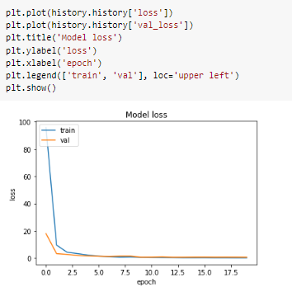

B12.6. VGG-16 Model Precision

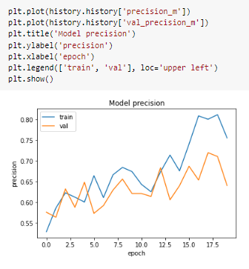

B12.6. VGG-16 Model Recall

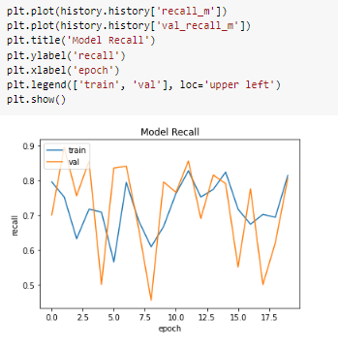

B12.6. VGG-16 Model F1

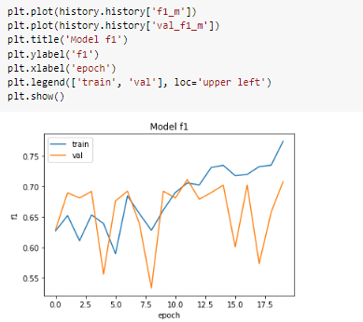

B12.7. Defining the confusion matrix

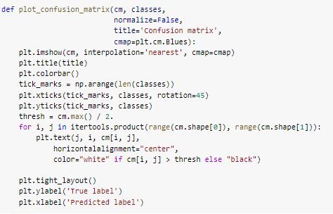

B12.8. VGG-16 Evaluation Metrics

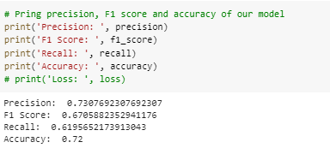

B12.9. VGG-16 Confusion Matrix

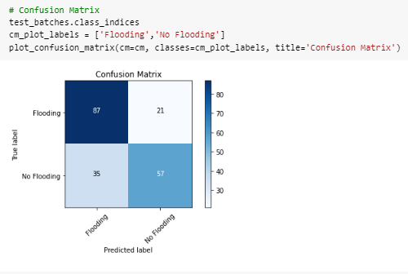

B12.10. Predicting the model output for an image

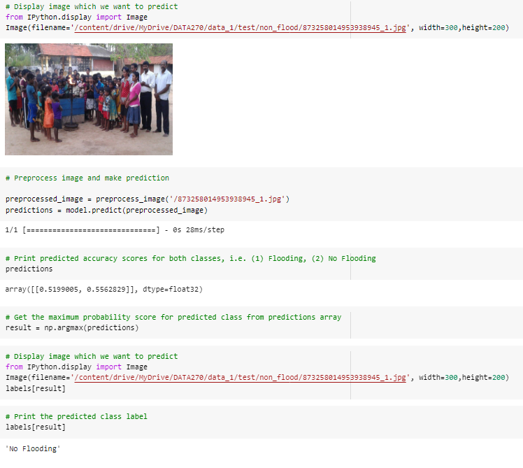

B13. ResNet Implementation

B13.1. Importing the required libraries

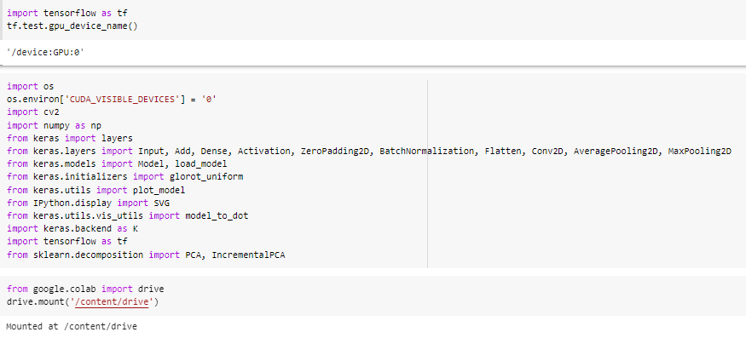

B13.2. Setting the parameters and defining the functions

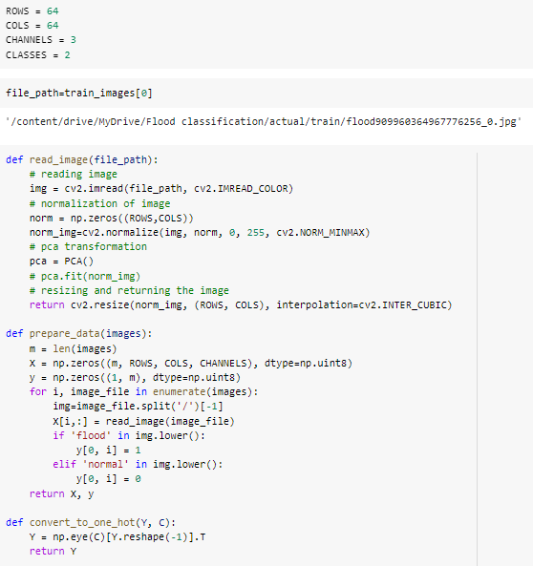

B13.3. Splitting the data

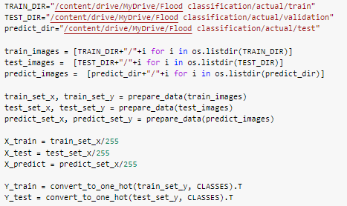

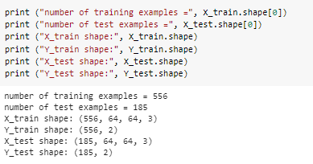

B13.4. Defining the identity block

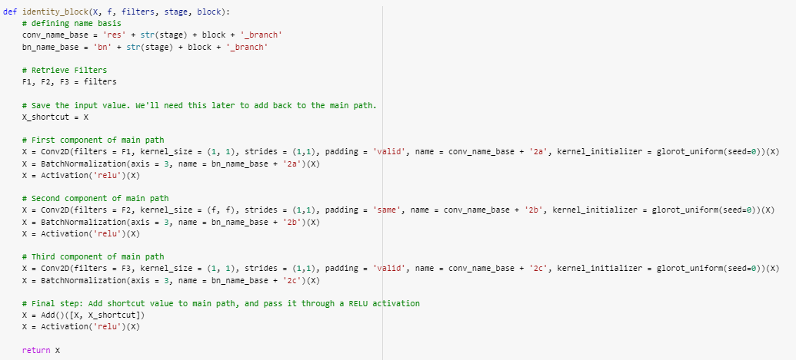

B13.5. Defining the session

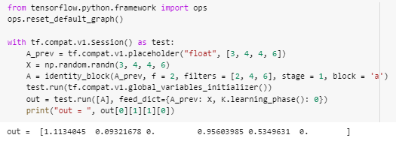

B13.6. Defining the convolutional block for ResNet

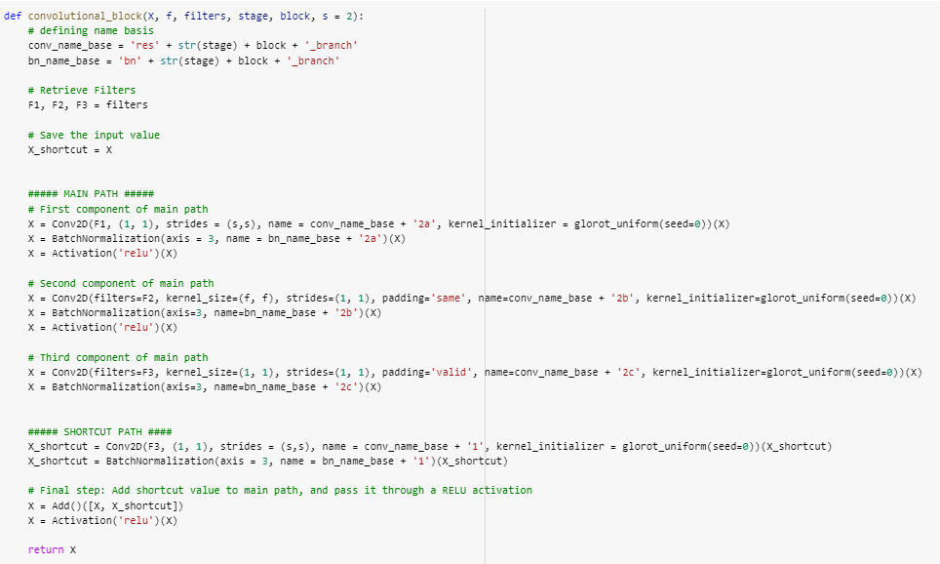

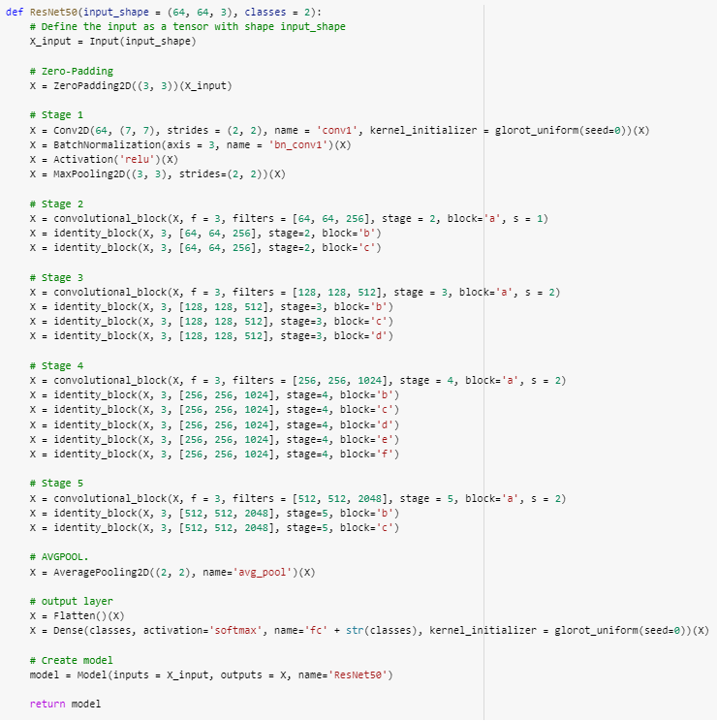

B13.7. Calling the function

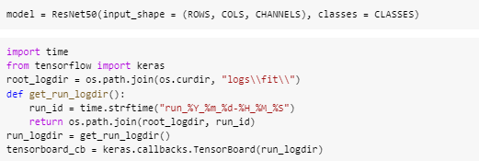

B13.8. Defining the evaluation parameters

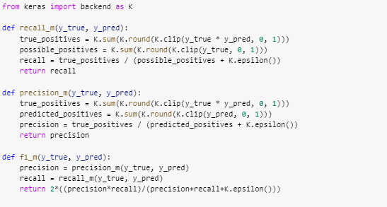

B13.9. Model compilation

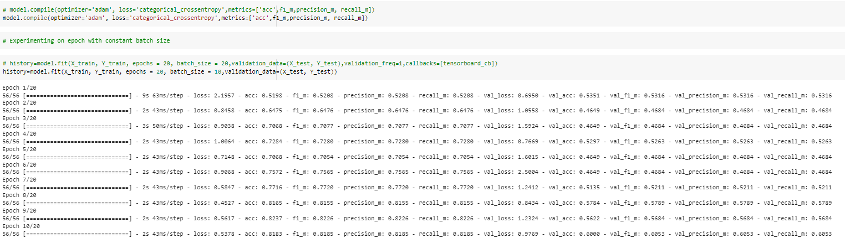

B13.10. ResNet Model Accuracy

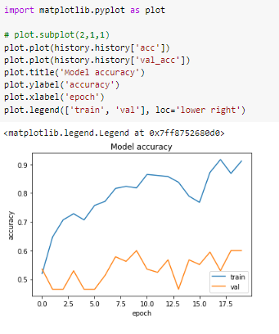

B13.11. ResNet Model Loss

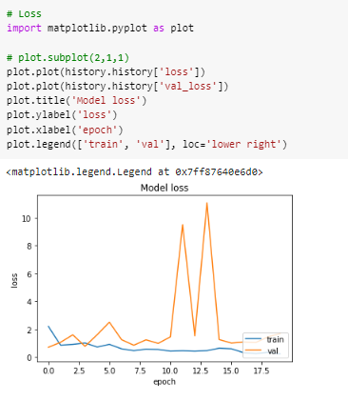

B13.12. ResNet Model F1

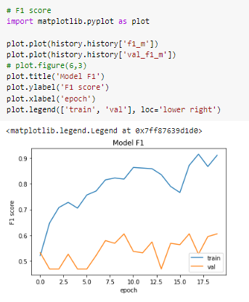

B13.13. ResNet Model Recall

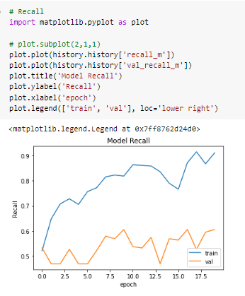

B13.14. ResNet Model Precision

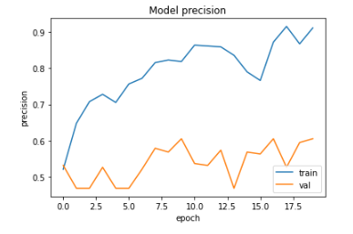

B13.14. ResNet Model Diagram

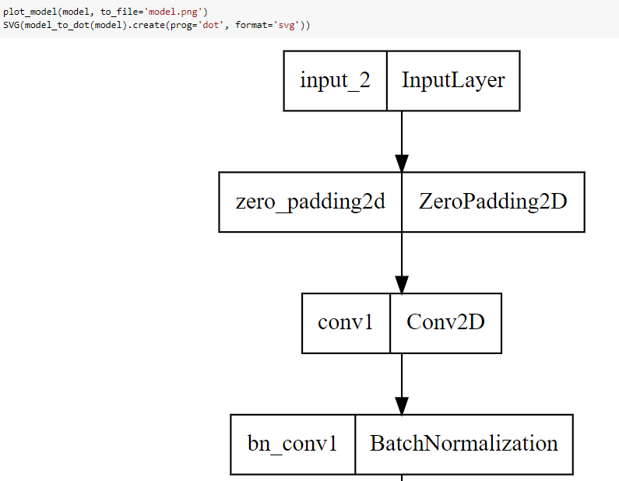

B14. Gantt Chart

